Running Head: Ballan wrasse spawning period

Assessment of the spawning season of ballan wrasse in south-west England to aid sustainability of a new fishery
Peter White* & Tim Ellis
Cefas Weymouth Laboratory, Barrack Road, The Nothe, Weymouth, Dorset, DT4 8UB, UK
*Communicating author:
E: peter.white@cefas.co.uk
T: +44 (0)1305 206600
F: +44 (0)1305 206601

© Crown Copyright 2020
ABSTRACT
A new inshore fishery has developed around the south-west coast of England for live wrasse which are transported to Scotland as “cleaner fish” to remove parasitic sea-lice from farmed salmon. Fishery management measures are being introduced to protect the wild wrasse stocks, such as minimum and maximum landing sizes and a closed season. However, there is limited information on local populations to inform such measures. This study aimed to identify the spawning season of ballan wrasse in south-west England to advise on the timing of the closed season. Ballan wrasse samples were provided by local fishers in the Weymouth Bay area from February 2018 through to May 2019. The samples (10-46.5 cm L_{T}) were dominated by females (91%) and all males were ≥33.5 cm. Both ovarian staging and gonadosomatic index indicated that spawning occurs in March-April with completion by May, earlier than in higher latitudes. Females matured at ≥ 24 cm L_{T}, and our samples support the suggestion that sex change from female to male occurs at >28 cm L_{T} . These data for south-west England can inform local fishery management measures to protect the local stock and identify future changes.

Keywords: Ballan wrasse; Wild wrasse stocks; Fishery independent sampling; Fishery management, Non-quota species, Inshore Fishery
INTRODUCTION
The ectoparasitic copepod salmon louse (Lepeophtheirus salmonis Krøyer, 1837) is a major fish health and welfare problem for farmed salmon (Salmo salar Linnaeus, 1758), and an economic and environmental issue for the industry (Pike & Wadsworth, 2000). The lice attach to the salmon feeding on their mucus and skin tissue. The global cost to the salmon industry was estimated at £700 million in 2015 (Brooker et al., 2018a); more recent estimates are that the Scottish salmon industry spends £40-300 million p.a. on sea-lice control (Vidal, 2017; Enright, 2018).
Pharmaceuticals, administered via bath or in-feed, have been the primary treatment for sea-lice (Roth et al., 1993; Burka et al., 1997; Burridge et al., 2010). However, due to development of resistance (Tully and McFadden, 2000; Sevatdal et al., 2005) and potential environmental effects (Davies et al., 2001; Mayor et al., 2008), an integrated control approach has been developed incorporating fallowing, area management, net-pen modifications, and non-chemical methods to remove lice. New lice-removal methods include brushing, pressure washing, and exposure to elevated temperature or reduced salinity. However, handling damage and stress are associated with such removal methods, and animal welfare concerns have been raised. One alternative, potentially sustainable, control method is to use cleaner fish as a biological control within a co-culture (Anon., 2020).
Use of cleaner fish started in the 1980s with several wild-caught wrasse species (Bjordal, 1988, 1990, 1991; Deady et al., 1995; Treasurer, 1994). Cleaner fish usage has evolved, and the Norwegian and Scottish aquaculture industries now farm lumpfish (Cyclopterus lumpus Linnaeus 1758), ballan wrasse (Labrus bergylta Ascanius, 1767) and other wrasse species (Gonzalez & de Boer, 2017; Munro, 2019) for deployment. However, as farmed wrasse production does not meet demand, wild fish continue to be caught. In Norway, over 17 million p.a. wild caught wrasse are used, of four main species: goldsinny (Ctenolabrus rupestris, Linnaeeus, 1758), corkwing (Symphodus melops Linnaeeus, 1758), ballan (Labrus bergylta Ascanius, 1767) and rock cook (Centrolabrus exoletus, Linnaeeus 1758) (Gonzalez & de Boer, 2017; Norwegian Directorate of Fisheries, 2020). Within Scotland, ballan wrasse are now the favoured wild species although corkwing, rock cook and cuckoo wrasse (Labrus mixtus Linnaeus, 1758) are also obtained from the wild. This represents a shift in species use from the 1990s (Darwall et al., 1992). Ballan wrasse are therefore the target species for the UK fishery, although due to retention of the other wrasse species it should be classed as a mixed wrasse fishery.
The source of wild wrasse for Scottish salmon farms has extended over time from Scotland to the south-west of England, where a new inshore fishery has opened in recent years (Hjul, 2017; McMurtrie et al., 2019). Landings are estimated at around 1 million p.a. (mainly ballan) wrasse (Riley et al., 2017). The fish are caught using baited traps and rod-and-line angling and held before transport to Scotland. Concerns have been raised about the impacts of the new fishery. Possible effects of fishing pressure on wrasse populations and the inshore ecosystem (Darwall et al., 1992; Riley et al. 2017; Gonzalez & de Boer, 2017; Brooker et al., 2018b; Faust et al., 2018) include: localised over-exploitation of wrasse populations; changes in social and population structure of wrasse as the fishery is sex- and size- -selective; reduced wrasse egg survival (and recruitment) if nest-guarding males are removed; changed community structure – as wrasse are considered a keystone grazing and prey species; increased sea-lice loads on wild fish – if wrasse perform a cleaning function in the wild.
The Inshore Fisheries and Conservation Authorities (IFCAs) have introduced several management measures aiming to ensure that the wrasse fishery in south-west England is sustainable. These include: submission of catch rate data as an index of population density; minimum and maximum landing sizes to prevent skewing of wild populations; no-take zones as local refuges from fishing; maximum fishing depths to minimise decompression damage to live fish; a closed season to allow fish to reproduce before they are caught. However, information on wrasse populations in the south-west of the UK to advise such measures is limited due to the previous non-commercial status of the species and the rocky inshore habitat (Morel et al. 2012) being unsuitable for routine fishery sampling methods. Indeed, there are no stock assessments for any species of wrasse in British waters, biological data is currently limited, and the quantities of wrasse being caught (as well as the species composition, size composition and sex ratio) are largely unrecorded (Riley et al., 2017). This study assessed a ballan wrasse population on the south-west coast of the UK and focused on identifying the local spawning period.
MATERIALS AND METHODS
Ballan wrasse were provided in 22 batches between February 2018 and May 2019 by inshore fishers supplying wrasse to the Scottish salmon farming industry. The fish had been captured from Weymouth Bay on the south coast of the UK (ICES area VIIE 30E7) between February 2018 and May 2019. During the months November through to July the wrasse were by-catch from lobster/crab pots and static nets. For the rest of the year (July to October), the fish were caught as a targeted species using fish traps and rod-and-line. This is in keeping with the seasonal fishing methods and reflects the only opportunity to obtain samples.
Fish were held by the fishers for ≤3 days before being transported live to the Cefas Weymouth Laboratory. Once at the Laboratory the fish were killed humanely by anaesthetic overdose (MS222; 200 mg l⁻¹) and destruction of the brain. The fish were measured for total length (L_{T} to nearest 0.5 cm) and total body weight (W_{T} to nearest g). The body cavity was opened for sex determination. The ovaries of ballan wrasse are above the gut and arranged as a paired elongated lobular structure. Testes are often firmer, milky white or pink in colour. The gonads were removed and weighed (W_{G}, to 0.1 g) for calculation of the gonadosomatic index (GSI).
GSI= (W_{G} / W_{T}) *100
Gonad samples were taken for histology. [Additional samples - otoliths for ageing, fin clips for genetic analysis, internal organs and gill for histopathology - were collected, although not reported here.] Sections of tissue were obtained from the larger gonads as oocyte development is uniform throughout the gonad (Muncaster et al., 2010). Smaller gonads were sampled whole. Gonad samples were fixed in neutral buffered formalin for a minimum of 24 h before transfer to 70% industrial methylated spirit. Fixed samples were processed to wax in a vacuum infiltration processor (Leica Peloris) using standard protocols. Sections were cut at a thickness of 3-5 µm on a rotary microtome, mounted onto glass slides, and stained with haematoxylin and eosin (H&E). Stained sections were viewed by light microscopy (Nikon Eclipse Ni) and digital images were taken using the NIS-Elements Imaging Software (Nikon, UK) for examination.
The ovary of ballan wrasse is of cystovarian structure with nested germ cells organised inside the epithelial margin of the lamelli. Ovarian development was classified into 5 stages (Table 1) using the leading cohort of oocytes as previously described by Muncaster et al. (2010). However, the ovarian maturity score (OMS) was reduced to 5 rather than 6 stages for this study.
R software (R Development Core Team 3.0.1., 2013) was used for statistical analyses and plotting data for visualisation of seasonal changes. A length-weight relationship was derived from all samples (both sexes) by predictive regression of ln W_{T} against ln L_{T} (Silva et al., 2013).

RESULTS
A total of 199 ballan wrasse were obtained, ranging from 10 to 46.5 cm L_{T} (Figure 1). The fish caught in the targeted fishery using wrasse traps and rod-and-line (July-October) were within the size range 13 to 29.5 cm L_{T} (n=56; mean L_{T} = 16.8 cm). The fish provided as by-catch from lobster/crab pots and static fish nets outside the wrasse fishing season were typically larger (n=143, mean L_{T} = 32.1 cm: Figure 1).
All fish were classified as either female or male, and no intersex fish were observed. Females compromised the bulk (91.5%) of the samples (n=199) and were in the length range 10-46.5 cm (Figure 1). Males (8.5%, n=17) ranged in length from 31.5-44.5cm (Figure 1). Both males and females were present in the by-catch, but the targeted catch was all female (χ² = 5.8; df=1, p<0.01). There was no indication of sexual dimorphism in the length-weight relationship (Figure 2).
Due to the limited number of male fish, assessment of gonad maturation focussed on females. Ovarian weight data was not collected for 3 fish. The gross appearance of the ovaries varied through the year, from thin, saggy opaque lobular structures to large extended sacks filled with ova. The ovarian maturity score (OMS) indicated clear changes through the year: Stage 1 immature oocytes were present between March and October; Stage 2 early-maturity oocytes were present between November and January; stage 3 mid-maturity oocytes were present between January and April; stage 4 mature oocytes were present in March and April; stage 5 resorbed oocytes were present between March and July (Figure 3A). The ovarian GSI followed the same pattern, increasing in November, peaking in March and April (many fish ≥4%), before declining in May (Figure 3B). The minimum size of fish observed with maturing ovaries (OMS >1) was 24 cm L_{T} (Figure 4A). Similarly, only fish ≥24 cm L_{T} were recorded with a GSI > 1% (Figure 4B).

DISCUSSION
In this study of ballan wrasse on the south-west cost of the UK, females compromised the bulk (91%) of the samples and encompassed the entire length range sampled (L_{T} 10-46.5 cm). Males were less frequent (9%) and were larger (L_{T} 33.5-44.5 cm). Females were judged to mature at ≥ 24 cm L_{T}. In relation to the seasonal reproductive cycle: immature oocytes were present between March and October within small ovaries; early-maturity oocytes were present between November and January as gonad size increased; mid-maturity oocytes were present between January and April; mature oocytes were present in March and April when gonad size peaked; resorbed oocytes were observed between March and July. Our ovary data therefore indicate a quiescent period between May and October (GSI <1%), ovary maturation starts in November and spawning occurs within the period February-April, being largely completed by the start of May.
Our identification of the spawning period is based on ovarian changes in samples of the population, rather than direct observation of spawning behaviour in the field which is difficult. In this study, the samples of wrasse were provided by commercial fishers using a variety of gears that changed over the course of the year. Any sampling/fishing method will be selective for fish of different sizes and behaviours. During the targeted wrasse fishing season for this study (July to October), fish were captured with fish traps and rod-and-line, and a specific size range of smaller fish relating to the legal landing sizes was provided (Figure 1). For the remainder of the year, larger size fish were provided as by-catch from static nets and crab/lobster pots. We do not feel that the use of different fishing gears however, affects our conclusions: female fish dominated the by-catch (as well as comprising all the targeted catch) and encompassed a broad size range; 30 female fish <24 cm L_{T} were caught during the period of ovary maturation; 23 female fish >24 cm L_{T} with immature, small ovaries were caught in May and June.
Our observations of females dominating the population, and the smallest male of 31.5 cm L_{T} fit with previous suggestions that ballan wrasse undergo a sex change from female to male at >28 cm. The sex change is thought to be driven predominantly by social cues within the local population (Dipper & Pullin, 1979; Hilldén, 1984; Muncaster et al. 2013), so there may be local variation and impacts of fishery exploitation.
Our study indicated that female ballan wrasse become mature at ≥ 24 cm L_{T}. It is difficult to compare this characteristic of the population to previous studies. Darwall et al. (1992) found that female ballan matured at a smaller size (16-18 cm; 6-9 years old) in North Europe. Dipper & Pullin (1979) suggested that although Irish Sea females mature at 5-6 years, younger females undergo abortive maturation (where some oocytes undergo vitellogenesis but do not complete development) so concluded maturation occurs at 6-9 years.
Muncaster et al. (2010) classified ballan wrasse as a group-synchronous multiple spawning species, meaning females within a local population produce more than one batch of eggs within an annual season. Photoperiod and temperature are thought to play key roles in the timing of reproduction of teleost fish. Ballan wrasse are found along the Atlantic coast of Morocco and Europe, reaching as far north as Trondheim in Norway (Quignard and Pras, 1986). The spawning period of ballan wrasse therefore varies with geographic location (Muncaster et al. 2010), and our results fit with a latitudinal trend:
- In Galicia (42°N; 8°W), spawning occurs before April when the quiescent period starts (Villegas 2013).
- Our study in Weymouth Bay (51°N: 02°W) indicates spawning within the period February-April, the quiescent period between May and October, with ovary maturation starting in November.
- In the Irish Sea (54°N 4°W), GSI and OMS peaked in March-April, with the quiescent period from June to October (Dipper & Pullin 1979).
- In Norway (60° N; 5°E) spawning occurred in April-June, with the quiescent period between August and October (Muncaster et al., 2010).
Male ballan wrasse are expected to guard the nest for a period of one to two weeks while the eggs develop and hatch. Larval ballan wrasse have been recorded in plankton samples in May, close to the area of our study near Plymouth (Ford, 1922; Fish & Fish, 1996), further supporting spawning before and during April.
Wrasse are atypical of exploited fish populations due to their life history, and populations are thought to be vulnerable to fishing pressure due to: a limited home range; complex social hierarchy; protogynous hermaphroditism and a skewed size-dependent sex ratio; male investment in maintaining a harem, nest-building and guarding; demersal eggs reducing dispersal; and late age at maturity (Sjolander et al., 1972; Dipper, 1977; Fish & Fish, 1996; Riley et al., 2017). The local fishery management measures associated with biological characteristics are: minimum and maximum landing sizes; and a closed season.
The minimum and maximum landing size range (18-28 cm) in the Southern IFCA encompasses the size at first maturity of female ballan wrasse, but would prevent the retention of male fish. Such landing sizes reflect a compromise between protecting the population and matching the demand for functional cleaner fish. Delousing effectiveness increases with ballan wrasse size, being greater in 75 g (ca.17 cm) than 23 g (ca. 12 cm) fish (Brooker et al., 2018b). The minimum size will also necessarily reflect mesh size for containment once fish are deployed into the salmon net-pens.
An effective closed season requires knowledge on the spawning (and nest-guarding) season to enable breeding and contribution to the next year-class. The current closed season for the mixed wrasse fishery around the south-west of England differs between IFCA districts: 1st January to 31st March in the Cornwall IFCA; 1st April to 30th June in the Southern IFCA; 1st May to 15th July in the Devon and Severn IFCA.
In our study area (Southern IFCA), the current closed would not protect ballan wrasse spawning before April. However, it must also be recognised that the wrasse fishery is a mixed fishery, targeting ballan and other wrasse species. Ballan wrasse spawn earlier than co-occurring wrasse species (Ford, 1922) and the closed season ideally needs to encompass the breeding period of all wrasse species. However, the spawning seasons of the target species are only one consideration in fishery management, and seasonal demand for the fished product must also be recognised. The wrasse fishery in south-west England is determined by the demand from, and value to, the Scottish salmon industry. The wrasse fishers liaise with the salmon industry who purchase their catch and then transport it to Scotland. The road fish-transporters used represent a significant additional cost to the salmon industry, and the numbers of wrasse available will determine the efficacy of transport. Demand for wrasse increases in the Spring when water temperatures, sea-lice loads on farmed salmon, and the effectiveness of wrasse as cleaner fish increase (Kelly et al. 2014).
The change in gear used by the commercial fishers to collect the samples in this study further illustrates that the closed season is just one factor determining when wrasse are targeted. Despite wrasse fishing being allowed between 1st July and 31st March, the fishers only targeted wrasse between July and October. The change in target species reflects both the change in demand from the salmon industry and the seasonality and value of other fisheries. These inshore fishers switch between target species, e.g. bass, pollock and mackerel in nets, and crab and lobster in pots. Therefore, the wrasse fishery cannot be looked at in isolation; as a diversification of inshore fisheries, it relieves pressure on other species, as well as providing an alternative source of income to fishers. Ultimately a sustainable wrasse fishery will need to consider the life history of wrasse, the demands of Scottish salmon farms, and the alternative species which these inshore fishers switch between.
There is currently a lack of data to determine the impacts of the new wrasse fishery in south-west England on the wrasse populations and the local communities. Fishers are now required to provide catch and effort data to enable calculation of catch per unit effort as a population density index. In Norway, additional fishery independent monitoring (e.g. surveys, mark-and-recapture studies) has been recommended to assess the population status of exploited wrasse populations (Skiftesvik et al., 2014). Studies will also be required to identify other changes, associated with the unusual life history of wrasse. Our study provides data on sex ratio, size at female maturity, size of males, and the length-weight relationship of ballan wrasse in south west England, to enable future comparisons. However, future studies and comparisons must recognise gear selectivity and that our data were obtained around 5 years after the fishery started.
ACKNOWLEDGMENTS
Thanks to Bob Summerhayes and the Weymouth Bay fishers for supplying fish, and Morgan Williams for his support.
FINANCIAL SUPPORT
Cefas Seedcorn Project 40200FK

REFERENCES
Anon. (2020) The benefits of cleaner fish. Fish Farmer Magazine, August 2020, 56-57. https://issuu.com/fishfarmermagazine/docs/fish_farmer_august_2020 Accessed online 14 August 2020.
Bjordal Å (1988) Cleaning symbiosis between wrasses (Labridae) and lice infested salmon (Salmo salar) in mariculture. ICES Mariculture Committee.
Bjordal Å (1990) Sea lice infestation of farmed salmon: possible use of cleaner ﬁsh as an alternative method for delousing. Canadian Journal of Fisheries and Aquatic Sciences 1761, 85–89.
Bjordal Å (1991) Wrasse as cleaner ﬁsh for farmed salmon. Progress in Underwater Science 16, 17–29.
Brooker AJ, Papadopoulou A, Gutierrez C, Rey S, Davie A and Migaud H (2018a) Sustainable production and use of cleaner fish for the biological control of sea lice: recent advances and current challenges. Veterinary Record 183, 383.
Brooker AJ, Skern-Mauritzen R and Bron JE (2018b) Production, mortality and infectivity of planktonic larval sea lice, Lepeophtheirus salmonis (Krøyer, 1837): current knowledge and implications for epidemiological modelling. ICES Journal of Marine Science 75, 1214–1234.
Burka JF, Hammell KL, Horsberg TE, Johnson GR, Rainnie DJ and Speare DJ (1997) Drugs in salmonid aquaculture - a review. Journal of Veterinary Pharmacology and Therapeutics 20, 333–349.
Burridge L, Weis JS, Cabello F, Pizarro J and Bostick K (2010) Chemical use in salmon aquaculture: a review of current practices and possible environmental effects. Aquaculture 306, 7–23.
Darwall WRT, Costello MJ, Donnelly R and Lysaght S (1992) Implications of life-history strategies for a new wrasse fishery. Journal of Fish Biology 41, 111-123.
Davies IM, Rodger, GK, Redshaw J and Stagg RM (2001) Targeted environmental monitoring for the effects of medicines used to treat sea-lice infestation on farmed ﬁsh. ICES Journal of Marine Science 58, 477–485.
Deady S, Varian SJA and Fives JM (1995) The use of cleaner-ﬁsh to control sea lice on two Irish salmon (Salmo salar) farms with particular reference to wrasse behaviour in salmon cages. Aquaculture 131, 73–90.

Dipper FA, Bridges CR and Menz A (1977) Age, growth and feeding in the ballan wrasse Labrus bergylta Ascanius 1767. Journal of Fish Biology 11, 105-120
Dipper FA and Pullin RSV (1979) Gonochorism and sex-inversion in British Labridae (Pisces). Journal of Zoology 187, 97-112.
Dipper FA (1987) British Sea Fishes. London: Underwater World Publication Ltd.
Enright JA (2018) Resistance: Understanding the impact of management agreements on reducing evolution of resistance in agriculture - sea lice management as an exemplar. https://gtr.ukri.org/projects?ref=BB%2FR009309%2F1 Accessed online 14 August 2020.
Faust E, Halvorsen KT, Andersen P, Knutsen H and André C (2018) Cleaner fish escape salmon farms and hybridize with local wrasse populations. R. Soc open sci 5, 171752. http://dx.doi.org/10.1098/rsos.171752.
Fish JD and Fish S (1996) A Student’s Guide to the Seashore, Second edition. Cambridge University Press.
Ford E (1922) On the post-larvae of the wrasse occurring near Plymouth. Journal of the Marine Biological Association of the United Kingdom 12, 693-699.
Gonzalez E B and de Boer F (2017) The development of the Norwegian wrasse fishery and the use of wrasses as cleaner fish in the salmon aquaculture industry. Fisheries Science 83, 661-670.
Hilldén NO (1984) Behavioural ecology of the labrid fishes (Teleostei:Labridae) at Tjärnö on the Swedish west coast. PhD thesis, University of Stockholm, Stockholm, Sweden.
Hjul J (2017) Call to halt wild wrasse ‘gold rush’. Fish Farmer Magazine https://www.fishfarmermagazine.com/news/call-halt-wild-wrasse-gold-rush/ Accessed online 14 August 2020.
Lees F, Baillie M, Gettinby G and Revie CW (2008) The efﬁcacy of emamectin benzoate against infestations of Lepeophtheirus salmonis on farmed Atlantic salmon (Salmo salar L) in Scotland, 2002–2006. PLoS One 3. e1549
Mayor DJ, Solan M, Martinez I, Murray L, McMillan H, Paton GI and Killham K (2008) Acute toxicity of some treatments commonly used by the salmonid aquaculture industry to Corophium volutator and Hediste diversicolor: whole sediment bioassay tests. Aquaculture 285, 102–108.
McMurtrie J, Verner-Jeffreys DW, Cochrane-Dyet T, White P, van Aerle R, Ryder D, Stone D, Green M, Feist SW and Cano I (2019) Health assessment of the cleaner fish ballan wrasse Labrus bergylta from the British south-west coast. Disease of Aquatic Organisms 136, 133-146.
Morel GM, Shrives J, Bossy SF and Meyer CG (2012) Residency and behavioural rhythmicity of ballan wrasse (Labrus bergylta) and rays (Raja spp.) captured in Portelet Bay, Jersey: implications for Marine Protected Area design. Journal of the Marine Biological Association of the United Kingdom 93, 1407–1414.
Muncaster S, Andersson E, Kjesbu OS, Taranger GL, Skiftesvik AB and Norberg B (2010) The reproductive cycle of female ballan wrasse Labrus bergylta in high latitude, temperate waters. Journal of Fish Biology 77, 494-511
Muncaster S, Norberg B and Andersson E (2013) Natural sex change in the temperate protogynous ballan wrasse Labrus bergylta. Journal of Fish Biology 82, 1858-1870
Munro LA (2019) Scottish fish farm production survey 2018. Scottish Government, 48 pp.
Norwegian Directorate of Fisheries (2020) Cleanerfish (lumpfish and wrasse). https://www.fiskeridir.no/English/Aquaculture/Statistics/Cleanerfish-Lumpfish-and-Wrasse. Accessed online 14 August 2020.
Pike A and Wadsworth S (2000) Sea lice on salmonids: their biology and control. Advances in Parasitology 44, 233‐337.
Quignard JP and Pras A (1986) Labridae. In Whitehead PJP, Bauchot M-L, Hureau J-C, Nielsen J and Tortonese E (eds) Fishes of the north-eastern Atlantic and the Mediterranean, Vol 2. Paris: UNESCO, pp. 919-942.
R Development Core Team 3.0.1. (2013) A language and environment for statistical computing, R Foundation for Statistical Computing. Vienna.
Riley A, Jeffery K, Cochrane-Dyet T, White P and Ellis J (2017) Northern European wrasse - summary of commercial use, fisheries and implications for management. https://www.gov.scot/binaries/content/documents/govscot/publications/foi-eir-release/2018/03/foi-18-00461/documents/foi-18-00461-documents-release-2-pdf/foi-18-00461-documents-release-2-pdf/govscot:document/FoI-18-00461%20%20Documents%20for%20release%202.pdf Accessed online 14 August 2020.
Roth M, Richards RH and Sommerville C (1993) Current practices in the chemotherapeutic control of sea lice infestations in aquaculture: a review. Journal of Fish Diseases 16, 1–26.
Sevatdal S, Copley L, Wallace C, Jackson D and Horsberg TE (2005) Monitoring of the sensitivity of sea lice (Lepeophtheirus salmonis) to pyrethroids in Norway, Ireland and Scotland using bioassays and probit modelling. Aquaculture 244, 19–27.
Silva JF, Ellis JR and Ayers RA (2013) Length-weight relationships of marine fish collected from around the British Isles. Sci. Ser. Tech. Rep., Cefas Lowestoft, 150: 109 pp.
Sjolander S, Larson HO and Engstrom J (1972) On the reproductive behaviour of two labrid fishes, the ballan wrasse (Labrus bergylta) and Jago's goldsinny (Ctenolabrus rupestris). Revue du Comportement Animal 6, 43–51.
Skiftesvik AB, Blom G, Agnal, A-L, Durif CMF, Browman HI, Bjelland RM, Harkestad LS, Farestveit E, Paulsen OI, Fauske M, Havelin T, Johnsen K and Mortensen S (2014) Wrasse (Labridae) as cleaner fish in salmonid aquaculture – The Hardangerfjord as a case study. Marine Biology Research 10, 289-300.
Treasurer J (1994) Prey selection and daily food consumption by a cleaner ﬁsh, Ctenolabrus rupestris (L.), on farmed Atlantic salmon, Salmo salar L. Aquaculture 122, 269–277.
Tully O and McFadden Y (2000) Variation in sensitivity of sea lice [Lepeophtheirus salmonis (Krøyer)] to dichlorvos on Irish salmon farms in 1991–92. Aquaculture Research 31, 849-854.
Vidal J (2017) Salmon farming in crisis: 'We are seeing a chemical arms race in the seas'. https://www.theguardian.com/environment/2017/apr/01/is-farming-salmon-bad-for-the-environment Accessed online 14 August 2020.
Villegas DR (2013) Life-history and behaviour of Labrus bergylta in Galicia. PhD thesis. University of Vigo, Vigo,
Whitehead PJP, Bauchot ML, Hureau JC, Nielsen J and Tortonese E (1986) Fishes of the North-Eastern Atlantic and the Mediterranean pp. 919-942. Paris: UNESCO.
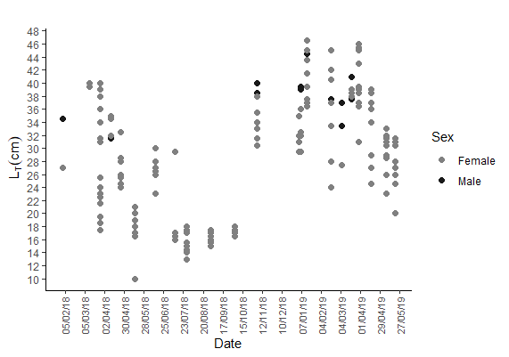
By-catch
Targeted catch

By-catch

Fig. 1. Total length (L_{T}) of individual ballan wrasse (n=199) caught in Weymouth Bay, UK by commercial fishers between February 2018 and May 2019. Lengths shown in relation to: (A) fish sex, and (B) catch category: by-catch was captured using static fish nets or lobster/crab pots; targeted catch was captured by fish traps or rod-and-line.

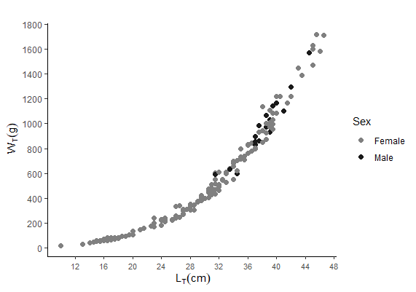

Fig. 2. Length-weight data for individual ballan wrasse (n=199) caught from Weymouth Bay, UK by commercial fishers between February 2018 and May 2019. The derived relationship was W_{T} =0.0091 L_{T}^{3.17} (r² = 0.99).
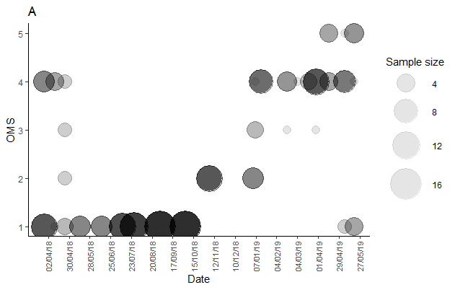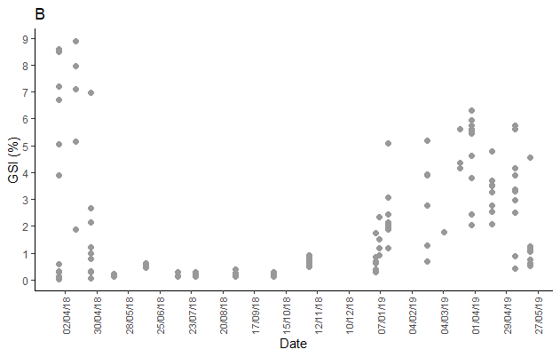
Fig. 3. Ovarian maturity of female ballan wrasse caught from Weymouth Bay, UK by commercial fishers between February 2018 and May 2019 in relation to the time of year. (A) Ovarian maturation score displayed as bubble plot, with number of individuals (total n=182) indicated by size of bubble; (B) Gonadosomatic index of individual fish (n=179).

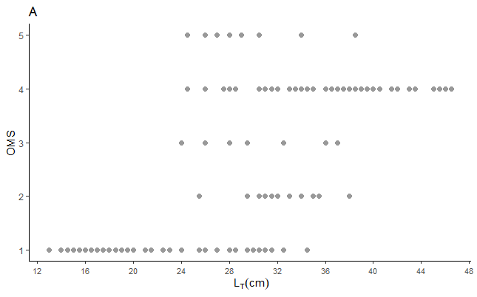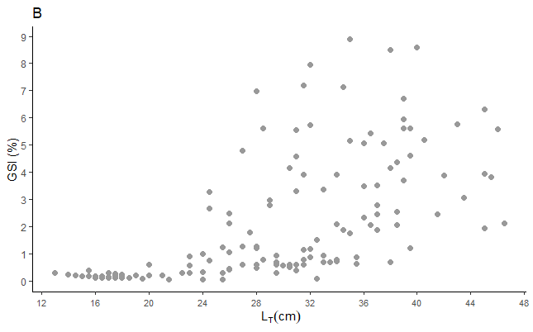

Fig. 4. Ovarian maturity status of individual female ballan wrasse caught from Weymouth Bay, UK by commercial fishers between February 2018 and May 2019 in relation to length of individual fish. (A) Ovarian maturation score (n=182); (B) Gonadosomatic index (n=179)

Table 1: Stages of ovarian maturity in ballan wrasse categorised by histological observation of the leading cohort of oocytes. Adapted from Muncaster et al. 2010.
Maturity Stage |  | Histological observation
1 | Immature | Previtellogenic oocytes present. Postovulatory follicles not present
2 | Early maturity | Cortical alveolus oocytes present.
3 | Mid maturity | Vitellogenic yolk globules present
4 | Mature | Mature hydrated oocytes with coalesent yolk. Germinal vesicle migrating towards animal pole
5 | Resorbing | Atretic oocytes evident

