Sedimentary blue carbon around decommissioned oil and gas platforms in the North Sea
Hugo Woodward-Rowe¹*, Franck Dal Molin², Benjamin H. Gregson^{1,3}, Claire Mason², Ruth Parker², Natalie Hicks¹
*Corresponding author: h.woodwardrowe@essex.ac.uk
¹ School of Life Sciences, University of Essex, Colchester, CO4 3SQ, United Kingdom
² Centre for Environment, Fisheries and Aquaculture Science, Lowestoft, NR33 0HT, United Kingdom
³ Applied Ecology Research Group, School of Life Sciences, Faculty of Science and Engineering, Anglia Ruskin University, Cambridge, Cambridgeshire, CB1 1PT, United Kingdom

Abstract
Shelf sea habitats contain significant carbon stocks in sediments, due to their large spatial extent, and act as key ecosystems for global carbon cycling. These shelf sediments are subject to a range of anthropogenic pressures including seabed trawling, climate change and the introduction of man-made structures (MMS), such as oil and gas platforms. In the North Sea, following their production lifespan, MMS are required to be mandatorily decommissioned under OSPAR Decision 98/3. Understanding the impact of decommissioned MMS on sedimentary carbon stores is a significant research gap, as these platforms are widespread throughout many shelf seas, with many now exceeding or approaching the end of their designed lifespan. In this study we quantify carbon stocks, content of organic and inorganic carbon, sediment characteristics, from shelf sediment cores taken at increasing distances (50 – 3200m) away from two decommissioned North Sea oil and gas platforms, Miller and North West Hutton. Carbon accumulation rates were also determined for sediments collected around North West Hutton. Organic carbon content at Miller was highest within 50 m (24.55 ± 2.49 mg/g of sediment) of the decommissioned platform and significantly lower across all other sampling distances. Conversely, organic carbon content at North West Hutton did not vary greatly with distance however, a significant decrease was seen at 200m. These findings highlight that carbon dynamics around decommissioned oil and gas platforms are site specific, and the effect of decommissioning on sedimentary carbon cannot be disentangled due to a lack of data prior to decommissioning.

- Introduction
Shelf sediment carbon dynamics play a key role in maintaining ocean carbon stocks (Legge et al., 2020; Burdige, 2007; Smeaton et al., 2021) and sequestration potential (Graves et al., 2022; Atwood et al., 2020; LaRowe et al., 2020). Blue Carbon is carbon that is captured and sequestered in marine ecosystems including coastal and ocean environments (Nellemann et al., 2009). Globally, the world’s oceans have absorbed 40% of anthropogenic CO₂ emissions since the industrial revolution, thereby lessening the severity of climate change (Sabine and Tanhua, 2010; Sabine et al., 2004). Organic carbon is modified and remineralised during its transportation through the water column (Soetaert et al., 2000). However, a proportion is stored within shelf sediment where it is further remineralised through diagenetic processes (Soetaert, Herman and Middelburg, 1996; Talin et al., 2002) or eventually, buried (Burdige, 2007). Despite only accounting for between 7-10% of worldwide ocean area, shelf seas contribute 80% of organic carbon and between 30-50% of inorganic carbon burial in sediments (Bauer et al., 2013). This amount of carbon is significant and acts as a major climate change mitigation factor (Luisetti et al., 2020). It is estimated that global sedimentary blue carbon stocks are 2322 Pg C in the top 1 m sediment (Atwood et al., 2020). The North-West European continental shelf area is estimated to have a standing organic carbon stock of between 230 – 882 Mt of POC in the upper 10 cm of sediment (Diesing et al., 2017). Shelf sediment also provide a variety of other ecosystem services including, nutrient cycling (Hunter, Mills and Kostka, 2006; Kristensen and Blackburn, 1987), habitat provisioning and contaminant deposition (Luisetti et al., 2019).
Previous Blue Carbon research foci has been on vegetated coastal habitats as these sequester significantly more carbon than other terrestrial habitats per unit area (McLeod et al., 2011; Macreadie et al., 2017, 2019; Lovelock and Duarte, 2019). More recently, shelf sediment ecosystems are increasingly recognised for their significant storage of Blue Carbon in both organic and inorganic form due to their large spatial extent (Legge et al., 2020; Thomas et al., 2004; Luisetti et al., 2019; Diesing et al., 2017). Shelf sediment is subject to substantial disturbance from activities such as trawling (Eigaard et al., 2017; Palanques et al., 2014; Dounas et al., 2007) and construction and decommissioning of offshore man-made structures (MMS) (Birchenough and Degraer, 2020; Dannheim et al., 2020; Fortune and Paterson, 2020). While the effect of disturbance on carbon stocks remains unclear (Epstein et al., 2022), it is essential to determine potential impacts of anthropogenic activity, such as decommissioning of MMS, on shelf sedimentary carbon stocks.
The North Sea has been modified over hundreds of years by anthropogenic impacts such as climate change (Hiddink, Burrows and García Molinos, 2015), trawling (van der Molin et al., 2013; Engelhard, Righton and Pinnegar, 2014), mineral extraction (Ducrotoy, Elliottà and De Jonge, 2000), and the introduction of MMS (Fowler et al., 2020; Dannheim et al., 2018). MMS, such as oil and gas platforms and offshore wind farms, are expanding in the oceans worldwide with projected increases to be from 32,000 km² in 2018 to 39,400 km² by 2028 (Bugnot et al., 2021), due to increasing demand for fossil fuels and renewable energy (Birchenough and Degraer, 2020). Within the OSPAR (Oslo and Paris Convention) maritime area there are over 1,350 offshore oil and gas installations that require decommissioning in the coming decades (Fortune and Paterson, 2020). Furthermore, the UK government has a target of 50 GW of offshore renewable energy by 2030 which will involve a vast number of structures being installed in the next 6 years (Putuhena et al., 2023)
The effect of O&G platforms on the marine environment is still an expanding area of research, which has primarily focused on changes to marine biology, such as food webs (Fowler et al., 2020; Todd, Lavallin and Macreadie, 2018; Wright et al., 2020; Fujii and Jamieson, 2016), connectivity and invasive species (Coolen et al., 2020; Molen et al., 2018; Tidbury et al., 2020), fish attraction versus production (Todd, Lavallin and Macreadie, 2018; Brickhill, Lee and Connolly, 2005; Grossman, Jones and Seaman, 1997; Pickering and Whitmarsh, 1997) and seabird interaction (Ronconi, Allard and Taylor, 2015). However, the effect of MMS on the seabed around these structures, and particularly on benthic carbon stocks, is poorly understood.
Currently under OSPAR Decision 98/3, MMS in the North Sea are required by law to be fully removed from the sea at the end of its active life cycle, and the marine environment to be returned to its natural state prior to MMS construction (Fortune and Paterson, 2020; Bull and Love, 2019; Fowler et al., 2014, 2020). Recent literature has started to explore the effect of disturbance to benthic carbon stocks, with an emphasis on trawling (Epstein et al., 2022; Epstein and Roberts, 2022; De Borger et al., 2021; Paradis et al., 2019). Any pressure which changes the degradation rates within upper sediment depth, or input of carbon to the seabed will likely disrupt the overall carbon stock and sequestration rates (Legge et al., 2020). Decommissioning of MMS, especially ‘whole removal’ which is preferred by OSPAR commission regulations (OPSAR, 1998) is a significant form of marine disturbance (Sommer et al., 2019). Removing oil and gas structures typically involves abrasive water jetting, diamond wire cutting, hydraulic shears or explosives (Sommer et al., 2019). Not only does this cause complete mortality of MMS-attached invertebrates and nearby fish, but likely impacts the benthic environment during the removal of the steel jackets and concrete foundation (Jagerroos and Krause, 2016). With the mandatory decommissioning of many of these platforms approaching rapidly, it is vital to determine how decommissioning these platforms affect sedimentary carbon storage and carbon sequestration rates. Exclusion zones surrounding MMS, particularly the 500 m zones around active O&G platforms, provide an area free of disturbance such as trawling and other extractive uses. Having these zones free from disturbance and fisheries exclusion could potentially safeguard carbon stocks and allow recovery (Epstein and Roberts, 2022). Moreover, decommissioned O&G platforms are often surrounded by drill cuttings piles (Breuer et al., 2004), which are produced during offshore hydrocarbon drilling operations, composed of subsurface rock coated with hydrocarbons and drilling fluids (Bakke, Klungsøyr and Sanni, 2013; Haanes et al., 2023), that could influence seabed carbon stocks.
This is the first study on understanding the benthic carbon dynamics around decommissioned O&G structures in the North Sea, and which samples as close as 50m away from the MMS. This overall aim of this study is to determine the effect of decommissioned O&G platforms on organic and inorganic carbon sedimentary carbon stocks and sedimentation/carbon accumulation rates, compared to areas which have not been excluded from anthropogenic extraction activities.

- Methods
2.1 Study sites
Sediments at two decommissioned O&G platforms, North West Hutton (61.107565N, 1.30915E) and Miller (58.431970N, 01.240740E), were sampled between 24th and the 30th of June 2021, during a research cruise on the MRV Scotia (Figure 1). The North West Hutton platform was installed in 1981, oil production began 1983 until 2003 (Blacklaws and Johnston, 2013). Topsides of the platform were removed in 2008 and removal of the jacket structure was completed in 2009 (BP, 2005, 2014). Water depth at the North West Hutton platform is 144.3m (BP, 2005), with prevailing currents in a NE/SW direction alongside weak residual currents (BP, 2005). The Miller platform was installed in 1991 and produced from June 1992 to September 2007 (BP, 2011). Topsides were removed between 2017 and 2018; jacket structure removal was completed in 2018 (BP, 2011; Chan et al., 2020). Water depth at the Miller platform is 103m, with the Fair Isle/Dooley current affecting the Miller platform which flows in a SE/NW direction. For both sites the jacket footings and drill cuttings piles remain in-situ. Jacket footings were cut at 45 m and 20 m above the seabed for the North West Hutton and Miller platforms, respectively. The drill cutting pile lies directly beneath the footings for NWH and is offset to the southeast footing for Miller. These sites were selected due to age (over 40 years since installation) and decommissioning status. Where possible, sediment cores were taken at different distances along northern and southern transects away from the decommissioned platforms (50, 100, 200, 400, 800, 1600 m) in triplicate. Due to safety features of the research vessel, samples could not be taken any closer than 50 m away from the platforms. Control sites of similar sediment composition were selected at 3200m away along each of the gradients. These control samples were known to not be near other oil rigs at any phase during their use (i.e., construction, operational or decommissioned). There were no visible signs of oil contamination on the sea surface during the survey.
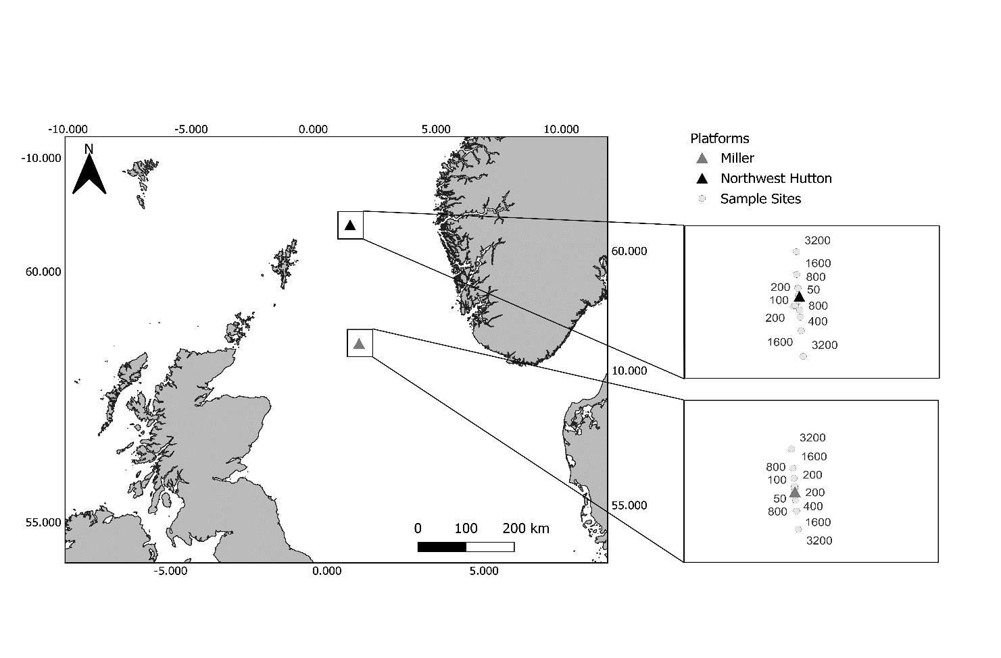
Figure 1: Location of North West Hutton and Miller decommissioned platforms in the North Sea with sampling sites at varying distances (50, 100, 200, 400, 800, 1600 and 3200m (Control)).

2.2 Sediment core sampling and processing

Samples were obtained using a multi-corer, when weather permitted, to extract three replicate sediment cores (inner Ø 9.8 cm) at each sampling distance. When weather was too severe for the multi-corer, cores were collected using a grab, and cores taken from the grab only if the sediment surface was intact (see Supplementary Table 1 for full sample details). Depths of each core collected were noted. Cores were extruded onboard and sliced into 1cm depth increments and stored in plastic bags at -20°C until further analysis. Each sediment slice was measured for wet weight (g) and freeze dried to give dry weight to determine porosity and dry bulk density (DBD).

2.3 Biogeochemical analysis
Three homogenous powder subsamples of each 1 cm layer were analysed for organic and inorganic carbon using a Formacs^{HT} TOC Analyser with Primacs^{MCS} add-on module (SKALAR, The Netherlands). Between 50-100mg of each sample was weighted into quartz crucibles, manually inserted into the analyser, and then heated to >1000°C. For inorganic carbon, samples were acidified using 5 M phosphoric acid and resultant CO₂ was measured. For each sample, inorganic carbon was subtracted from total carbon to give a measurement of organic carbon, giving measures of total, organic and inorganic carbon for each core slice.
Particle size analysis (PSA) was conducted using the laser diffraction unit Bettersizer S3 Plus (China). PSA methodology was adapted from the National Marine Biological Analytical Quality control (NMBAQC) scheme (Mason, 2016). Freeze dried sediment samples were analysed using laser diffraction. The quantity of sample entered varied to ensure lazer beam obscuration remained within 8 and 12%. One replicate was analysed for each 1 cm depth of the core with the particle size analyser, taking another three replicate readings from each. Sediment characteristics statistics, mean and median grain size, skew, kurtosis were calculated using GRADISTAT software version 9.1 (S. Blott, June 2020). Characterisation of sediment was determined using Folk description assigning sites to one of the fifteen major textural groups as defined by the relative percentage of gravel (>2 mm), sand (between 0.0625 and 2 mm), mud (less than 0.625 mm) (Folk, 1954).
Sediment pH was determined by adding 30 ml of 0.01 M calcium chloride (CaCl₂) to 5 g of freeze-dried sediment. This was shaken in an orbital shaker for one hour (20°C, 120 rpm) and left to stand for 10 minutes to allow sediment settlement. pH was measured using a SevenGo Duo pH/conductivity meter SG23 (Mettler Toledo), which was calibrated against five standards at pH 2, 4, 7, 9, and 12.
2.4 Estimated mass accumulation and sedimentation rates
Mass accumulation and linear sedimentation rates (MAR/LSR) were determined using the Constant Flux – Constant Sedimentation (CFCS) ²¹⁰Pb-based modelling approach from ten sediment cores collected at five distances (50, 100, 200, 400 and 3200 m) from each directional transect at North West Hutton (NWH) (Krishnaswamy et al., 1972). Approximately 27 g of each 1 cm slice were freeze dried, sieved down to 500 μm, compressed, and sealed into plastic containers. After a period of three weeks (to allow for secular equilibrium between ²²⁶Ra and ²¹⁴Pb), samples were analysed by gamma spectrometry using Broad Energy Germanium detectors (ORTEC, GEM-FX 8530-S model, USA) to determine the total ²¹⁰Pb and ¹³⁷Cs activity concentrations with the emission peaks of 46.5 and 662 keV respectively. Activity concentrations of total ²²⁶Ra were indirectly measured using the peak at 352keV from the presence of ²¹⁴Pb, one of its decay products. A certified reference material from International Atomic Energy Agency (IAEA) – IAEA-465 Baltic Sea Sediment was used as a reference for quantifying these radioelements in the studied samples (International Atomic Energy Agency, 2021).
2.4.1 Lead-210 based modelling and validation
Lead-210-based modelling approaches have been widely used to estimate organic carbon accumulation rates (OCAR) in marine sediment cores (Haas, 1997; Masque et al., 2002; Arias-Ortiz et al., 2018). These approaches rely on the depth distribution of unsupported fraction of ²¹⁰Pb, directly sourced from the decay of radon gas (²²²Rn) present in the atmosphere and decaying at rate of 22.23 years. As the studied cores were relatively shallow (<15 cm) and many natural and anthropogenic disturbance were anticipated, including the presence of oil and gas produced water derived particles enriched in ²²⁶Ra, ²¹⁰Pb and stable elemental analogues, such as Ba and Pb (Ahmad et al., 2021; Haanes et al., 2023) the constant flux-constant sedimentation (CF-CS) modelling approach was favoured against other common modelling approaches and selected to estimate directly the mass accumulation rate (MAR) from each core following equation 1:
²¹⁰Pb_{x} = ²¹⁰Pb₀.e^{-λmx/MAR} [1]
with ²¹⁰Pb_{x}: activity concentration of unsupported ²¹⁰Pb at mass depth x (in Bq.kg⁻¹); ²¹⁰Pb₀: activity concentration of unsupported ²¹⁰Pb at water/sediment interface (in Bq.kg⁻¹); λ: decay constant of ²¹⁰Pb = 0.031 y⁻¹; m_{x}: accumulated mass stock (in g.cm⁻²) at depth x; MAR: mass accumulation rate (g.cm⁻².y⁻¹).
Linear sedimentation rates (LSR) could then be estimated at each studied location by dividing with the average DBD of the core segment selected in the CF-CS model. Organic carbon accumulation rates (OCARs) were determined using MAR multiplied by percentage of organic carbon (%OC).
Fractions of anthropogenic ²²⁶Ra were subtracted from the total ²²⁶Ra activity concentrations prior to utilising the CF-CS model, by referring to barium (Ba) depth profiles, a chemical analogue of ²²⁶Ra, and measured by ICP-MS following total microwave-assisted digestion, alongside other stable elements (Agilent, 7900ce model, USA).
Where possible, the oil and gas ²²⁶Ra and Ba/Pb signatures as well as the 1978 Sellafield-derived ¹³⁷Cs signature (i.e., 1974-1975 peak discharge including a 4-year transient time from discharge point (Gray, Jones and Smith, 1995; Povinec et al., 2003) were also used to validate LSR results obtained from CF-CS modelling.
2.5 Carbon stock calculations
Stock calculations of sedimentary carbon surrounding both platforms were calculated using methods and equations from (Diesing et al., 2017). Estimation of mass of particulate organic carbon ($m_{POC}$) was calculated by multiplying particulate organic carbon as a dimensionless fraction, dry bulk density ($ρ_{d}$), sediment depth ($d$) and area ($A$).
$m_{POC}=POC ∙ ρ_{d} ∙d ∙ A$ (2)
2.5.1 Dry bulk density
Dry bulk density was calculated using equation 2. Where dry bulk density ($p_{d}$) was determined using porosity ($φ$) and grain density ($ρ_{s}$). Grain density was assumed to be 2650 kg m⁻³.
$p_{d}=(1- φ)ρ_{s}$ (3)

2.5.2 Porosity
Porosity was calculated using weight before (${Weight}_{Wet}$) and after (${Weight}_{Dry}$) freeze drying as well as the specific gravity of the sediment (${SG}_{Sed}$) and density of water calculated based on salinity ($ρ_{Water}$). For offshore sediments of this nature this was assumed to be composed of mostly quartz/feldspar so specific gravity was assumed to be 2.7. Salinity for the density of water was assumed to be that of offshore water (35) and a density of 1.035 kg/l.

$φ =\frac{\left[{SG}_{Sed}-{SG}_{Sed}\left({{Weight}_{Wet}}/{{Weight}_{Dry}}\right)\right]}{\left[{SG}_{Sed}-{SG}_{Sed}\left({{Weight}_{Wet}}/{{Weight}_{Dry}}\right)\right]+\left[ρ_{Water}-ρ_{Water}\left({{Weight}_{Wet}}/{{Weight}_{Dry}}\right)\right]}$ (4)

2.6 Statistical analysis
All statistical analysis was conducted using R version 4.2.1. All figures were generated using the ‘ggplot2’ (Wickham, 2010), ‘corrplot’ (Wei and Simko, 2021) and ‘cowplot’ (Wilk, 2020) packages. Data was initially tested for normality using Shapiro-Wilks tests (Shapiro and Wilk, 1965) and subsequent Bartlett tests (Bartlett, 1937) to determine homogeneity of variance between groups. Normally distributed data were tested for significance using ANOVAs, with p-values adjusted for multiple comparisons using the Benjamini-Hochberg procedure(Benjamini and Hochberg, 1995), followed by a Tukey’s HSD (Tukey, 1953) post hoc test within the ‘agricolae’ (De Mendiburu, 2020) package. Non-normally distributed data were tested for significance using a Kruskal-Wallis test, with p-values adjusted for multiple comparisons with Bonferroni corrections (Bonferroni, 1936), followed by Dunn’s post hoc test (Dunn, 1964) within the 'FSA’ package (Ogle, Wheeler and Dinno, 2020). Spearman correlation tests were applied to assess correlations between organic carbon content, inorganic carbon content, mud content, sand content sedimentation rates and distance from platform.
- Results

3.1 Sediment composition

Sediment classifications varied from sand to sandy mud across both sites and distance gradients. Sediment water depth, core type, classification and porosity are displayed in Supplementary Table 2. Mud content across all sites ranged from 1.58% to 86.28%, although North West Hutton had higher average mud content across all distances compared to Miller (Fig. 2). Highest average mud content was found at 50 m and 100 m away from North West Hutton, with average mud percentage being 59% and 38%, respectively. Average mud content at Miller was similarly high at the 50m distance with an average of 47%. Mud content remained lower with greater distance from Miller. Sediment composition at both sites was predominantly either sand or mud, with very few observed gravel particles, hence, mud and sand percentages inversely mirror each other. Sand content across all sites ranged from 13.72% to 96.96% (Fig. 2). Miller consistently had higher sand content across all distances compared to North West Hutton.
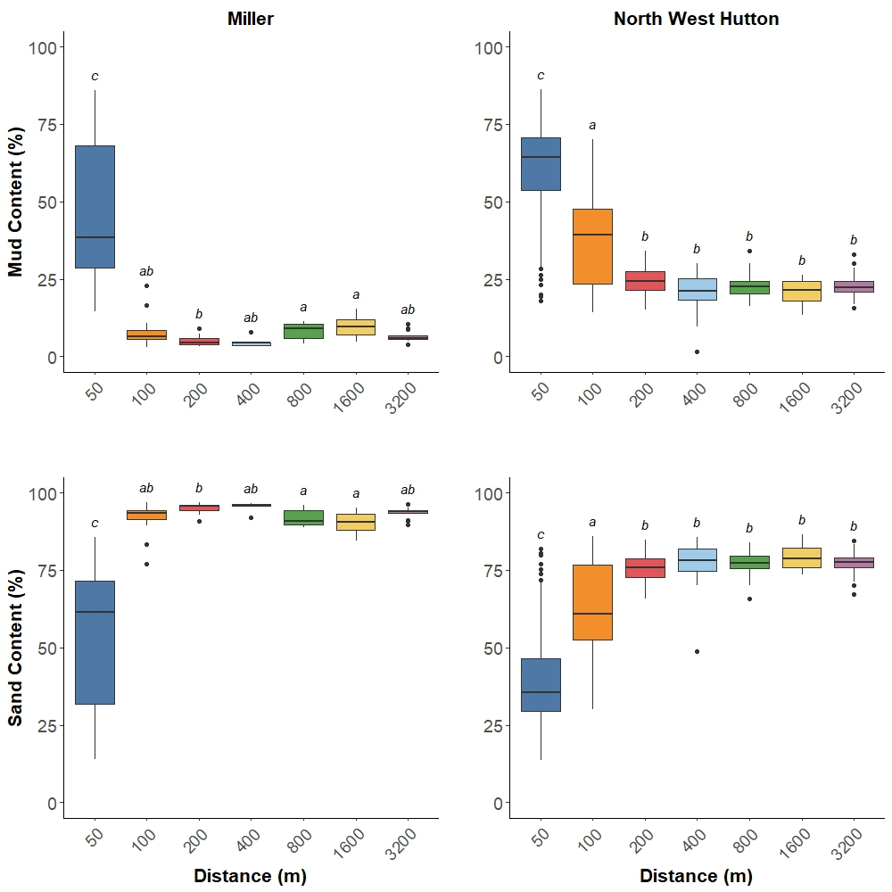
Figure 2: Mud and sand content (%) of 1 cm sediment core slices at increasing sampling distances (50, 100, 200, 400, 800, 1600 and 3200 m) away from two decommissioned oil and gas platforms, Miller and North West Hutton. North West Hutton sediment was analysed up to 10 cm depth and Miller up to 6 cm depth. Letters above boxes (a,b,c) indicate significant difference in mud and sand content between sampling distance (P < 0.05 Kruskal-Wallis test followed by Dunn’s post hoc test).
3.2 Organic and inorganic carbon content

Organic carbon content ranged from 0.26 to 51.78 mg/g of sediment (Fig. 3). Highest average organic carbon content (31.62 ± 1.09 mg/g of sediment; mean ± SE) was found 1600 m from North West Hutton, followed by the control site (3200 m) (27.78 ± 1.12 mg/g of sediment). These sediments collected at the furthest sampling distances had statistically similar levels of organic carbon as those closest to North West Hutton (e.g., 50 m and 100 m). Organic carbon content was significantly lower at 200 m (17.86 ± 1.22 mg/g of sediment) away from North West Hutton (Kruskal-Wallis, χ2 = 76.535, P = 1.854e⁻¹⁴ ) compared to all other sampling distances. Conversely, a different trend was seen at the Miller, with the highest average organic carbon content at the closest distance (50 m) (24.54 ± 2.49 mg/g of sediment), which was significantly higher (Kruskal-Wallis, χ2 = 66.084, P = 2.635e⁻¹²) than all other distances. On average, organic carbon content was higher at the North West Hutton compared to Miller, for example average organic carbon content at the control site of North West Hutton was up to 6.6-fold higher compared to sediment collected at the same site at Miller. Organic carbon depth profiles are displayed in supplementary figures 3 to 5.
Inorganic carbon content ranged from 0.14 to 45.14 mg/g of sediment across both decommissioned platforms. A similar pattern was observed for inorganic carbon content, that was also seen for organic carbon content. A significantly higher average inorganic carbon content (Kruskal-Wallis, χ2 = 133.16, P = 2.2e⁻¹⁶) was as found at the control site of North West Hutton (24.29 ± 0.62 mg/g of sediment), when compared to closer distances (e.g. 50, 100, 200, 400 and 800 m) away (Fig. 3). The lowest average inorganic carbon content was found at the 50 m distance, closest to North West Hutton (6.04 ± 0.66 mg/g of sediment). Conversely, at Miller, average inorganic carbon content was significantly higher (Kruskal-Wallis, χ2 = 82.07, P = 1.334e⁻¹⁵) closer, at 50m distance (7.27 ± 1.19 mg/g of sediment) than all other distances (100, 200, 400, 800, 1600 and 3200m). On average, organic carbon content was higher at North West Hutton compared to Miller. For example, average inorganic carbon content at the control site of North West Hutton was up to 20.4-fold higher compared to sediment collected at the same site at Miller.
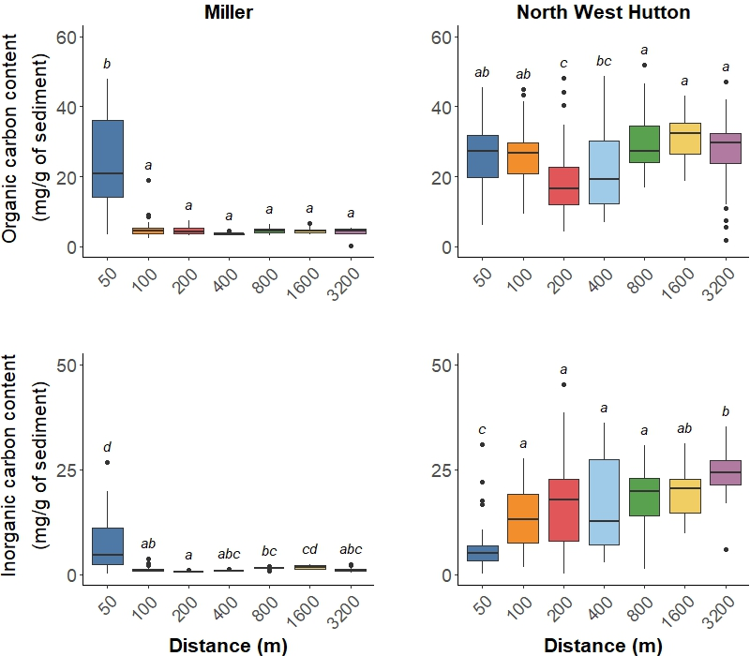
Figure 3: Organic and inorganic carbon content (mg/g of sediment) of 1 cm sediment core slices at increasing sampling distances (50, 100, 200, 400, 800, 1600 and 3200m) away from two decommissioned oil and gas platforms, Miller and North West Hutton. North West Hutton sediment was analysed up to 10cm depth and Miller up to 6cm depth. Letters above boxes (a,b,c) indicate significant difference in organic and inorganic carbon content between sampling distance (P < 0.05 Kruskal-Wallis test followed by Dunn’s post hoc test).
3.4 Sediment organic carbon stocks
Average sediment organic carbon stocks ranged from 0.59 to 5.01 kg m⁻² across both sites and distances (Fig. 4). Resolution of stocks ranged from 3 cm to 10 cm with consistently higher resolution at North West Hutton (ten sampling sites had 10cm depths analysed). Miller resolution ranged from 3 to 10cm, but had an average depth of 6cm. Estimated carbon stock to 10cm was determined using averages of available core slices. Largest average organic carbon stocks were found at 800 m on the southern transect from North West Hutton (5.01 ± 0.62 kg m⁻²) and lowest was found at 400 m on the southern transect of Miller (0.59 kg m⁻²), though this distance only had one replicate to 5cm depth.
Miller had highest organic carbon stocks at 50 m on both the northern and southern transects with averages of 1.47 ± 0.53 and 3.74 ± 0.36 kg m⁻², respectively. At greater distances (100 to 3200 m) along the southern transect, organic carbon stocks remained consistently lower with an average of 0.88 ± 0.13 kg m⁻² , at 100 m distance, to 0.72 ± 0.05 kg m⁻² , at 1600m, and 0.68 kg m⁻²at 3200 m, however at 3200 m there was only one core available. A similar trend occurred on the northern transect with average organic carbon stocks of 0.65 ± 0.04 kg m⁻², at 100m, and 0.65 ± 0.03 kg m⁻² at 3200m.
Comparatively, North West Hutton had consistently higher organic carbon stocks than those found at Miller, which generally remained constant with distance. Along the southern distance transect, average organic carbon stocks at 50 m were 2.44 ± 0.223 kg m⁻² which gradually increased to 3.65 ± 0.35 kg m⁻² at 400m. At 800m, organic carbon stocks increased to 5.01 ± 0.63 kg m², but subsequently decreased to 3.27 ± 0.67 kg m⁻² at 3200m. Along the northern transect at North West Hutton, average organic carbon stocks increased from 2.75 ± 0.20 kg m⁻² at 50m to 3.38 ± 0.32 kg m⁻² at 100 m. However, average organic carbon stock decreased at 200 and 400m to 1.44 ± 0.24 kg m⁻²and 1.63 ± 0.13 respectively. Organic carbon stocks then increased at 800 and 3200 m to 3.33 ± 0.16 and 3.95 ± 0.18 kg m⁻² , respectively.

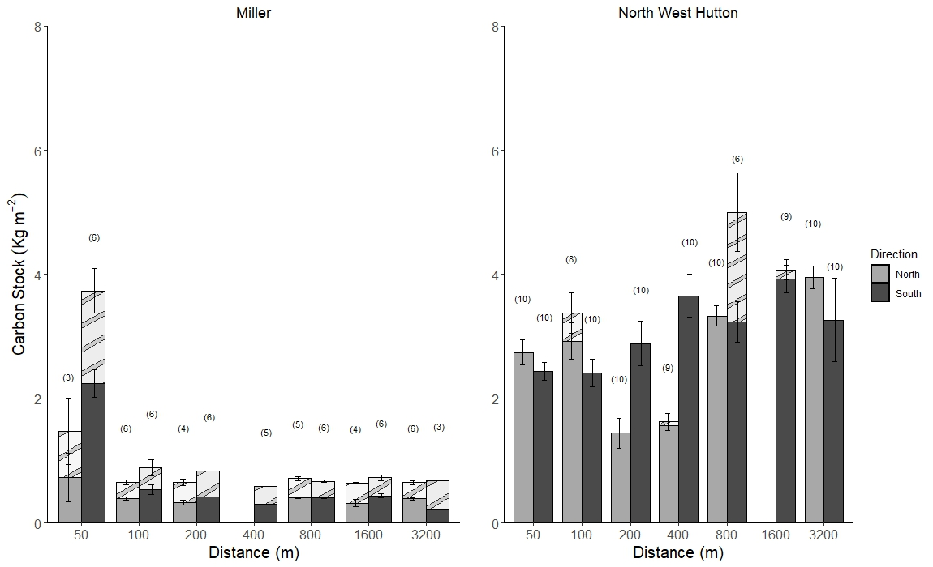
Figure 4: Mean ± SE of sediment organic carbon stocks (kg m⁻²) for cores at increasing sampling distances (50, 100, 200, 400, 800, 1600 and 3200m) away from two decommissioned oil and gas platforms, Miller and North West Hutton. Numbers in brackets indicate lowest sampling depth (cm) of core. Where sampling depth was <10 cm, stocks were averaged and extrapolated to 10 cm. Where bars are missing this indicates no samples taken at that distance.
  - Mass accumulation and sedimentation rates
Radiometric depth profiles of total ²¹⁰Pb, total ²²⁶Ra, ¹³⁷Cs as well as stable Ba and Pb depth profiles at 50m N/S and 3,200m N/S (control) are displayed in Figs. 5 and 6, respectively.
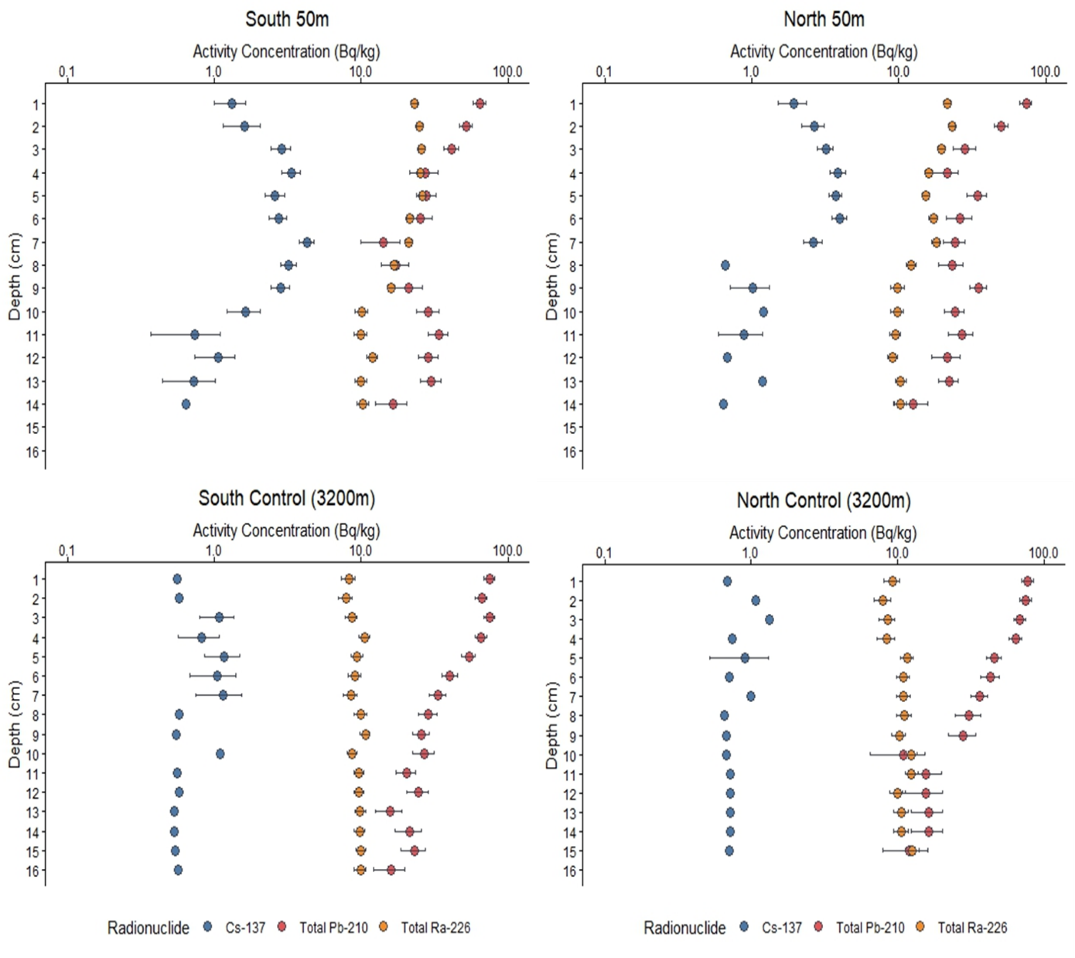
Figure 5: Depth (cm) plots of activity concentration (Bq/kg) of three radionuclides (Cs-137, Total Pb-210, Total Ra-226) within four sediment cores taken at 50 and 3200m away from North West Hutton decommissioned platform on both North and South transects. Error bars indicate unsupported fractions of each radionuclide. Where no error bars are present, radionuclide was below the limit of detection.
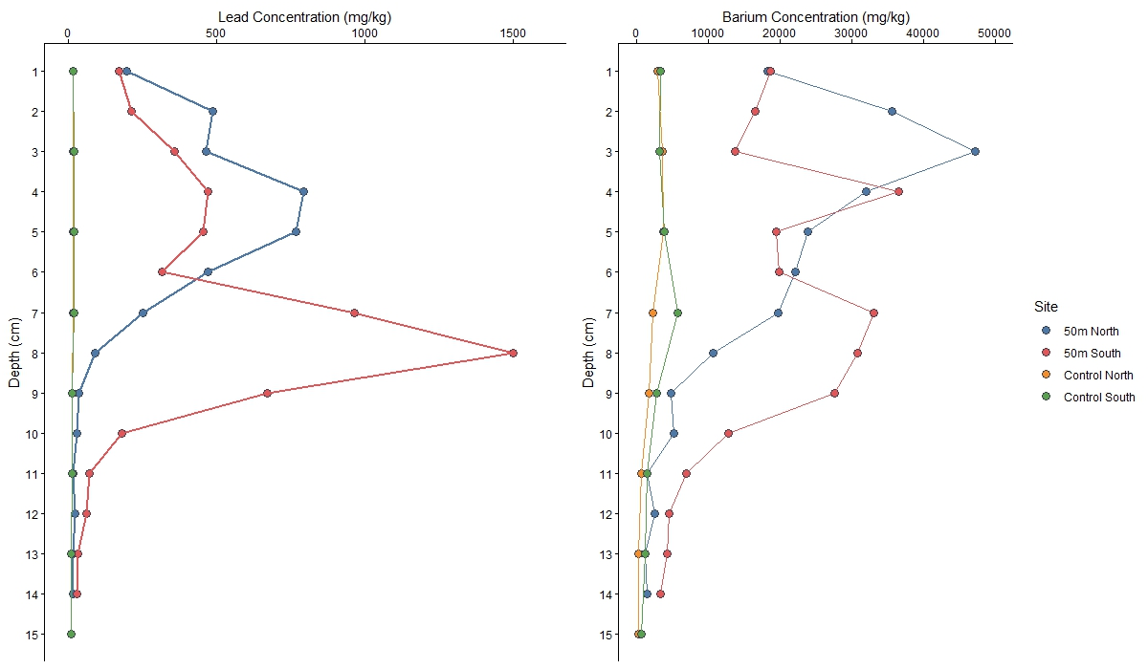
Figure 6: Depth (cm) plots of stable lead and barium concentrations (mg/kg) of within four sediment cores taken at 50 and 3200m away from North West Hutton decommissioned platform on both North and South transects.
As shown in Fig. 5, the depth profiles at 50 m North and South of the NWH platform presented enhanced concentrations of ²²⁶Ra in the top 10 cm, a clear signature from the legacy discharges of oil and gas produced water. This observation was confirmed when measuring its chemical analogue Ba (Fig. 6), showing a net increase of barium in the top 9 cm in the 50 m N. core and 10 cm depth in the 50 m S. core, suggesting the presence of radiostrontiobarite particles (Ahmad et al., 2021). These industrially derived signature were subsequently used to estimate LSR at these two locations. As the fate of radium particles remains unclear (Ahmad et al., 2021) and operational discharge information was not available, the middle of the two contaminated core segments (i.e., 4.5 cm in the 50 m N and 5 cm in the 50 m S) were assumed to correspond to the middle of the operational life of NWH (1993) and indicated the LSR to be ranging between 0.16 and 0.18 cm.y⁻¹ .

Due to the presence of low activity concentrations of ¹³⁷Cs observed near the NWH platform, unconfirmed at control distances, as well as the potential presence of other ¹³⁷Cs sources (i.e., from major nuclear fallout events such as Chernobyl), the use of this nuclear-derived fingerprint was not further considered in this study.
Also, as shown in Fig.6, the Pb depth profiles did not follow the same pattern as Ba profiles, implying the ratio of anthropogenic ²²⁶Ra/anthropogenic ²¹⁰Pb to be variable over time. Therefore, it was not possible to estimate the fraction of anthropogenic ²¹⁰Pb accurately close to the platform (50 m). It is worth noting that the direct measurement of ²¹⁰Pb by gamma spectrometry in sediment materials highly contaminated in Pb and other heavy metals such as Zn, Ba, Sr, would have also suffered from high matrix self-attenuation (Dal Molin et al., 2018)., limiting event further the application of ²¹⁰Pb based modelling approaches for these contaminated sediment cores above 10 cm. In addition, the levels of unsupported natural ²¹⁰Pb observed below 10 cm were found to be very low and associated with high uncertainties from gamma counting. As a consequence, the CF-CS ²¹⁰Pb modelling approach could not be applied in cores collected within 200 m N/S from the NWH platform. Nevertheless, a negligible influence was observed at 400 m and 3,200 m N/S (control), enabling the use of the full core ²¹⁰Pb excess profiles for CF-CS modelling at these four sampling locations (see supp fig.2).
Averaged MARs were found to be approximately 0.27 and 0.19 g cm⁻² y⁻¹ within the North and South transects, respectively (Table 1). Organic carbon accumulation rates (OCARs) ranged from 0.003 to 0.009 g cm⁻² y⁻¹ across both transects. The subsequent LSRs were estimated to be averaging at 0.21 cm y⁻¹ within the North transect and found to be slightly lower within the South transect, ranging between 0.14 and 0.15 cm y⁻¹ and agreeing with the estimations from ²²⁶Ra fingerprinting.
Table 1: Linear sedimentation rates from traditional ²¹⁰Pb radiometric dating techniques and novel ²²⁶Ra oil and gas attributed fingerprint, average dry bulk densities (DBD), ²¹⁰Pb mass accumulation rates (MAR) and ²¹⁰Pb organic carbon accumulation rate (OCAR) of six cores taken at various distances (50 – 3200 m) along two directional gradients (North and South) from North West Hutton decommissioned platform.
Distance (m) | Direction (N/S) | ²¹⁰Pb LSR (cm/y) | Mean Dry Bulk Density (DBD) | ²¹⁰Pb MAR (g/cm²/y) | Average carbon content (%) | Pb OCAR  (g/cm²/y) | ²²⁶Ra LSR O&G fingerprint (cm/y)
50 | North | * | 1.102 | * | 2.83 | * | 0.161
400 | North | 0.211 | 1.211 | 0.258 | 1.26 | 0.003 | N/A
3200 | North | 0.216 | 1.330 | 0.286 | 3.24 | 0.009 | N/A
50 | South | * | 1.056 | * | 2.78 | * | 0.179
400 | South | 0.141 | 1.252 | 0.176 | 2.45 | 0.004 | N/A
3200 | South | 0.154 | 1.292 | 0.199 | 3.16 | 0.006 | N/A
*not estimated

  - Correlation analysis
Spearman’s correlation analysis between the measured variables was separated by site (Figure 8). For Miller, organic carbon was significantly positively correlated to mud content (0.65), porosity (0.59), inorganic carbon (0.39) and gravel content (0.18) and significantly negatively correlated with distance (-0.49), dry bulk density (-0.59), mean grain size (-0.52) and sand content (-0.65). Inorganic carbon content at Miller was also positively correlated with mud content (0.73), porosity (0.48) and organic carbon content (0.39) and negatively correlated with distance (-0.13), dry bulk density (-0.48), mean grain size (-0.72) and sand content (-0.73). At North West Hutton inorganic carbon content was significantly positively correlated with distance (0.56), dry bulk density (0.57), mean grain size (0.45) and sand content (0.54) and significantly negatively correlated with porosity (-0.57) and mud content (0.52). Conversely, organic carbon content at North West Hutton was positively correlated with distance (0.18), dry bulk density (0.25), sand content (0.13) and inorganic carbon (0.06) and negatively correlated with mud content (-0.11), porosity (-0.25) and gravel content (-0.10).
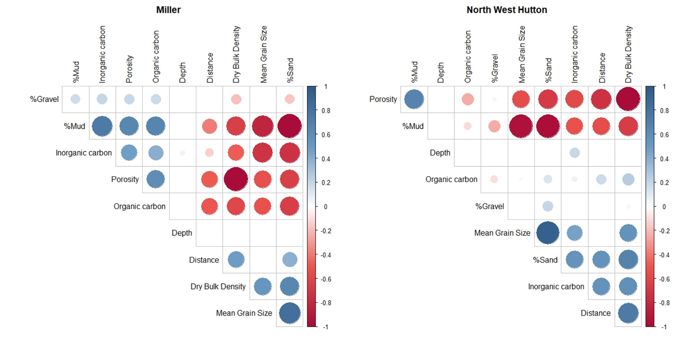
Figure 8: Correlogram of spearman’s correlation (ρ) between measured variables, organic carbon, inorganic carbon, porosity, dry bulk density, distance from site, mean grain size, percentage sand, percentage mud and percentage gravel from sediment cores at Miller and North West Hutton. Spearman’s rank correlation (P < 0.05) was tested between each variable. Size of circles represent level of significant with larger circles indicating higher significance. Colour of circles represent negative and positive correlations with blue being positive and red being negative. Relationships without significance are left blank.

4. Discussion

4.1 Organic carbon content/stock variability between sites
The North West Hutton decommissioned platform had consistently higher average organic and inorganic carbon content across all sampling distances compared to Miller. Additionally, the relationship between organic and inorganic carbon and distance varied between sites, with North West Hutton carbon content increasing slightly with distance, whereas Miller displayed elevated levels closer to the structure (50 m), with consistently lower levels at increasing distance away from the decommissioned platform. In this study, Miller exhibited an enrichment of organic and inorganic carbon within close proximity (50m), displaying a ‘halo’ effect from the decommissioned platform, likely linked to activity of or on the O&G platform during its active production stage. This enrichment could be caused by the presence of attached epifauna located on the remaining jacket footings, enriching the local area with organic carbon from fecal matter which would be displayed from sediment organic carbon content (Schutter et al., 2019). Compared to soft sediment, artificial structures can reach up to 500-fold more biomass due to the presence of hard substrate which allows the attachment of organisms (Maar et al., 2009). As organisms that associate with artificial structures tend to be fouling attached epifauna, they are dominated by filter feeders (Schutter et al., 2019). These organisms may act as a large-scale biofilter which depletes the water column of organic matter while enriching nearby sediment with faeces, larvae, dissolved organics, and nutrients (Coates et al., 2014; Maar et al., 2009). For example, in Maar et al’s model, sedimentation rate around an offshore wind structure in the North Sea significantly increased up to 40 m from the foundation caused by excretion of faecal pellets (Maar et al., 2009).
The ‘halo’ trend seen at Miller aligns with separate environmental impact assessments of decommissioned O&G platforms within the North Sea. For example, the Ninian northern decommissioned platform showed similar results of sedimentary organic carbon content (CNR International, 2017). At Ninian northern, the innermost sediment sites (0 m from decommissioned platform) had higher organic matter with percentages of 5.5 and 4.9% compared to sites at greater distance (100 – 10,000 m) which ranged from 0.9 to 3.8% (CNR International, 2017). This tallies with results at Miller with higher carbon content found at the sites closest to this site. Similarly, at another decommissioned platform in the North Sea, sediment surrounding the Murchison platform had higher organic carbon at 250 m and 500 m sampling sites (3 and 4% respectively) when compared to all other sampling distance up to 8000 m, where all were below 1% (CNR International, 2013). The hypothesized causation of this was attributed to drilling activity at the site, which elevated the proportion of fine-grained sediment and organic matter content (CNR International, 2017), some of which is likely to be hydrocarbons. This aligns with Miller sediment composition results in this study, where higher fines were observed at 50 m compared to the rest of the distances, indicating a localised halo area of mud content (fines) and organic carbon. Elevated mud was also present at the North West Hutton site. However, the relationship between mud content and organic carbon content was weakly negatively correlated, so does not appear to explain this change in carbon content. The higher sediment carbon content near the platform could be due to elevated epifauna based faeces, increased fine-grained sediments, increased hydrocarbons, or a combination of these factors. Regardless, this halo effect at Miller has implications for decommissioning practice of specific platforms to protect the seabed integrity, and the carbon stored within them. MMS (active or decommissioned) will likely have different signatures and impacts on the seabed, linked to environmental context such as water depth, distance from MMS, and time and activity since decommissioning (change in trawling activity on seabed since decommissioning and removal of exclusion zone). As current OSPAR regulations require complete removal of these structures, except for a few derogations (such as those presented in this study), this destructive practice of removing embedded structures causes a significant disturbance to the seabed (Fortune and Paterson, 2020; Birchenough and Degraer, 2020).
In contrast, a different trend was seen at North West Hutton, with the lowest organic carbon content found at 200 and 400 m distance with significant similar levels at all other distances, with a slight decrease at 200 and 400 m. Lower carbon content at 200 and 400 m could suggest increased carbon mineralization from microbes or bioturbation from macrofauna, as during the active phase of the platform, the 500 m exclusion zone limits disturbance from anthropogenic activities, such as trawling (Sciberras et al., 2016; De Borger et al., 2021; van der Molin et al., 2013) which alters macrofauna assemblages within sediment (Eigaard et al., 2017). Carbon mineralization rates are strongly impacted by physical organic carbon removal through trawling-induced resuspension of sediment, which is further exacerbated by removal of bioturbating macrofauna (De Borger et al., 2021). Bioturbation is the movement of sediment particles by organisms, such as bivalves, and burrowing polychaetes, which create burrows moving sediment (and carbon) within the surface layers (Kristensen and Blackburn, 1987; Michaud et al., 2006). This movement oxygenates sediment which enhances mineralisation through oxidation (Soetaert, Herman and Middelburg, 1996; Talin et al., 2002) causing a reduction in organic carbon content in the surface layers (Glud et al., 2016). The lack of trawling activity within the exclusion zone would increase the presence and abundance of these bioturbators, (De Borger et al., 2021) increasing the oxic status of the sediments and reducing the amount of carbon sequestered in the surface sediments. The dip in carbon content at 200 and 400m is likely due to the absence of trawling over a number of years or decades and distance from localised contaminants. Trawling is known to cause mortality of benthic organisms (Sciberras et al., 2016; Hiddink et al., 2017; Epstein and Roberts, 2022; Eigaard et al., 2017) , which may be why the amount of carbon increases again outside of the set exclusion zone distance, and at 800m (the next distance increment) the carbon content is similar to what is seen at the control site (3200 m), where reduced bioturbation enhances carbon content in surface sediments.
This trend in decreasing carbon away, as seen in the carbon stock values, from the MMS was also seen in a study around the L7A decommissioned platform (in the Southern North Sea), where decreasing carbon content at greater distances away from the structure was observed in 3 out of 4 directional transects (Klunder et al., 2018). The L7A platform is located much further south, but this suggests that decommissioned platforms may affect organic and inorganic carbon differently depending on a variety of factors such as sediment composition and subsequent natural background particular organic and inorganic carbon, decommissioning practices, sedimentation rates, current regimes, drill cutting composition and time of production. The L7A platform, in a different location, combined with the carbon dynamics seen around NWH and Miller in this study, implies patterns of carbon storage around different decommissioned platforms are site specific and cannot be generalized for all MMS - each needs to be assessed on a case-by-case basis considering the different environmental variables and age of structures.
Interestingly, organic carbon results correlated differently with mud percentage between sites with a positive correlation at Miller and a negative correlation at North West Hutton. A positive relationship between organic carbon and mud/fines content is typical of shelf sediment (De Falco et al., 2004; Diesing et al., 2017; Leipe et al., 2011; Smeaton et al., 2021). However, we observed a weak reverse correlation, indicating that there are some underlying and unknown variables, perhaps the presence of North West Hutton, may alter this relationship, as despite highest mud content occurring at 50 and 100m, these were sites with the lower recorded organic carbon content.
Inorganic carbon content mirrored organic carbon results at Miller, with highest inorganic carbon content at sampling distances closest to Miller (50 m). However, inorganic carbon increased with distance from North West Hutton. Despite inorganic carbon dominating shelf sediment carbon budgets, quantifying the vulnerability of this type of carbon remains a research gap (Legge et al., 2020), and inorganic carbon is not routinely measured as part of environmental surveys. pH of sediment closer to North West Hutton were more neutral compared to those further away from the platform (Supplementary Figure 1) which could contribute to the dissolution of particulate inorganic carbon (Krumins et al., 2013). While it is unlikely that physical disturbance, such as trawling, impacts particulate inorganic carbon, the effect of global ocean acidification and local sources, such as O&G attributed pH changes close to the platforms could alter the resilience of this sedimentary particulate inorganic stock.
This study presents organic and inorganic carbon content (mg/g of sediment) as well as organic carbon stocks (kg m²) for sediment surrounding these decommissioned platforms. By including carbon stocks rather than just carbon content, more detail to carbon dynamics is provided as these are determined by using porosity and dry bulk density of sediment (Graves et al., 2022). Carbon stock values are a useful indicator of how sediment composition affects carbon content. Furthermore, unlike other carbon stock assessments this study provides mass accumulation rates for the North West Hutton site, allowing quantification of the rate that carbon accumulates over time (g cm⁻² yr⁻¹) which is rarely directly measured in offshore shelf sediment, with the exception of de Haas (1997) and Lerida-Toro (2022). Comparing carbon stocks between the two sites was limited by poor resolution of sediment core depths at the Miller decommissioned platform, so stock measurements were extrapolated from shallow core depths. Despite this, a clear trend was still seen at this site with significantly higher carbon content at the 50 m distance.
4.2 Naturally occurring radioactivity from legacy oil and gas produced water discharges and impact on sedimentation rate estimations
Elevated levels of ²²⁶Ra were observed in the top 10cm fraction of the cores collected within 200m from North West Hutton and could be directly attributed to legacy discharge of oil and gas produced water during the its operating period (Olsgard and Gray, 1995; Ahmad et al., 2021). The radiological and chemical effect of these industrially derived elements to the benthos and associated fauna remains unclear, nevertheless these site-specific signatures could be used as powerful tool to better understand the spatial and temporal extent of the impact of wastewater contamination to nearby sediment and help estimate a sedimentation rate near the studied platform.
The combination of ²²⁶Ra and Ba concentrations provide new insights and a novel tool in environmental forensic science to help more accurately determine the impact of offshore oil and gas platforms on local sedimentary processes in the North Sea, without the need for more common nuclear forensic tools such as¹³⁷Cs peaks from nuclear incidents from Chernobyl and Sellafield. These validation tools are typically used for UK estuarine and coastal sediments (Arias-Ortiz et al., 2018), but have limited use in offshore sediments due to the presence of multiple sources of ¹³⁷Cs and at very low concentrations. . Novel nuclear forensic tools could be envisaged but further research is needed in this area. Determining offshore carbon accumulation rates within sediment remains a constraint of UK shelf sea carbon budgets (Luisetti et al., 2019) and currently, there are few novel forensic approaches for determining offshore sedimentation rates including the use of less conventional nuclear derived isotopes such as ¹²⁹I, but these approaches are generally limited to a specific UK marine region or area (Lérida Toro et al., 2022). As highlighted in this study, using oil and gas platform operational time provides the ability to track changes in sedimentation and carbon accumulation rate in recent timescales. Measuring current carbon stocks gives useful data on carbon dynamics, however, by obtaining accurate accumulation rates this can inform carbon stock changes on a temporal scale (Graves et al., 2022). In turn, we can disentangle the long-term impacts of man-made structures from other anthropogenic activities and determine how carbon stock dynamics vary across the shelf in an area of ocean which has historically, poor resolution of mass accumulation of sediment.
Mass accumulation rates could not be determined accurately for sediment cores taken within 400 m of North West Hutton through traditional lead-210 measurement by gamma spectrometry as these sediments showed elevated levels of heavy metals, including Pb and Ba causing high levels of matrix self-attenuation during gamma counting (Dal Molin, et al, 2018). In this context, the use of the alternative alpha spectrometric method for measuring polonium-210, ²¹⁰Po, a direct decay product of ²¹⁰Pb, seems to be a better analytical option.
4.3 Influence of drill cuttings pile
Both sites sampled in this study exhibit large areas of drill cutting piles close to the decommissioned structure site, where drilling fluids are pumped into the well and return carrying hydrocarbon rich rock to the seafloor (Ball et al., 2012). Drill cuttings often consist of drilling mud fluids (oil-based muds, synthetic muds, and water-based muds) depending on the age of the structure and the drilling practice at the time of construction (Breuer et al., 2004). The higher mud percentage close to each of the decommissioned platforms, and the subsequent change in sediment composition to finer, carbon rich particles, could be due to drill cuttings, as the deposits tend to remain close to the drilling well (Breuer et al., 2004). At North West Hutton, wells were drilled with two types of drilling fluid, water based muds, for shallower (1000 m) sections of the well, and oil-based muds for deeper sections of the well (BP, 2005). Similarly, at Miller, oil-based muds were used throughout production as drilling mud fluids (Aquatera Ltd, 2007). Despite the presence of oil-based drilling fluid within drill cuttings piles at North West Hutton, carbon content was similar at 50 to 100m and 800 to 3200m, indicating that the pile had little effect on carbon content. This may be due to the decommissioning regime (BP, 2005), which included a final trawl around the site after the physical removal of the structures. This trawling would disperse and resuspend the finer particles of sediment, reducing the amount of carbon in close proximity. Conversely, elevated organic carbon was found at 50m from Miller with the cutting’s pile possible enhancing the amount of organic carbon. However, the influence of elevated hydrocarbons on sediment carbon storage from drill cutting piles on carbon storage was not determined in this study. Determining the contaminant composition and hydrocarbon influence on carbon stored around oil and gas decommissioned platforms would help identify the effect of drill cuttings piles on local microbes and fauna involved in carbon cycling.
4.4 Local current regime
Carbon stocks vary between direction of transects, particularly at the North West Hutton decommissioned platform. A potential factor influencing this is the local hydrodynamics around the decommissioned platform. A study by Klunder et al (2018) observed a ‘shadow’ effect at the L7A decommissioned platform in the southern North Sea where the predominant current direction dictated a depleted gradient of total organic carbon with increasing distance; explained by a biofilter effect of epifauna and the acceleration of flow due to the physical structure causing a deposition of particles at a greater distance from the decommissioned. North West Hutton is on the edge of the North East Atlantic Current and only experiences small residual currents (Winther and Johannessen, 2006). Therefore, it is unlikely hydrodynamics was the driver in different benthic measurements. Despite being affected by the Fair Isle/Dooley current, very little difference in organic carbon was seen between the North and South transects at Miller. However, hydrodynamics would likely play a larger role in more dispersive environments, such as the Southern North Sea, where the ‘shadow’ effect has previously been recorded (Klunder et al., 2018), and where drill cuttings piles do not persist due to dispersive hydrodynamics.
5. Conclusion
In conclusion, this study finds that carbon dynamics around decommissioned platforms are site specific and therefore extrapolating carbon dynamics from one or two decommissioned sites across the North Sea is not recommended. Decommissioning practice and activity may have an impact on the carbon stocks and dynamics within surface sediments, however this requires sampling pre and post decommissioning to disentangle the effects. Future work could include carbon stock, sediment composition and carbon accumulation assessments during all phases of oil and gas activity to determine the overall effect of these structures on sedimentary blue carbon throughout their operational and then decommissioning lifespan. By sampling pre-construction, during operational phase and pre and post decommissioning could provide greater insight into the effect of oil and gas activity on sedimentary blue carbon. This would also give an insight into OSPAR mandatory decommissioning as partial removal may reduce the impact on sedimentary blue carbon and maintenance of a small-scale exclusion zone, at specific sites, could provide protection for this elevated carbon.
References
Ahmad, F., Morris, K., Law, G. T. W., Taylor, K. G. and Shaw, S. (2021). Fate of radium on the discharge of oil and gas produced water to the marine environment. Chemosphere, 273, Elsevier Ltd. [Online]. Available at: doi:10.1016/j.chemosphere.2021.129550.
Aquatera Ltd. (2007). Initial screening assessment of BP’s UKCS cuttings piles.
Arias-Ortiz, A., Masqué, P., Garcia-Orellana, J., Serrano, O., Mazarrasa, I., Marbá, N., Lovelock, C. E., Lavery, P. S. and Duarte, C. M. (2018). Reviews and syntheses: 210Pb-derived sediment and carbon accumulation rates in vegetated coastal ecosystems - Setting the record straight. Biogeosciences, 15 (22), Copernicus GmbH., pp.6791–6818. [Online]. Available at: doi:10.5194/bg-15-6791-2018.
Atwood, T. B., Witt, A., Mayorga, J., Hammill, E. and Sala, E. (2020). Global Patterns in Marine Sediment Carbon Stocks. Frontiers in Marine Science, 7 (165), Frontiers Media S.A., pp.1–9. [Online]. Available at: doi:10.3389/fmars.2020.00165.
Bakke, T., Klungsøyr, J. and Sanni, S. (2013). Environmental impacts of produced water and drilling waste discharges from the Norwegian offshore petroleum industry. Marine Environmental Research, 92, Elsevier Ltd., pp.154–169. [Online]. Available at: doi:10.1016/j.marenvres.2013.09.012.
Bartlett, M. S. (1937). Properties of Sufficiency and Statistical Tests. Proc. R. Soc. London. Ser. A - Math. Phys. Sci. , 160, pp.268–282. [Online]. Available at: doi:https://doi.org/10.1098/rspa.1937.0109.
Bauer, J. E., Cai, W. J., Raymond, P. A., Bianchi, T. S., Hopkinson, C. S. and Regnier, P. A. G. (2013). The changing carbon cycle of the coastal ocean. Nature, 504, pp.61–70. [Online]. Available at: doi:10.1038/nature12857.
Benjamini, Y. and Hochberg, Y. (1995). Controlling the False Discovery Rate: A Practical and Powerful Approach to Multiple Testing. Source: Journal of the Royal Statistical Society. Series B (Methodological), 57 (1), pp.289–300.
Birchenough, S. N. R. and Degraer, S. (2020). Science in support of ecologically sound decommissioning strategies for offshore man-made structures: Taking stock of current knowledge and considering future challenges. ICES Journal of Marine Science, 77 (3), Oxford University Press., pp.1075–1078. [Online]. Available at: doi:10.1093/icesjms/fsaa039.
Blacklaws, J. and Johnston, D. (2013). North West Hutton Decommissioning Programme Close-out Report.
Bonferroni, C. (1936). Teoria statistica delle classi e calcolo delle probabilita. Pubbl. del R Ist. Super. di Sci. Econ. e Commericiali di Firenze, pp.3–62.
De Borger, E., Tiano, J., Braeckman, U., Rijnsdorp, A. D. and Soetaert, K. (2021). Impact of bottom trawling on sediment biogeochemistry: A modelling approach. Biogeosciences, 18 (8), Copernicus GmbH., pp.2539–2557. [Online]. Available at: doi:10.5194/bg-18-2539-2021.
BP. (2005). North West Hutton Decommissioning Programme.
BP. (2011). Miller Decommissioning Programme.
Breuer, E., Stevenson, A. G., Howe, J. A., Carroll, J. and Shimmield, G. B. (2004). Drill cutting accumulations in the Northern and Central North Sea: A review of environmental interactions and chemical fate. Marine Pollution Bulletin, 48 (1–2), Elsevier Ltd., pp.12–25. [Online]. Available at: doi:10.1016/j.marpolbul.2003.08.009.
Brickhill, M. J., Lee, S. Y. and Connolly, R. M. (2005). Fishes associated with artificial reefs: attributing changes to attraction or production using novel approaches. Journal of Fish Biology, 67, pp.53–71. [Online]. Available at: doi:10.1111/j.1095-8649.2005.00915.x.
Bugnot, A. B., Mayer-Pinto, M., Airoldi, L., Heery, E. C., Johnston, E. L., Critchley, L. P., Strain, E. M. A., Morris, R. L., Loke, L. H. L., Bishop, M. J., et al. (2021). Current and projected global extent of marine built structures. Nature Sustainability, 4 (1), Nature Research., pp.33–41. [Online]. Available at: doi:10.1038/s41893-020-00595-1.
Bull, A. S. and Love, M. S. (2019). Worldwide oil and gas platform decommissioning: A review of practices and reefing options. Ocean and Coastal Management, 168, Elsevier Ltd., pp.274–306. [Online]. Available at: doi:10.1016/j.ocecoaman.2018.10.024.
Burdige, D. J. (2007). Preservation of organic matter in marine sediments: Controls, mechanisms, and an imbalance in sediment organic carbon budgets? Chemical Reviews, 107 (2), pp.467–485. [Online]. Available at: doi:10.1021/cr050347q.
CNR International. (2017). Ninian Northern Platfrom late life & decommissioning project.
Coolen, J. W. P., Boon, A. R., Crooijmans, R., van Pelt, H., Kleissen, F., Gerla, D., Beermann, J., Birchenough, S. N. R., Becking, L. E. and Luttikhuizen, P. C. (2020). Marine stepping-stones: Connectivity of Mytilus edulis populations between offshore energy installations. Molecular Ecology, 29 (4), Blackwell Publishing Ltd., pp.686–703. [Online]. Available at: doi:10.1111/mec.15364.
Dal Molin, F., Warwick, P. E. and Read, D. (2018). Under-estimation of 210Pb in industrial radioactive scales. Analytica Chimica Acta, 1000, Elsevier B.V., pp.67–74. [Online]. Available at: doi:10.1016/j.aca.2017.08.037.
Dannheim, J., Beermann, J., Lacroix, G., De Mesel, I., Kerckhof, F., Schön, I., Degraer, S., Birchenough, S., Garcia, C., Coolen, J. W. P., et al. (2018). Understanding the influence of man-made structures on the ecosystem functions of the North Sea (UNDINE).
Dannheim, J., Bergström, L., Birchenough, S. N. R., Brzana, R., Boon, A. R., Coolen, J. W. P., Dauvin, J. C., De Mesel, I., Derweduwen, J., Gill, A. B., et al. (2020). Benthic effects of offshore renewables: Identification of knowledge gaps and urgently needed research. ICES Journal of Marine Science, 77 (3), Oxford University Press., pp.1092–1108. [Online]. Available at: doi:10.1093/icesjms/fsz018.
Diesing, M., Kroger, S., Parker, R., Jenkins, C., Mason, C. and Weston, K. (2017). Predicting the standing stock of organic carbon in surface sediments of the North-West European continental shelf. Biogeochemistry , (135), pp.183–200. [Online]. Available at: doi:10.1594/PANGAEA.871584.
Dounas, C., Davies, I., Triantafyllou, G., Koulouri, P., Petihakis, G., Arvanitidis, C., Sourlatzis, G. and Eleftheriou, A. (2007). Large-scale impacts of bottom trawling on shelf primary productivity. Continental Shelf Research, 27 (17), pp.2198–2210. [Online]. Available at: doi:10.1016/j.csr.2007.05.006.
Ducrotoy, J.-P., Elliottà, M. and De Jonge, V. N. (2000). The North Sea. Marine Pollution Bulletin, 41, pp.5–23.
Dunn, O. J. (1964). Multiple Comparisons Using Rank Sums. Technometrics , 6 (3), pp.241–252. [Online]. Available at: doi:https://doi.org/10.1080/00401706.1964.10490181.
Eigaard, O. R., Bastardie, F., Hintzen, N. T., Buhl-Mortensen, L., Buhl-Mortensen, P., Catarino, R., Dinesen, G. E., Egekvist, J., Fock, H. O., Geitner, K., et al. (2017). The footprint of bottom trawling in European waters: Distribution, intensity, and seabed integrity. ICES Journal of Marine Science, 74 (3), Oxford University Press., pp.847–865. [Online]. Available at: doi:10.1093/icesjms/fsw194.
Ellingsen, K. E. (2001). Biodiversity of a continental shelf soft-sediment macrobenthos community. Marine Ecology Progress Series , 218, pp.1–15.
Ellingsen, K. E. (2002). Soft-sediment benthic biodiversity on the continental shelf in relation to environmental variability. Marine Ecology Progress Series, 232, pp.15–27.
Engelhard, G. H., Righton, D. A. and Pinnegar, J. K. (2014). Climate change and fishing: A century of shifting distribution in North Sea cod. Global Change Biology, 20 (8), Blackwell Publishing Ltd., pp.2473–2483. [Online]. Available at: doi:10.1111/gcb.12513.
Epstein, G., Middelburg, J. J., Hawkins, J. P., Norris, C. R. and Roberts, C. M. (2022). The impact of mobile demersal fishing on carbon storage in seabed sediments. Global Change Biology, 28 (9), John Wiley and Sons Inc., pp.2875–2894. [Online]. Available at: doi:10.1111/gcb.16105.
Epstein, G. and Roberts, C. M. (2022). Identifying priority areas to manage mobile bottom fishing on seabed carbon in the UK. Nagai, R. H. (Ed). PLOS Climate, 1 (9), p.e0000059. [Online]. Available at: doi:10.1371/journal.pclm.0000059.
Folk, R. L. (1954). The Distinction between Grain Size and Mineral Composition in Sedimentary-Rock Nomenclature. The Journal of Geology, 62 (4), pp.344–359.
Fortune, I. S. and Paterson, D. M. (2020). Ecological best practice in decommissioning: A review of scientific research. ICES Journal of Marine Science, 77 (3), Oxford University Press., pp.1079–1091. [Online]. Available at: doi:10.1093/icesjms/fsy130.
Fowler, A. M., Jørgensen, A. M., Coolen, J. W. P., Jones, D. O. B., Svendsen, J. C., Brabant, R., Rumes, B. and Degraer, S. (2020). The ecology of infrastructure decommissioning in the North Sea: What we need to know and how to achieve it. ICES Journal of Marine Science, 77 (3), Oxford University Press., pp.1109–1126. [Online]. Available at: doi:10.1093/icesjms/fsz143.
Fowler, A. M., Macreadie, P. I., Jones, D. O. B. and Booth, D. J. (2014). A multi-criteria decision approach to decommissioning of offshore oil and gas infrastructure. Ocean and Coastal Management, 87, Elsevier Ltd., pp.20–29. [Online]. Available at: doi:10.1016/j.ocecoaman.2013.10.019.
Fujii, T. and Jamieson, A. J. (2016). Fine-scale monitoring of fish movements and multiple environmental parameters around a decommissioned offshore oil platform: A pilot study in the North Sea. Ocean Engineering, 126, Elsevier Ltd., pp.481–487. [Online]. Available at: doi:10.1016/j.oceaneng.2016.09.003.
Glud, R. N., Berg, P., Stahl, H., Hume, A., Larsen, M., Eyre, B. D. and Cook, P. L. M. (2016). Benthic Carbon Mineralization and Nutrient Turnover in a Scottish Sea Loch: An Integrative In Situ Study. Aquatic Geochemistry, 22 (5–6), Springer Netherlands., pp.443–467. [Online]. Available at: doi:10.1007/s10498-016-9300-8.
Graves, C. A., Benson, L., Aldridge, J., Austin, W. E. N., Dal Molin, F., Fonseca, V. G., Hicks, N., Hynes, C., Kröger, S., Lamb, P. D., et al. (2022). Sedimentary carbon on the continental shelf: Emerging capabilities and research priorities for Blue Carbon. Frontiers in Marine Science, 9, Frontiers Media S.A. [Online]. Available at: doi:10.3389/fmars.2022.926215.
Gray, J., Jones, S. R. and Smith, A. D. (1995). Discharges to the environment from the Sellafield Site, 1951-1992. J. Radiol. Prot, 15, pp.99–131.
Grossman, G. D., Jones, G. P. and Seaman, W. J. (1997). Do artificial reefs increase regional fish production? A review of existing data. Artificial Reef Management , pp.1–7.
Haanes, H., Jensen, H. K. B., Lepland, A. and Heldal, H. E. (2023). Increased barium levels in recent marine sediments from the Norwegian and Barents Seas suggest impact of hydrocarbon drilling and production. Marine Pollution Bulletin, 186, Elsevier Ltd. [Online]. Available at: doi:10.1016/j.marpolbul.2022.114478.
Haas, H. de. (1997). Transport, preservation and accumulation of organic carbon in the North Sea. Univ.
Hiddink, J. G., Burrows, M. T. and García Molinos, J. (2015). Temperature tracking by North Sea benthic invertebrates in response to climate change. Global Change Biology, 21 (1), Blackwell Publishing Ltd., pp.117–129. [Online]. Available at: doi:10.1111/gcb.12726.
Hiddink, J. G., Jennings, S., Sciberras, M., Szostek, C. L., Hughes, K. M., Ellis, N., Rijnsdorp, A. D., McConnaughey, R. A., Mazor, T., Hilborn, R., et al. (2017). Global analysis of depletion and recovery of seabed biota after bottom trawling disturbance. Proceedings of the National Academy of Sciences of the United States of America, 114 (31), National Academy of Sciences., pp.8301–8306. [Online]. Available at: doi:10.1073/pnas.1618858114.
Hunter, E. M., Mills, H. J. and Kostka, J. E. (2006). Microbial community diversity associated with carbon and nitrogen cycling in permeable shelf sediments. Applied and Environmental Microbiology, 72 (9), pp.5689–5701. [Online]. Available at: doi:10.1128/AEM.03007-05.
International Atomic Energy Agency. (2021). Certification of Activity Concentration of Radionuclides in IAEA-465 Baltic Sea Sediment. IAEA Analytical Quality in Nuclear Applications Series, (65), pp.1–60.
Jagerroos, S. and R Krause, P. (2016). Rigs-To-Reef; Impact or Enhancement on Marine Biodiversity. Journal of Ecosystem & Ecography, 6 (2), OMICS Publishing Group. [Online]. Available at: doi:10.4172/2157-7625.1000187.
Klunder, L., Lavaleye, M. S. S., Filippidi, A., Van Bleijswijk, J. D. L., Reichart, G. J., Van Der Veer, H. W., Duineveld, G. C. A. and Mienis, F. (2018). Impact of an artificial structure on the benthic community composition in the southern North Sea: Assessed by a morphological and molecular approach. ICES Journal of Marine Science, 77 (3), Oxford University Press., pp.1167–1177. [Online]. Available at: doi:10.1093/icesjms/fsy114.
Krishnaswamy, S., Lal, D., Martin, J. M. and Meybeck, M. (1972). Geochronology of lake sediments. Earth and Planetary Science Letters, 11 (1–5), pp.407–414.
Kristensen, E. and Blackburn, T. H. (1987). The fate of organic carbon and nitrogen in experimental marine sediment systems: Influence of bioturbation and anoxia. Journal of Marine Research, 45.
Krumins, V., Gehlen, M., Arndt, S., Van Cappellen, P. and Regnier, P. (2013). Dissolved inorganic carbon and alkalinity fluxes from coastal marine sediments: Model estimates for different shelf environments and sensitivity to global change. Biogeosciences, 10 (1), pp.371–398. [Online]. Available at: doi:10.5194/bg-10-371-2013.
LaRowe, D. E., Arndt, S., Bradley, J. A., Estes, E. R., Hoarfrost, A., Lang, S. Q., Lloyd, K. G., Mahmoudi, N., Orsi, W. D., Shah Walter, S. R., et al. (2020). The fate of organic carbon in marine sediments - New insights from recent data and analysis. Earth-Science Reviews, 204, Elsevier B.V. [Online]. Available at: doi:10.1016/j.earscirev.2020.103146.
Legge, O., Johnson, M., Hicks, N., Jickells, T., Diesing, M., Aldridge, J., Andrews, J., Artioli, Y., Bakker, D. C. E., Burrows, M. T., et al. (2020). Carbon on the Northwest European Shelf: Contemporary Budget and Future Influences. Frontiers in Marine Science, 7, Frontiers Media S.A. [Online]. Available at: doi:10.3389/fmars.2020.00143.
Lérida Toro, V., Abascal, U., Villa Alfageme, M., Klar, J., Hicks, N. and López Gutiérrez, J. M. (2022). 129I in sediment cores from the Celtic Sea by AMS through a microwave digestion process. Nuclear Instruments and Methods in Physics Research B, 529, Elsevier B.V., pp.61–67. [Online]. Available at: doi:10.1016/j.nimb.2022.08.016.
Lovelock, C. E. and Duarte, C. M. (2019). Dimensions of blue carbon and emerging perspectives. Biology Letters, 15 (3), Royal Society Publishing. [Online]. Available at: doi:10.1098/rsbl.2018.0781.
Luisetti, T., Ferrini, S., Grilli, G., Jickells, T. D., Kennedy, H., Kröger, S., Lorenzoni, I., Milligan, B., van der Molen, J., Parker, R., et al. (2020). Climate action requires new accounting guidance and governance frameworks to manage carbon in shelf seas. Nature Communications, 11 (1), Nature Research. [Online]. Available at: doi:10.1038/s41467-020-18242-w.
Luisetti, T., Turner, R. K., Andrews, J. E., Jickells, T. D., Kröger, S., Diesing, M., Paltriguera, L., Johnson, M. T., Parker, E. R., Bakker, D. C. E., et al. (2019). Quantifying and valuing carbon flows and stores in coastal and shelf ecosystems in the UK. Ecosystem Services, 35, Elsevier B.V., pp.67–76. [Online]. Available at: doi:10.1016/j.ecoser.2018.10.013.
Macreadie, P. I., Anton, A., Raven, J. A., Beaumont, N., Connolly, R. M., Friess, D. A., Kelleway, J. J., Kennedy, H., Kuwae, T., Lavery, P. S., et al. (2019). The future of Blue Carbon science. Nature Communications, 10 (1), Nature Publishing Group. [Online]. Available at: doi:10.1038/s41467-019-11693-w.
Macreadie, P. I., Nielsen, D. A., Kelleway, J. J., Atwood, T. B., Seymour, J. R., Petrou, K., Connolly, R. M., Thomson, A. C. G., Trevathan-Tackett, S. M. and Ralph, P. J. (2017). Can we manage coastal ecosystems to sequester more blue carbon? Frontiers in Ecology and the Environment, 15 (4), Wiley Blackwell., pp.206–213. [Online]. Available at: doi:10.1002/fee.1484.
Mason, C. (2016). NMBAQC’s Best Practice Guidance Particle Size Analysis (PSA) for Supporting Biological Analysis.
Masque, P., Isla, E., Sanchez-Cabeza, J. A., Palanques, A., Bruach, J. M., Puig, P. and Guillen, J. (2002). Sediment accumulation rates and carbon fluxes to bottom sediments at the Western Bransfield Strait (Antarctica). Deep-Sea Research II, 49.
McLeod, E., Chmura, G. L., Bouillon, S., Salm, R., Björk, M., Duarte, C. M., Lovelock, C. E., Schlesinger, W. H. and Silliman, B. R. (2011). A blueprint for blue carbon: Toward an improved understanding of the role of vegetated coastal habitats in sequestering CO2. Frontiers in Ecology and the Environment, 9 (10), pp.552–560. [Online]. Available at: doi:10.1890/110004.
De Mendiburu, F. (2020). R package: ‘agricolae’. [Online]. Available at: doi:https://cran.r-project.org/web/packages/agricolae/index.html.
Michaud, E., Desrosiers, G., Mermillod-Blondin, F., Sundby, B. and Stora, G. (2006). The functional group approach to bioturbation: II. The effects of the Macoma balthica community on fluxes of nutrients and dissolved organic carbon across the sediment-water interface. Journal of Experimental Marine Biology and Ecology, 337 (2), pp.178–189. [Online]. Available at: doi:10.1016/j.jembe.2006.06.025.
Molen, J. van der, García-García, L. M., Whomersley, P., Callaway, A., Posen, P. E. and Hyder, K. (2018). Connectivity of larval stages of sedentary marine communities between hard substrates and offshore structures in the North Sea. Scientific Reports, 8 (1), Nature Publishing Group. [Online]. Available at: doi:10.1038/s41598-018-32912-2.
van der Molin, J., Aldridge, J. N., Coughlan, C., Parker, E. R., Stephens, D. and Ruardij, P. (2013). Modelling marine ecosystem response to climate change and trawling in the north sea. Biogeochemistry, 113, pp.213–236.
Nellemann, C., Corcoran, E., Duarte, C. M., Valdes, L., De Young, C., Fonseca, L. and Grimsditch, G. (2009). Blue carbon : the role of healthy oceans in binding carbon : a rapid response assessment. GRID-Arendal.
Ogle, D., Wheeler, P. and Dinno, A. (2020). R package ‘FSA’. [Online]. Available at: doi:https://cran.r-project.org/web/packages/FSA/index.html.
Olsgard, F. and Gray, J. S. (1995). A comprehensive analysis of the effects of offshore oil and gas exploration and production on the benthic communities of the Norwegian continental shelf. Marine Ecology Progress Series , 122, pp.277–306.
OPSAR. (1998). OSPAR Commission Ministerial Meeting of the OSPAR Commission Sintra, Programmes and Measures.
Palanques, A., Puig, P., Guillén, J., Demestre, M. and Martín, J. (2014). Effects of bottom trawling on the Ebro continental shelf sedimentary system (NW Mediterranean). Continental Shelf Research, 72, Elsevier Ltd., pp.83–98. [Online]. Available at: doi:10.1016/j.csr.2013.10.008.
Paradis, S., Pusceddu, A., Masqué, P., Puig, P., Moccia, D., Russo, T. and Iacono, C. Lo. (2019). Organic matter contents and degradation in a highly trawled area during fresh particle inputs (Gulf of Castellammare, southwestern Mediterranean). Biogeosciences, 16 (21), Copernicus GmbH., pp.4307–4320. [Online]. Available at: doi:10.5194/bg-16-4307-2019.
Pickering, H. and Whitmarsh, D. (1997). Artificial reefs and fisheries exploitation: a review of the ‘attraction versus production’ debate, the influence of design and its significance for policy. Fisheries Research, 31, pp.39–59.
Povinec, P. P., Bailly Du Bois, P., Kershaw, P. J., Nies, H. and Scotto, P. (2003). Temporal and spatial trends in the distribution of 137Cs in surface waters of Northern European Seas - A record of 40 years of investigations. Deep-Sea Research Part II: Topical Studies in Oceanography, 50 (17–21), Elsevier Ltd., pp.2785–2801. [Online]. Available at: doi:10.1016/S0967-0645(03)00148-6.
Putuhena, H., White, D., Gourvenec, S. and Sturt, F. (2023). Finding space for offshore wind to support net zero: A methodology to assess spatial constraints and future scenarios, illustrated by a UK case study. Renewable and Sustainable Energy Reviews, 182, Elsevier Ltd. [Online]. Available at: doi:10.1016/j.rser.2023.113358.
Ronconi, R. A., Allard, K. A. and Taylor, P. D. (2015). Bird interactions with offshore oil and gas platforms: Review of impacts and monitoring techniques. Journal of Environmental Management, 147, Academic Press., pp.34–45. [Online]. Available at: doi:10.1016/j.jenvman.2014.07.031.
Sabine, C. L., Feely, R. A., Gruber, N., Key, R. M., Lee, K., Bullister, J. L., Wanninkhof, R., Wong, C. S., Wallace, D. W. R., Tilbrook, B., et al. (2004). The oceanic sink for anthropogenic CO2. Science, 305 (5682), pp.367–371. [Online]. Available at: doi:10.1126/science.1097403.
Sabine, C. L. and Tanhua, T. (2010). Estimation of anthropogenic CO 2 inventories in the ocean. Annual Review of Marine Science, 2 (1), pp.175–198. [Online]. Available at: doi:10.1146/annurev-marine-120308-080947.
Sciberras, M., Parker, R., Powell, C., Robertson, C., Kröger, S., Bolam, S. and Geert Hiddink, J. (2016). Impacts of bottom fishing on the sediment infaunal community and biogeochemistry of cohesive and non-cohesive sediments. Limnology and Oceanography, 61 (6), Wiley Blackwell., pp.2076–2089. [Online]. Available at: doi:10.1002/lno.10354.
Shapiro, S. S. and Wilk, M. B. (1965). An Analysis of Variance Test for Normality (Complete Samples) An analysis of variance test for normality (complete samples)t. Biometrika , 52 (3 and 4), pp.591–611.
Smeaton, C., Hunt, C. A., Turrell, W. R. and Austin, W. E. N. (2021). Marine Sedimentary Carbon Stocks of the United Kingdom’s Exclusive Economic Zone. Frontiers in Earth Science, 9, Frontiers Media S.A. [Online]. Available at: doi:10.3389/feart.2021.593324.
Soetaert, K., Herman, P. M. J. and Middelburg, J. J. (1996). A model of early diagenetic processes from the shelf to abyssal depths. Ceochimica et Cosmochimica Acta, 60 (6), pp.1019–1040.
Soetaert, K., Middelburg, J. J., Herman, P. M. J. and Buis, K. (2000). On the coupling of benthic and pelagic biogeochemical models. Earth-Science Reviews, 51, pp.173–201. [Online]. Available at: www.elsevier.comrlocaterearscirev.
Sommer, B., Fowler, A. M., Macreadie, P. I., Palandro, D. A., Aziz, A. C. and Booth, D. J. (2019). Decommissioning of offshore oil and gas structures – Environmental opportunities and challenges. Science of the Total Environment, 658, Elsevier B.V., pp.973–981. [Online]. Available at: doi:10.1016/j.scitotenv.2018.12.193.
Talin, F., Tolla, C., Rabouille, C. and Poggiale, J. (2002). Relations between bacterial biomass and carbon cycle in marine sediments: an early diagenetic model. Acta Biotheoretica , 51, French Society of Theoretical Biology., pp.295–315.
Thomas, H., Bozec, Y., Elkalay, K. and de Baar, H. J. W. (2004). Enhanced open ocean storage of CO2 from Shelf Sea pumping. Science, 304 (5673), pp.1005–1008. [Online]. Available at: doi:10.1126/science.1096033.
Tidbury, H., Taylor, N., van der Molen, J., Garcia, L., Posen, P., Gill, A., Lincoln, S., Judd, A. and Hyder, K. (2020). Social network analysis as a tool for marine spatial planning: Impacts of decommissioning on connectivity in the North Sea. Journal of Applied Ecology, 57 (3), Blackwell Publishing Ltd., pp.566–577. [Online]. Available at: doi:10.1111/1365-2664.13551.
Todd, V. L. G., Lavallin, E. W. and Macreadie, P. I. (2018). Quantitative analysis of fish and invertebrate assemblage dynamics in association with a North Sea oil and gas installation complex. Marine Environmental Research, Elsevier Ltd., pp.69–79. [Online]. Available at: doi:10.1016/j.marenvres.2018.09.018.
Tukey, J. W. (1953). Some selected quick and easy methods of statistical analysis. Transactions of the New York Academy of Sciences, 16 (2), pp.88–97. [Online]. Available at: doi:10.1111/j.2164-0947.1953.tb01326.x.
Wei, T. and Simko, V. (2021). Package ‘corrplot’: Visualization of a Correlation Matrix. (Version 0.92). [Online]. Available at: doi:https://github.com/taiyun/corrplot.
Wickham, Hadley. (2010). ggplot2 : elegant graphics for data analysis. Journal of Statistical Software, 35 (1), Springer., p.1.
Wilk, C. (2020). R package ‘cowplot’. [Online]. Available at: https://cran.r-project.org/web/packages/cowplot/index.html [Accessed 20 September 2023].
Winther, N. G. and Johannessen, J. A. (2006). North Sea circulation: Atlantic inflow and its destination. Journal of Geophysical Research: Oceans, 111 (12), Blackwell Publishing Ltd. [Online]. Available at: doi:10.1029/2005JC003310.
Wright, S. R., Lynam, C. P., Righton, D. A., Metcalfe, J., Hunter, E., Riley, A., Garcia, L., Posen, P. and Hyder, K. (2020). Structure in a sea of sand: Fish abundance in relation to man-made structures in the North Sea. ICES Journal of Marine Science, 77 (3), Oxford University Press., pp.1206–1218. [Online]. Available at: doi:10.1093/icesjms/fsy142.

Supplementary figures
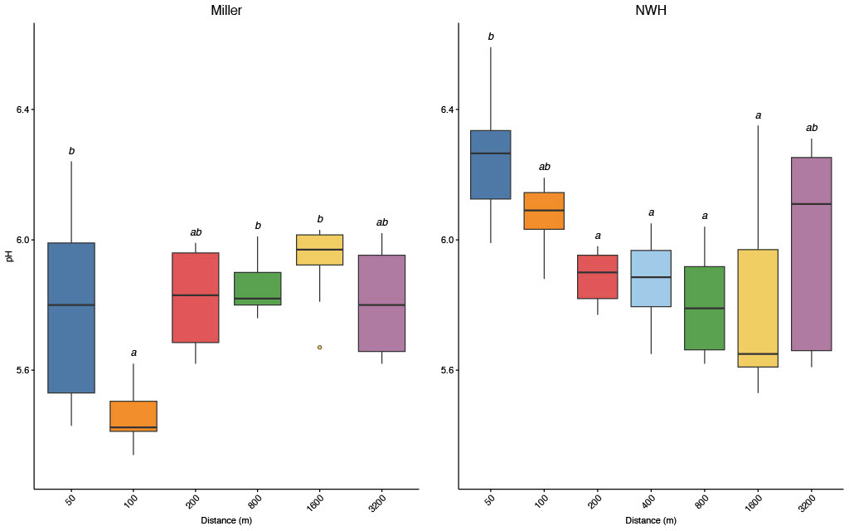
Supplementary figure 1: pH of sediment at increasing distances (50, 100, 200, 400, 800, 1600 and 3200m) away from two decommissioned oil and gas platforms, Miller and North West Hutton. Letters above boxes (a,b) indicate significant difference in pH between sampling distance (P < 0.05 Kruskal-Wallis test followed by Dunn’s post hoc test).
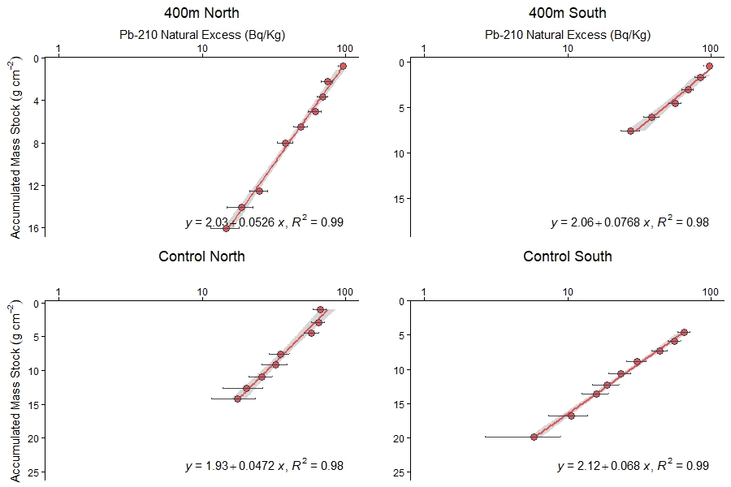
Supplementary figure 2: Accumulated mass stock (g cm⁻²) of Pb-210 natural excess (Bq/kg) within four sediment cores taken at 50 and 3200m away from North West Hutton decommissioned platform on both North and South transects. Error bars indicate unsupported fractions Pb-210.

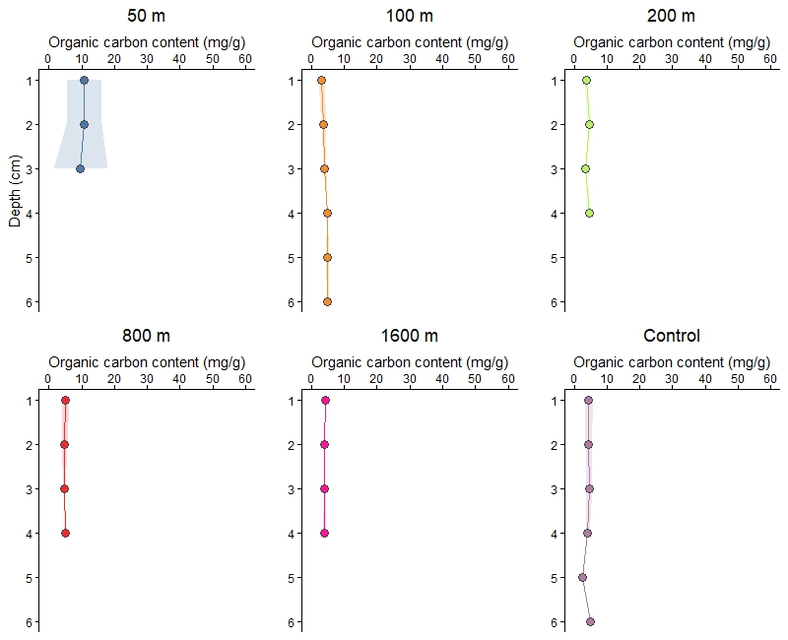
Supplementary figure 3: Averaged organic carbon content (mg/g of sediment) depth profiles at the decommissioned Miller platform, along the northern transect. Where possible, three cores were averaged, and standard deviation is displayed as coloured area around the line. Three cores were used for 50m and 800m.Two cores were used for 100 m, 1600 m and control (3200 m).
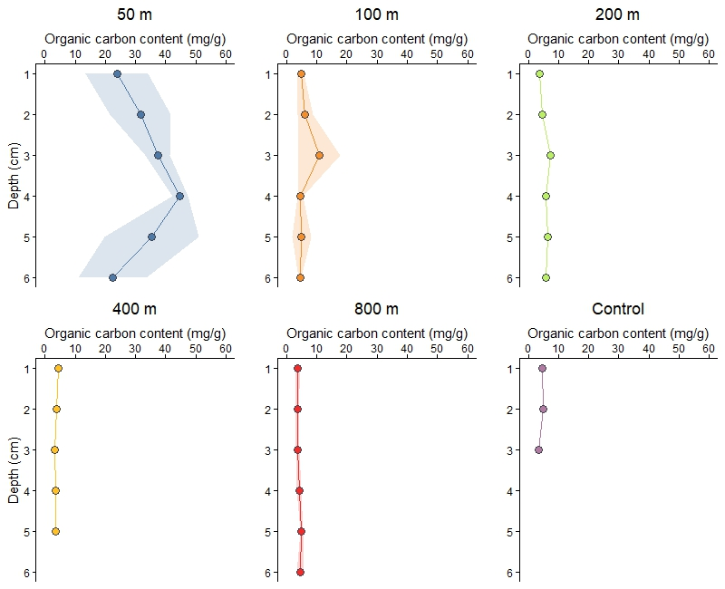
Supplementary figure 4: Averaged organic carbon content (mg/g of sediment) depth profiles at the decommissioned Miller platform, along the southern transect. Where possible, three cores were averaged, and standard deviation is displayed as coloured area around the line. Three cores were used for 50m and 100m. Two cores were used for 800m. Only one core was available for 200, 400 and control (3200m).

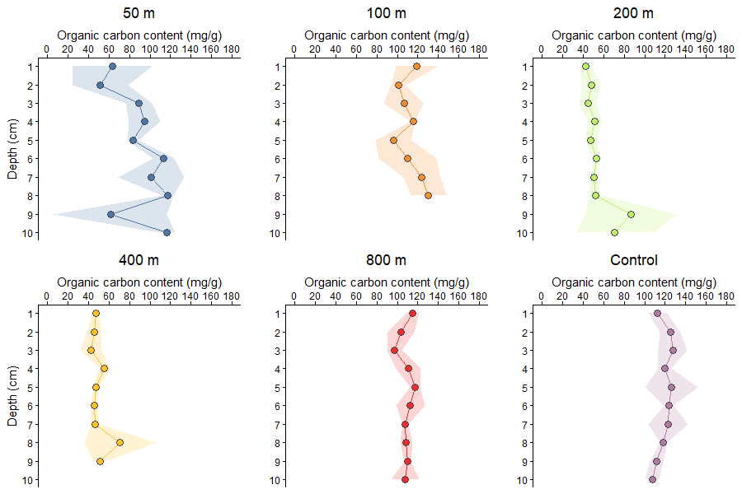
Supplementary figure 5: Averaged organic carbon content (mg/g of sediment) depth profiles at North West Hutton decommissioned platform along the northern transect. Where possible, three cores were averaged, and standard deviation is displayed as coloured area around the line. Three cores were used for 50m, 100m, 200m, 400m, 800m and control (3200m).
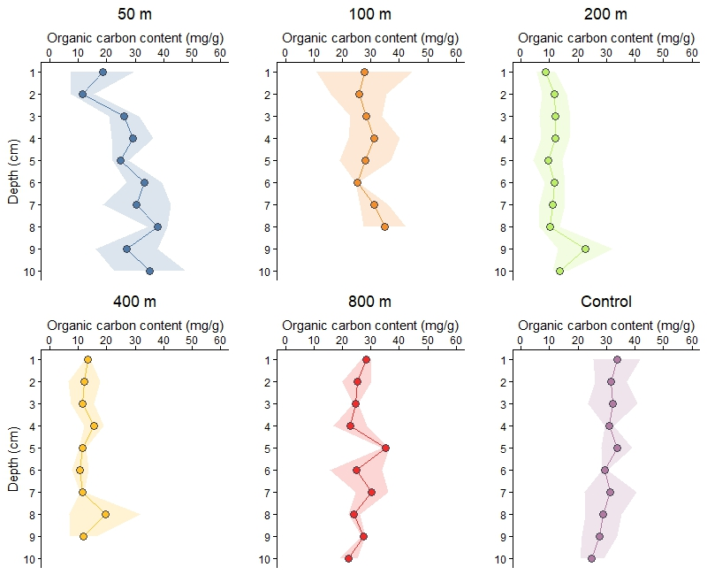
Supplementary figure 5: Averaged organic carbon content (mg/g of sediment) depth profiles at the decommissioned North West Hutton platform along the northern transect. Where possible, three cores were averaged, and standard deviation is displayed as coloured area around the line. Three cores were used for 50m, 100m, 200m, 400m, 800m, and control (3200m).

Supplementary data
Table 1: Sampling information of sediment cores collected from the decommissioned Miller and North West Hutton platforms including, distance from site (m), direction of transect from site (North/South), core type, water depth (m), modal sediment classification and mean porosity.
Site | Distance (m) | Direction | Core Type | Depth (m) | Modal Sediment Classification | Mean Porosity
Miller | 50 | North | Grab | 104.3 | Muddy Sand | 0.55
Miller | 50 | North | Grab | 104.3 | Muddy Sand | 0.49
Miller | 50 | North | Grab | 104.1 | Muddy Sand | 0.49
Miller | 50 | South | Grab | 104.5 | Sandy Mud | 0.58
Miller | 50 | South | Grab | 102.4 | Sandy Mud | 0.58
Miller | 50 | South | Grab | 103.9 | Sandy Mud | 0.57
Miller | 100 | North | Grab | 105.7 | Sand | 0.42
Miller | 100 | North | Grab | 105.4 | Sand | 0.43
Miller | 100 | South | Multi corer | 103.2 | Sand | 0.45
Miller | 100 | South | Multi corer | 103.4 | Sand | 0.42
Miller | 100 | South | Multi corer | 103.4 | Sand | 0.46
Miller | 200 | North | Grab | 105.2 | Sand | 0.40
Miller | 200 | North | Grab | 105.2 | Sand | 0.40
Miller | 200 | South | Multi corer | 104 | Sand | 0.44
Miller | 400 | South | Multi corer | 105.2 | Sand | 0.41
Miller | 800 | North | Grab | 109.2 | Muddy Sand | 0.46
Miller | 800 | North | Grab | 107.2 | Muddy Sand | 0.43
Miller | 800 | North | Grab | 107.5 | Sand | 0.43
Miller | 800 | South | Multi corer | 108.1 | Sand | 0.40
Miller | 800 | South | Multi corer | 108 | Sand | 0.41
Miller | 1600 | North | Grab | 108.7 | Sand | 0.43
Miller | 1600 | North | Grab | 109.2 | Sand | 0.43
Miller | 1600 | South | Multi corer | 110.3 | Sand | 0.42
Miller | 1600 | South | Multi corer | 110.3 | Muddy Sand | 0.44
Miller | 1600 | South | Multi corer | 110.3 | Muddy Sand | 0.43
Miller | 3200 | North | Grab | 107.1 | Sand | 0.43
Miller | 3200 | North | Grab | 106.6 | Sand | 0.43
Miller | 3200 | South | Multi corer | 109.2 | Sand | 0.45
Hutton | 50 | North | Grab | 104.3 | Sandy Mud | 0.64
Hutton | 50 | North | Grab | 104.3 | Sandy Mud | 0.65
Hutton | 50 | North | Grab | 104.1 | Sandy Mud | 0.67
Hutton | 50 | South | Multi corer | 104.5 | Sandy Mud | 0.66
Hutton | 50 | South | Multi corer | 102.4 | Sandy Mud | 0.66
Hutton | 50 | South | Multi corer | 103.9 | Sandy Mud | 0.67
Hutton | 100 | North | Multi corer | 144.5 | Muddy Sand | 0.60
Hutton | 100 | North | Multi corer | 144.4 | Muddy Sand | 0.59
Hutton | 100 | North | Multi corer | 144.4 | Muddy Sand | 0.61
Hutton | 100 | South | Multi corer | 145.3 | Muddy Sand | 0.64
Hutton | 100 | South | Multi corer | 144.8 | Muddy Sand | 0.65
Hutton | 100 | South | Multi corer | 145.5 | Muddy Sand | 0.58
Hutton | 200 | North | Multi corer | 145.2 | Muddy Sand | 0.57
Hutton | 200 | North | Multi corer | 144.8 | Muddy Sand | 0.58
Hutton | 200 | North | Multi corer | 144.7 | Muddy Sand | 0.57
Hutton | 200 | South | Multi corer | 145 | Muddy Sand | 0.55
Hutton | 200 | South | Multi corer | 145 | Muddy Sand | 0.54
Hutton | 200 | South | Multi corer | 145.5 | Muddy Sand | 0.56
Hutton | 400 | North | Multi corer | 145.9 | Muddy Sand | 0.53
Hutton | 400 | North | Multi corer | 145.2 | Muddy Sand | 0.55
Hutton | 400 | North | Multi corer | 145.5 | Muddy Sand | 0.56
Hutton | 400 | South | Multi corer | 147 | Muddy Sand | 0.54
Hutton | 400 | South | Multi corer | 144.3 | Muddy Sand | 0.52
Hutton | 400 | South | Multi corer | 144.3 | Muddy Sand | 0.55
Hutton | 800 | North | Multi corer | 144.8 | Muddy Sand | 0.54
Hutton | 800 | North | Multi corer | 145.3 | Muddy Sand | 0.53
Hutton | 800 | North | Multi corer | 145.1 | Muddy Sand | 0.53
Hutton | 800 | South | Multi corer | 144.1 | Muddy Sand | 0.54
Hutton | 800 | South | Multi corer | 143.8 | Muddy Sand | 0.51
Hutton | 800 | South | Multi corer | 144.3 | Muddy Sand | 0.54
Hutton | 1600 | South | Multi corer | 145.5 | Muddy Sand | 0.53
Hutton | 1600 | South | Multi corer | 145.5 | Muddy Sand | 0.53
Hutton | 1600 | South | Multi corer | 145.1 | Muddy Sand | 0.54
Hutton | 3200 | North | Multi corer | 147.9 | Muddy Sand | 0.52
Hutton | 3200 | North | Multi corer | 147.1 | Muddy Sand | 0.51
Hutton | 3200 | North | Multi corer | 147.1 | Muddy Sand | 0.52
Hutton | 3200 | South | Multi corer | 147.4 | Muddy Sand | 0.52
Hutton | 3200 | South | Multi corer | 147.4 | Muddy Sand | 0.52
Hutton | 3200 | South | Multi corer | 147.9 | Muddy Sand | 0.52

