Journal | Article Type:
Fish and Fisheries | Original Articles

Title:
Global synthesis of the operating behaviour of marine small-scale fishers
Running Title:
Small-scale fisheries operating behaviour

Authors:
Pedro Warner^{1,2}, Ana Nuno^{1,3*}, David A. Kroodsma⁴, Nathan A. Miller⁴, Christopher Kerry^{1,5}, and Kristian Metcalfe^{1**}
Author Affiliations:
¹ Centre for Ecology and Conservation, Faculty of Environment, Science and Economy, University of Exeter, Penryn Campus, Penryn, Cornwall, TR10 9FE, UK.
² Centre for Environment, Fisheries & Aquaculture Science (Cefas), Weymouth Laboratory, Barrack Road, Weymouth, Dorset, DT4 8UB, UK.
³ Interdisciplinary Centre of Social Sciences (CICS.NOVA), School of Social Sciences and Humanities (NOVA FCSH), NOVA University Lisbon, Lisbon, Portugal.
⁴ Global Fishing Watch, Washington, DC, United States
⁵ Institute for Data Science and Artificial Intelligence, University of Exeter, Streatham Campus, Exeter, Devon, EX4 4PY, UK.

Corresponding Authors: * Dr Ana Nuno, Email: ananuno@fcsh.unl.pt; ** Dr Kristian Metcalfe, Email: kristian.metcalfe@exeter.ac.uk;

Word Count: 8,256 (inclusive of abstract – references, and tables/figures in main text)
References: 96 Tables 2; Figures 4

Abstract:
Small-Scale Fisheries (SSF) are globally prevalent, playing a critical role in food security, employment, and poverty alleviation. Yet, there is a scarcity of data on the operating behaviour of SSF, despite their importance for management. To address this knowledge gap, we performed a structured review of published literature to synthesise available data on the operating behaviour of SSF. This field of research in SSF is relatively young with only 64 peer-reviewed publications from 34 countries – with 89% (n = 57) of studies published after 2010. We also show 66% (n = 42) of published studies that include data on operating behaviours are focused on SSF in emerging and high-income countries, and 77% (n = 49) of studies include ≤ 2 behavioural metrics, providing only a limited understanding of behaviour of SSF. Nonetheless, our findings suggest a high degree of variability in SSF operating behaviour globally – with trips ranging between 2 - 305 kilometres (mean 57.7 km S.D. ± 71 km; n = 37 studies) and lasting 1 – 170 hours (mean 42.7 hrs S.D. ± 54 hrs, n = 35 studies). This behavioural variability was influenced by the economic status of a country, with fishers from lower-income countries travelling further than fishers in emerging and high-income countries. This is the first global synthesis of published knowledge in this field, providing critical insights into the operating behaviour of SSF. More robust and comparable data to industrial fisheries and other maritime sectors must be generated to enhance transparency and equity in decision making.

Keywords: Artisanal fisheries, decision-making, operating behaviour, small scale fisheries, spatiotemporal behaviour, vessel monitoring

Introduction
Globally, 113 million people are engaged in small-scale fisheries (SSF) with up to 500 million people thought to rely on SSF for their livelihoods, accounting for approximately 90% of total capture fisheries employment and generating an estimated $77 billion USD annually (FAO et al., 2023)(Teh and Sumaila, 2013). Approximately 40% of the SSF workforce comprises of women who are heavily involved in pre- and post- production activities alongside subsistence fishing predominantly through shore-based harvesting whilst male participation in SSF is often characterised by income generating ventures further offshore (Harper et al., 2013, FAO et al., 2023). SSF also provide a host of other benefits to communities by contributing to social cohesion, providing a sense of identity and honouring heritage (Nunan et al., 2018, Leite et al., 2023). Consequently, SSF make a significant contribution to local and national economies due to their pivotal role in food security, employment, poverty alleviation and wellbeing (Chuenpagdee et al., 2006, Islam and Chuenpagdee, 2022).

Despite being extensively distributed and a mainstay of the fisheries sector, particularly in developing countries, there is a limited understanding of spatiotemporal patterns of resource use in SSF in comparison to large-scale and industrialised fisheries (Chuenpagdee, 2012, Metcalfe et al., 2017). Large-scale and industrial fisheries are often legally required to be equipped with vessel tracking technologies that report vessel positions at regular intervals which can be used to characterise fishing effort (Witt and Godley, 2007, Kroodsma et al., 2018), behaviour (Li et al., 2021) and compliance (Doherty et al., 2021). In contrast, the large number of vessels and dispersed nature of many SSF fleets has made this approach economically and logistically challenging, particularly where government regulations do not enforce their use (Behivoke et al., 2021, Baker Jr et al., 2016). Consequently, policy and management decisions directed at SSF which are designed to influence, modify, or change behaviours (e.g., gear restrictions and spatial management measures) are often based on limited understanding of fisher behaviour and the extent of their fishing grounds (Behivoke et al., 2021, Teh et al., 2012). This could ultimately reduce the effectiveness of interventions, hamper fishers’ compliance (Hauck, 2013), lead to marginalisation (Nayak et al., 2014), and result in socioeconomic impacts that generate conflict (Freduah et al., 2017); particularly where there are competing interests for access to resources (Alfaro-Shigueto et al., 2010).

Over the last decade, researchers and practitioners have adopted a variety of approaches to fill data gaps and improve understanding of the behaviour of fisheries fleets (Table 1). These range from low-tech approaches such as interviews, participatory mapping (Turner et al., 2015, Thiault et al., 2017), and onboard observers (Mendo et al., 2019); to high-tech approaches such as vessel monitoring systems, VMS (Campbell et al., 2014, Torres-Irineo et al., 2021), and satellite automatic information systems, S-AIS (Natale et al., 2015, James et al., 2018). Although these high-tech approaches have been used to monitor SSF (Birchenough et al., 2021, James et al., 2018), they are predominately used in large-scale industrialised fisheries which can afford the maintenance and operating costs, have the technological capacity, and access to a sufficient on-board energy supply (Behivoke et al., 2021, Baker Jr et al., 2016). However, in the context of SSF, recent improvements in tracking technology (e.g., miniaturisation) have led to the increased use and development of various low cost, battery or battery-solar hybrid powered global positioning systems (GPS) and global systems for mobile communications (GSM) devices (Burgos et al., 2013), which are well suited to the complexities of SSF (Orofino et al., 2023, Metcalfe et al., 2017, Alvard and Carlson, 2020, Alvard et al., 2015, Behivoke et al., 2021). The UK Government in particular has begun to phase in the use of inshore Vessel Monitoring Systems (iVMS) devices for SSF vessels < 12 metres, that will provide high-resolution data, with positional updates every two minutes, which can be linked to logbook and landings data (MMO, 2023). A similar strategy is being explored by several EU Member States (EMFF, 2020).

Nonetheless, whilst most global literature reviews on SSF have focused on socio-economic characteristics (Schuhbauer and Sumaila, 2016, d’Armengol et al., 2018), management factors (Berkes, 2001, Barreto et al., 2020), impacts of fishing activities (Jones et al., 2018) or the SSF science field in general (Smith et al., 2021), there has been no attempt to synthesise the operating behaviour of small-scale fishers despite the importance of this data for management. To address this knowledge gap, we undertook a structured review of published literature with the aim of: (1) understanding this nascent field of research, and identifying the characteristics of studies that include spatiotemporal data on operating behaviours; (2) evaluating variability in the fishers’ spatiotemporal operating behaviours; and (3) exploring the relationships between the characteristics of fishing vessels (e.g. size, gear type and engine power) and fishers’ behaviour.
Table 1 | Summary of advantages and disadvantages (which were identified from a review of the cited studies) for each of the SSF monitoring approaches, including categorisation of their financial cost (low <£100, medium < £500, high >£1000) relating to the total cost of buying and operating device/method per boat being assessed; and logistical cost (low, medium, high), relating to the costs in terms time management, and data processing.
Monitoring Method | Advantages | Disadvantages | Financial  Cost | Logistical  Cost | Examples of references employing method to monitor SSF
Automatic Identification Systems (AIS) | Provides higher resolution spatial-temporal data on fishing activity than VMS. Satellite AIS can detect vessels beyond limits of traditional terrestrial receivers. Information can be received by other ships equipped with AIS making it more accessible and cheaper than VMS. AIS data is publicly available (high accessibility). | Provides slightly lower resolution than iVMS. Terrestrial AIS receivers have range limitations and so complex coastal topography could impair AIS detection. The data requires high computational demands; high maintenance and startup costs; not possible on small vessels. | High | Medium | (James et al., 2018)
Electronic Video-based monitoring (EVM) | The cost of EVM can be less than other similar monitoring methods such as onboard observers. It can be extremely effective when used to review self-reported logbook data; useful in vertical hook and line fisheries. | Costly in terms of set up cost and processing time. Data does not provide any spatial temporal information; more informative for characterising behaviours when used in combination with VMS or GPS tracking data. | Medium | High | (Stanley et al., 2009, Ames et al., 2007)
Global Positioning System (GPS) | Widely used and so makes use of existing infrastructure. Can be set up to provide high resolution data that can be used to derive vessel speeds. GPS devices are small so easily taken on SSF vessels; signal transmits from anywhere on the globe (compared to AIS and iVMS). | Remote data download requires additional infrastructure (i.e., base stations), and so often requires frequent intervention to download tracking data. Devices require more regular servicing. Reliant on fishers using device correctly. | Low | Medium | (Cardiec et al., 2020, Metcalfe et al., 2017, Alvard et al., 2015, Baker Jr et al., 2016, Behivoke et al., 2021, Daw, 2011, Navarrete Forero et al., 2017)
Global System Mobile Communication (GSM) | Uses mobile phone networks to transmit GPS data. Low-cost method that offers good coverage if within a GSM area. Very small in size and easily accessible. | Reliant on fishers using device correctly. Longevity of devices is low, and devices require more regular servicing. | Low | Medium | (Hsu et al., 2019, Burgos et al., 2013)
Interviews & Participatory Mapping | Can rapidly provide good representation of spatial patterns of resource use which in combination with GIS can be used to map fishing effort distribution and extract behavioral metrics. Can track changes over large temporal scales at minimal costs. This approach can increase relations with local communities and provide information on cultural services. | Requires extensive engagement to initiate. Limited by restrictions in fishers’ knowledge that are spatially localised and seasonal. Requires large sample size to provide robust data on sector wide patterns. Differences in fishers’ spatial perceptions can impact accuracy. | Low | High | (Turner et al., 2015, Thiault et al., 2017, Aswani and Lauer, 2006, Szostek et al., 2017, Scholz et al., 2004, De Freitas and Tagliani, 2009, Ardron and Wallace, 2005, Lima et al., 2017, Hall and Close, 2007)
Models Using Generalised Behaviour Rules (FEET) | When data is scare, these rules can be universally applied; allows interregional comparisons of fishing effort and behavioural characteristics. | Generalisations can lead to under- or over- estimation of fishing effort as it often assumes all fishers behave uniformly. | Low | Medium | (Stewart et al., 2010, Dunn et al., 2010, Chuenpagdee et al., 2006, Chuenpagdee and Pauly, 2008, Johnson et al., 2017)
Onboard Observers | Can be used to record fishers’ behaviours (e.g., set and haul locations). Reliable data on bycatch and gear type; can monitor with global navigation satellite system (GNSS); easily combined with data from VMS or GPS tracking data. | Space limits this approach to larger vessels. Expensive in terms of personnel time to implement on SSF. If not used in combination with GPS or VMS tracking data, it doesn’t provide detailed spatial temporal information. Logistically hard to organise in LEDCs with complex SSF. | High | High | (Cardiec et al., 2020, Mendo et al., 2019)
Vessel Sightings | Reliable and accurate spatial temporal data on SSF when other statistical data for the fishery is scarce. | This data is often limited in its breadth; comes as a by-product of patrol vessels; doesn’t record entire trip only a specific moment in space and time. | Low | Low | (Turner et al., 2015, Breen et al., 2015, Kleiven et al., 2011)
Inshore Vessel Monitoring System (iVMS) | Provide robust overall package in terms accessibility to managers and of scrutiny of units and data. Has the ability to integrate plug-ins for catch reporting; higher resolution than AIS and VMS. | iVMS track data is not yet publicly available. High maintenance and startup costs and are typically limited to inshore areas in developed nations with established infrastructure as linked to GPRS mobile phone signals to transmit data. | High | Medium | (Tully, 2017)
Vessel Monitoring Systems (VMS) | Provides good temporal and spatial coverage of patterns of fisheries activity. High-resolution real-time data with high transmission range. Independence of vessel master and catch book; previous use on SSF vessels. | High logistical and computational cost when processing data.; High financial start-up and maintenance costs. Not possible to install on small vessels that lack a sufficient energy source. | High | Medium | (Witt and Godley, 2007, Birchenough et al., 2021, Lee et al., 2010, Campbell et al., 2014, Jennings and Lee, 2012, Russo et al., 2014)

Methods

Structured literature review
A structured literature review was conducted to identify sources that provided information on spatiotemporal operating behaviours of fishers within marine SSF. This followed the PRISMA statement for meta-analysis and standardised systematic literature reviews (Moher et al., 2009, Iacarella et al., 2021); which aims to enhance the transparency of reviews. The Publish or Perish software application (Harzing, 2007) was used to extract sources from Web of Science and Google Scholar using combinations of boolean search terms that accounted for variations in British and American spelling of key words (Table 2). Given that grey literature is more difficult to access systematically (Mahood et al., 2014) we focused only on peer-reviewed literature. Furthermore, as there are very few publications on SSF prior to 2000 (Smith et al., 2021), the literature search was constrained to the period 2000 – 2022. Papers were selected if they specified that the study and metrics were derived from marine small-scale fisheries, which is typically defined by vessel length (< 15 meters), vessel gross tonnage (< 5 GT), gear type, and socioeconomic characteristics (Halim et al., 2019, Smith and Basurto, 2019).

Table 2 | Boolean search terms used in the structured literature review to identify relevant sources.
Search Terms
“small scale fisher*” OR “artisanal fisher*” AND “spatial dynamics”
“small scale fisher*” OR “artisanal fisher*” AND “characteri*” OR “behavio*”
“small scale fisher*” OR “artisanal fisher*” AND “temporal dynamics”
“small scale fisher*” OR “artisanal fisher*” AND “spatial temporal” OR “spatio temporal”
“small scale fisher*” OR “artisanal fisher*” AND “GPS” OR “participatory mapping” OR “AIS” OR “VMS” OR “GSM”
“small scale fisher*” OR “artisanal fisher*” AND “GPS” AND “Monitoring”

On the 18th of June 2023, the search terms returned a total of 975 publications (Figure 1). Duplicates were removed (n = 152) and the title and abstract were screened to exclude papers that were not focused on marine small-scale fisheries and/or did not allude to the study of fisher operating behaviour (n = 576). The screening process resulted in a total of 247 papers that met the eligibility criteria, of which 13 publications (5.26%) were not accessible. The remaining papers (n = 234) were read in full to determine whether they included spatiotemporal metrics describing fisher behaviour (e.g., fishing trip duration, total trip distance, maximum offshore distance), with a total of 64 papers selected for inclusion to build a database on fishers’ spatiotemporal operating behaviours (Table S1).
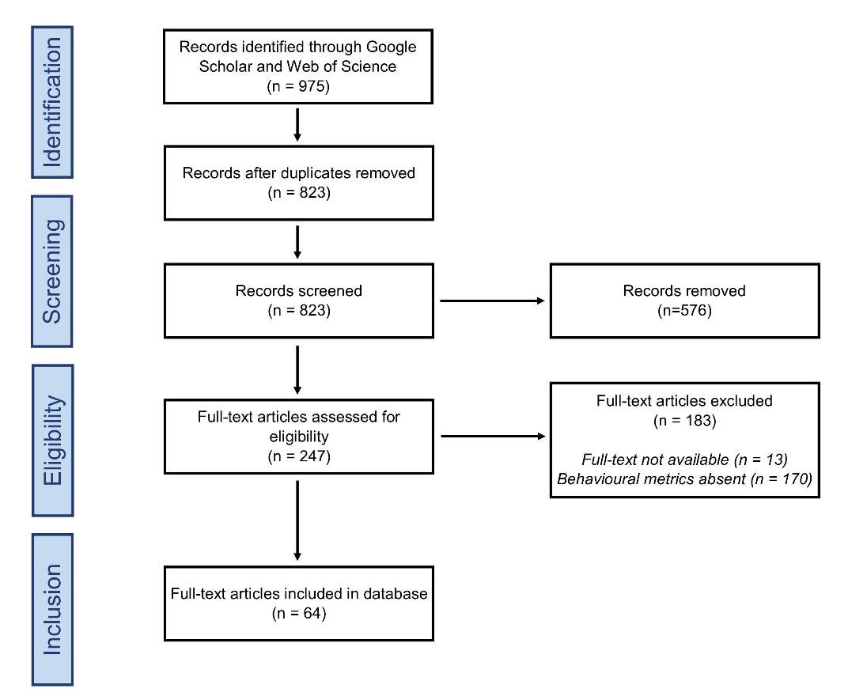
Figure 1 | Structured literature review process

Data extraction
For the 64 papers included in the analysis, the information extracted consisted of: (1) year of the publication; (2) country of the lead authors’ institution; (3); method used to collect or derive spatiotemporal metrics of fisher behaviour; (4) country of the fishery, and its socioeconomic status (e.g., high-income; upper-middle income; lower-middle income; and low-income) as defined by its World Bank economic development classification (World Bank, 2021); (5) type and characteristics of the fishing vessels (e.g., motorised, non-motorised, engine size, vessel length); and (6) type of fishing gear deployed, which were classified as either fisheries using only static fishing gear (hand line, pots and traps, spear gun), mobile gears (e.g., drift/gill nets, mid water trawls, long lines) or a combination of both mobile and static, hereafter defined as mixed.

Where available, the following study and behavioural metrics were also extracted: (1) sample size of the study (e.g., number of boats and/or fishers); (2) maximum trip duration (hr); (3) mean trip duration (hr); (4) mean time spent fishing (hr); (5) maximum trip distance (km); (6) mean trip distance (km); (7) maximum offshore distance (km); (8) maximum average speed (km/h); (9) mean speed (km/h); (10) maximum depth (meters); and (11) maximum spatial footprint (km²). To support full text screening, a keyword search (e.g., “kilometre”, “km”, “mile”, “nautical mile”, “nm”, “distance”, “duration”, “hour”, “minute”) was employed to facilitate data extraction. These spatiotemporal behavioural variables were chosen based upon Metcalfe et al. (2017); a study which looked at a variety of fine-scale behavioural characteristics of small-scale fishers operating in the Republic of the Congo.

Data analysis
Each entry in the database represented a fishery from a specific study region, however, as 14 of the 64 publications included data from multiple regions and fishery types within the same country, it translated into 94 spatiotemporal data entries. To better understand the current state of knowledge around the spatiotemporal behaviours of small-scale fishers, we assessed three aspects.

First, we evaluated trends in studies that included spatiotemporal components. This included: (1) summarising the number of peer-reviewed publications by year to highlight trends in the reporting of spatiotemporal behaviours of SSF over time; (2) aggregating publications by the type of methodology and number of spatiotemporal behaviour metrics evaluated to ascertain the variability in the adoption of different approaches used to characterise SSF behaviour; and (3) establishing the number of publications by country, continent and across world bank economic development categories to identify geographic gaps in the availability of behaviour data.

Second, we assessed the level of variability in spatiotemporal behaviours as this is important for informing policy and management (Teh et al., 2012). To achieve this, we presented the range in fishers’ operating behaviour for: (1) four temporal variables (maximum trip distance, maximum offshore distance, mean trip distance and maximum depth) and (2) three spatial variables (maximum trip duration, mean trip duration and mean gear soak time).

Third, we explored the relationship between maximum fishing trip distances and vessel characteristics by World Bank economic development classification to assist policy makers and practitioners understand what factors potentially influence fisher behaviour. Maximum trip distance was chosen as metrics with under 20 data points (i.e., soak time, maximum offshore distance) were excluded after being deemed to have insufficient sample sizes for further statistical analysis, whilst all remaining spatiotemporal variables (maximum trip duration, maximum depth, mean duration and mean distance) were found to correlated with maximum trip distance (Figure S1) using the stats 3.6.2 package in R 4.3.0 (R Core Team, 2023). This is likely because greater distances travelled by fishers are linked to longer travel times and access to deeper waters.

Vessel characteristics were chosen based on past studies which have found causal relationships with fisher behaviour. Relationships between continuous predictor variables (fishing vessel length, engine size; Natale et al., 2015) were assessed by creating generalised linear models with gaussian error structures using the MASS 7.3-60 package in R 4.3.0 (R Core Team, 2023). Relationships between categorical predictor variables (i.e., method of propulsion, such as motorised, or non-motorised (e.g., sail or hand powered; Metcalfe et al., 2017, Daw, 2011), the socio-economic context of the fishery (Agar et al., 2017), and gear type (Wiyono et al., 2006)) were explored using the non-parametric Kruskal Wallis rank sum test with pairwise Wilcoxon rank sum tests implemented on significant results using the stats 3.6.2 package in R 4.3.0 (R Core Team, 2023).

Results

Characteristics of the field
The 64 sources identified during the structured literature review were published between 2005 and 2022, with 89% (n = 57) of those studies published after 2010 and peaking in 2020 (Figure 2A). Between 2005 and 2014, only four methods were used with data gathered primarily through interviews (n = 8; 67%), whilst from 2015 to 2022 this shifted to GPS tracking (n = 8; 29%) with nine methods adopted (Figure 2A). In terms of methodology, the most frequent approach adopted to characterise spatiotemporal metrics of fisher behaviour were interviews (n = 23; 36%) followed by GPS tracking (n = 22; 34%) with nine other methods accounting for the remaining 19 (30%) studies (Figure 2B). The number of behavioural metrics reported in each study ranged from 1 to 10 metrics per publication (mean number of metrics per study: 2.08 S.D. ± 1.48; n = 64), with most studies (n = 49; 77%) including ≤ 2 metrics (Figure 2C). In terms of regional distribution, most publications that included spatiotemporal components were from Europe (n = 15; 23%), followed by Africa and North America (n = 14; 22%), and Asia (n = 12; 19%) (Figure 2D). Most studies that included components of SSF behaviour were conducted in high-income countries (n = 22; 35%), whilst low-income-countries were represented by only 5 (8%) studies (Figure 2E). The 64 sources included spatiotemporal metrics on SSF from 34 countries with Mexico (n = 9) and the UK (n = 5) accounting for 22% of publications. In contrast, countries with extensive coastlines such as the USA, France, Philippines, and South Africa were represented by only one publication (6%) each (Figure 2F).

Variability in spatiotemporal behaviour
Data from the 64 studies included in our analysis revealed that there is a great deal of variance in both the reporting of, and variability in, the spatial and temporal behaviour of SSF (Figure 3). For instance, the difference between the maximum documented trip distances ranged between 2 km and 305 km (mean 57.7 km S.D. ± 71 km, n = 37 studies; Figure 3A). Similar trends were evident for maximum trip duration which ranged between 1 hr and 170 hrs across studies (mean 42.7 hrs S.D. ± 54 hrs, n = 35 studies; Figure 3B).
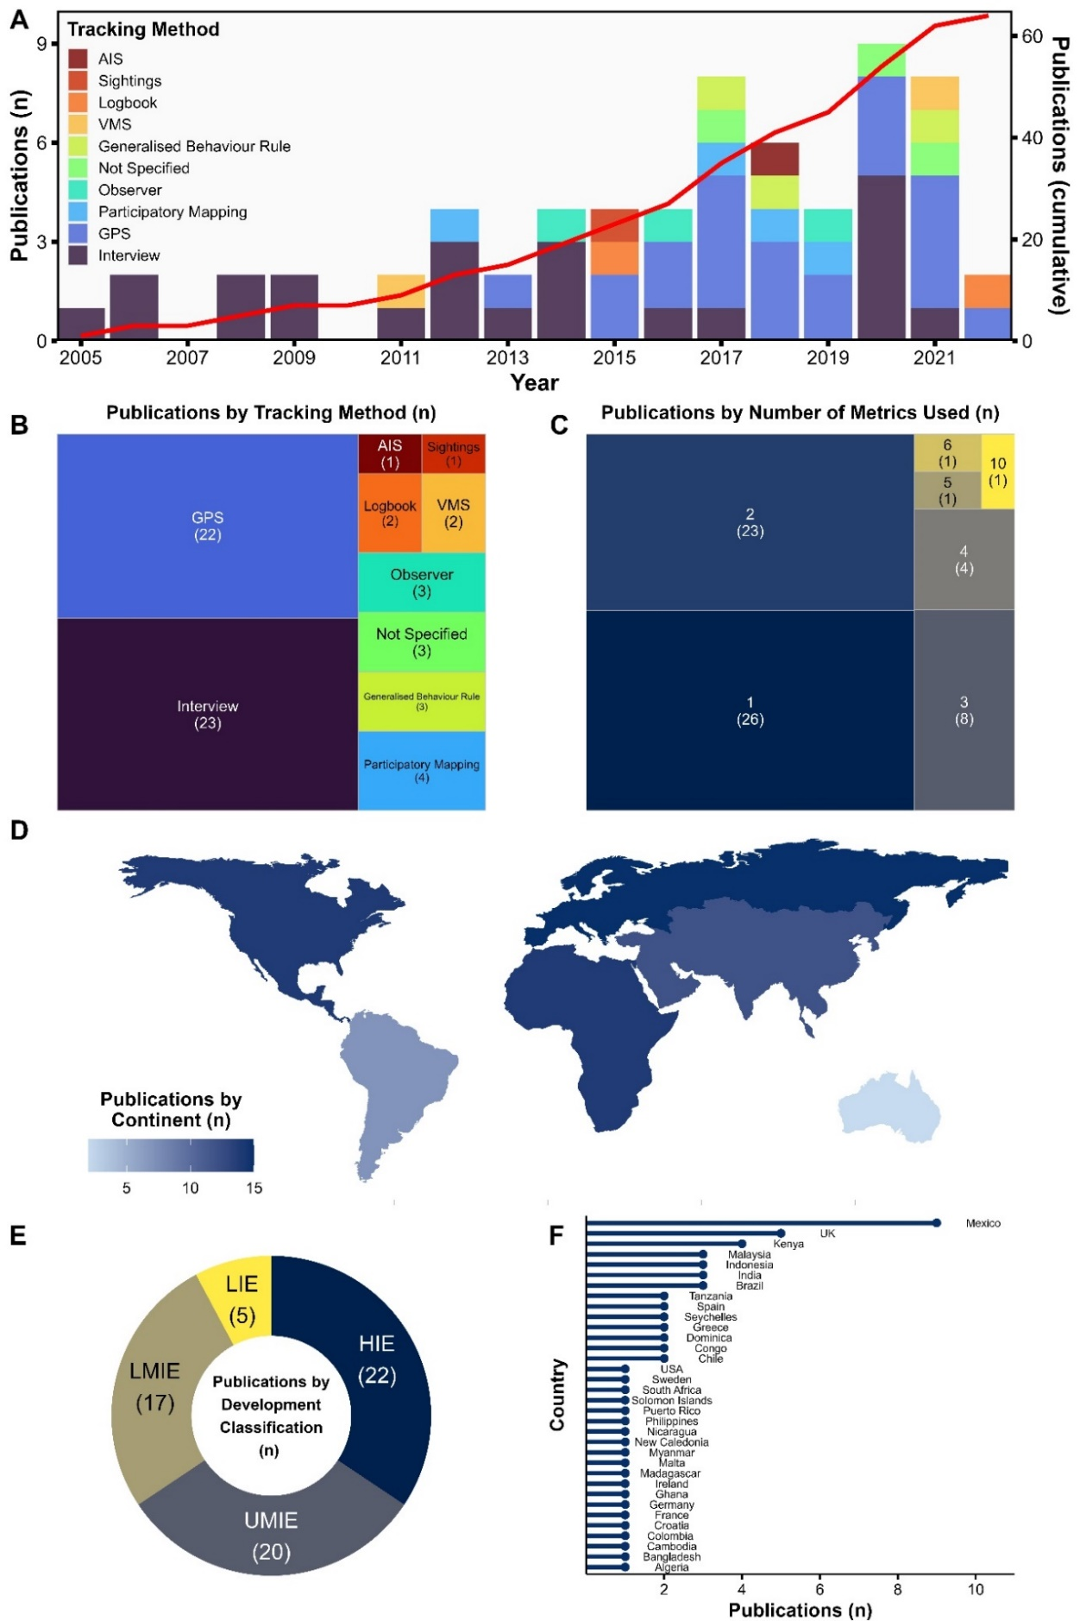
Figure 2 | Sources identified from the structured literature review including spatiotemporal metrics of small-scale fishers operating behaviour: (A) the number of publications and methods utilised by year between 2000 and 2022 ; (B) the methodology employed to derive spatiotemporal information of small-scale fishers operating behaviour; (C) the number of metrics derived by each publication; (D) the number of publications by continent; (E) the number of publications by World Bank economic development classification (HIE – high income economy; UMIE – upper middle income economy; LMIE - lower middle income economy; LIE - lower income economy) and (F) the number of publications by country.

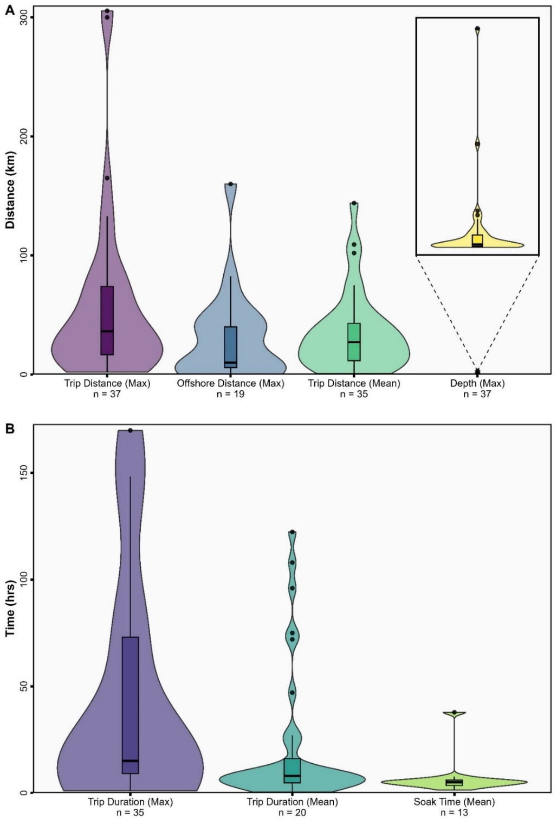
Figure 3 | Small-scale fishers operating behaviour: (A) spatial variability in distance and depth; and (B) temporal variability in duration of fishing events.

Spatiotemporal relationships
Variability in fisher behaviour could not be explained by vessel length (Figure 4A), engine size (Figure 4B), method of propulsion (motorised or non-motorised) (Figure 4C), gear type (static, mobile, or mixed) or by continent (Figure 4E). However, variability in fisher behaviour could be explained by the World Bank economic classification of the flag state of fleets (Figure 4D) with the maximum trip distance of fleets from lower income countries being significantly higher than those from lower middle income (p = 0.02) and higher income countries (p = 0.02). The maximum trip distance of fleets from upper middle-income countries was also significantly higher than those from lower middle income (p = 0.006) and higher income countries (p = 0.005) (Figure 4C).

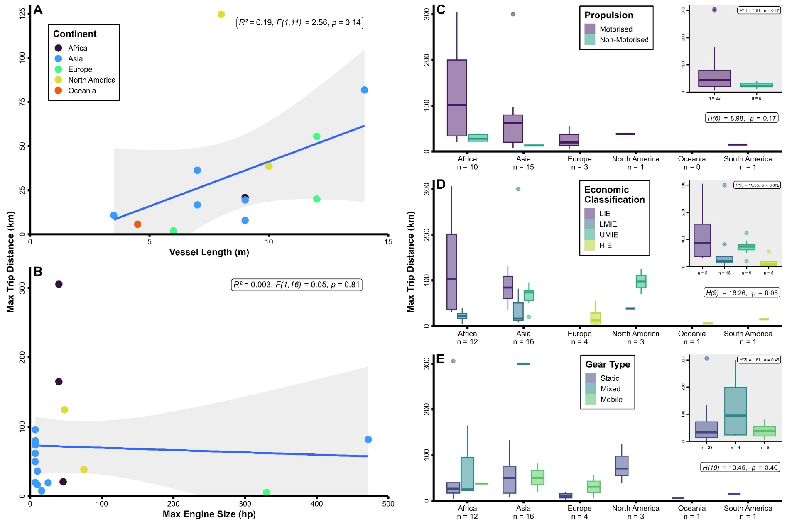
Figure 4 | The relationship between fisher operating behaviour (maximum trip distance (km)) and: (A) vessel length (m); (B) engine size (hp); (C) method of propulsion by World Bank economic development classification (inset – overall); (D) continent by World Bank economic development classification (inset – overall); and (E) gear type by World Bank economic development classification (inset – overall).

Discussion
Small-scale fisheries are prevalent throughout the world, employing more individuals than large-scale industrialised fisheries, shipping, and oil and gas sectors combined (Kelleher et al., 2012, OECD, 2016). However, despite their critical role (Kraan, 2009, Loring et al., 2019), there is very little understanding or awareness of the variability in their operating behaviour. Our findings provide critical insights into this sector, which can be used to guide future research priorities and better inform policy and management to ensure appropriate governance mechanisms are in place to enhance transparency and equity in decision-making.

Characteristics of the field
Since 2005, there has been an increased focus in recording or reporting of SSF spatiotemporal operating behaviours. However, whilst data is available from most continents (e.g., Africa, North America, Europe, Asia, South America, and Oceania), it is not representative of the global distribution of SSF fleets. For example, only two studies provided data on the operating behaviour of SSF in Oceania, despite the important role of SSF in this region (Schnierer and Egan, 2016, Smith et al., 2021). Furthermore, we found that studies on the operating behaviour of fishers from low-income economies was limited (n = 5) in contrast to high-income countries (n = 22), despite this sector playing an important social and economic role in terms of employment, food security, poverty alleviation and well-being in countries with fewer alternative livelihood opportunities (Chuenpagdee et al., 2006, Loring et al., 2019). These findings could reflect the fact that we did not review the grey literature and that the search protocol excluded languages other than English and so will likely have missed locally specific or national reports published in other languages. Similarly, we focused on a small number of well recognised and specific search terms and so may have excluded studies that used broader terms to describe SSF behaviour.

Our review also revealed the most common approach to characterise SSF behaviour prior to 2015 was interviews. The low-cost and flexible nature of this approach has been well suited to the complexities and low technological capacities of SSF (Lima et al., 2017, Metcalfe et al., 2017). However, in recent years (i.e., 2015 onwards), GPS trackers have become dominant as advances in technology and increased affordability have enabled their deployment within SSF (Tassetti et al., 2022). This method has been particularly useful as it can be combined with other approaches such as participatory mapping (Borges et al., 2021), video-based electronic monitoring (Baker Jr et al., 2016) and onboard observers (Behivoke et al., 2021), to provide greater insights into fishing activities. The benefits of this approach have been demonstrated in industrial fleets where access to large amounts of data have highlighted Illegal, Unreported or Unregulated (IUU) fishing operations (Park et al., 2020, Seto et al., 2023, Ford et al., 2018), species risk (White et al., 2017, Kroodsma et al., 2023, Queiroz et al., 2019, Womersley et al., 2022) and the effectiveness of policy and management interventions (Dureuil et al., 2018, Lynham et al., 2020, Visalli et al., 2020, Kerry et al., 2022). Advances in machine learning capabilities and computer processing power have also meant that the ability of this data to perform predictive analysis is now being realised which should improve resource management through pre-emptive conservation efforts (White et al., 2019, Watson and Woodill, 2022, Welch et al., 2022). Similarly, there is a growing opportunity with advances in satellite technology to use high resolution optical imagery to perform object-based image analysis to detect SSF vessels and identify patterns of fishing practices and behaviours, such as for industrial fisheries and shipping (Aiello et al., 2019, Park et al., 2020). Nonetheless, our study demonstrates that comparable data for SSF is both lacking and dispersed with a small set of studies that generally evaluate fleets using a limited number of metrics. Consequently, as policy and management decisions become increasingly data driven, SSF risk becoming further marginalised if data collection and centralisation efforts are not improved.

Variability in small-scale fisher behaviour
As well as characterising the field, understanding the full extent of the variability in small-scale fisher behaviour is essential if both policy makers and practitioners are to develop effective policies. Within the context of SSF, several researchers have defined SSF by their vessel length, size, weight (Halim et al., 2019) and operational range to quantify fishing effort (Natale et al., 2015). Others have developed generalised behavioural rules that apply uniform operational ranges to small-scale fishers globally to map the footprint of activities (e.g., Fishing Effort Envelope Tool, FEET and Predicted Fishing Effort, PFE; Stewart et al., 2010, Johnson et al., 2017). However, this study demonstrates that these approaches do not account for the high degree of variability observed in the operating behaviours of small-scale fishers which are comprised of varying vessel types and employ a range of fishing practices and gears. Consequently, failure to account for such differences in fisher behaviour could reduce the effectiveness of policies that are designed to influence, modify, or change behaviours (Fulton et al., 2011, Metcalfe et al., 2017).

Similarly, the application of generalised behaviour rules to quantify SSF fishing effort and spatial patterns of resource use (i.e., fishery footprints) could lead to the over- or under-representation of the extent of fishing grounds and level of effort within these areas (Nayak et al., 2014, Hiddink et al., 2007, Navarrete Forero et al., 2017). More specifically, the under-estimation of fishers operating behaviours could result in increasing competition for access to near-shore fishing grounds with other competing marine resource users and activities such as tourism, large-scale and industrialised fisheries, marine protected areas, and resource exploitation (e.g., petrochemicals); which could subsequently lead to declines in catches and socio-economic living standards (Chuenpagdee et al., 2006, d’Armengol et al., 2018). Additionally, the over-representation of SSF operating behaviours could obstruct the full extent of the impact fishers have on the marine environment from being accurately quantified thereby leading to the overexploitation of target stocks (Stewart et al., 2010, Thoya et al., 2020, Navarrete Forero et al., 2017). This can be particularly problematic when considering the high levels of bycatch associated with many SSF (Shester and Micheli, 2011, Jones et al., 2018).

Exploring relationships
Despite previous national scale studies finding vessel length to be correlated with operational range (Natale et al., 2015) – we found no significant relationship between the length of vessels and the operating behaviour of SSF – such as distance travelled. These differences in findings could reflect the sample size of our analyses that were small in part due to the limited number of published studies, or that the high variability in fisher behaviour observed at a global scale masks differences commonly observed within national SSF fleets.

Whilst no significant relationship was found between the operating behaviour of SSF and method of propulsion (i.e., motorised or non-motorised), previous national scale studies have shown that motorised SSF vessels are able to fish further and for longer than their non-motorised counterparts that are typically small, low-tech, low power vessels (e.g., paddle or sail powered) which limits the distances they can travel offshore (Daw, 2011, Metcalfe et al., 2017). Similarly, we detected no relationship between engine size/power and the operating behaviour of fishers despite previous national scale studies showing that engine power could predict fishers operational range (Natale et al., 2015). These findings may reflect fishers’ financial power as well as the size, construction and condition of many vessels which are typically wooden hulled vessels that can be in service for up to a decade and lack powered refrigeration. All of which combined may constrain how far fishers can safely and physically operate (i.e., how much fuel they can purchase) and the amount of catch that they can store onboard without compromising its quality and value (Chuenpagdee et al., 2006, Natale et al., 2015); ultimately leading to a high dependency on nearshore shallow waters.

Our findings also show that the type of fishing gear deployed had no observed effect on the operating behaviour of SSF. Similar trends were observed in a previous study, investigating a single fishery (Natale et al., 2015). However, it is worth noting that fishers using small vessels with low engine power have been observed travelling great distances to deeper waters to combat fish stock declines in their local grounds (Damasio et al., 2020), and so the health of fish stocks are also likely to play an important role in shaping fishers’ operating behaviour.

Perhaps most interestingly, we found a significant difference in the operating behaviour of SSF fleets from low- to high-income countries. These differences could reflect the high dependency on fish as a source of protein (Kraan, 2009, Loring et al., 2019), the presence of overfishing driven by IUU fishing, and weaker governance that forces fishers in these countries to travel further afield to find productive fishing grounds (Chuenpagdee et al., 2006, Hall et al., 2009).

Conclusion
Although some of our main findings have previously been replicated at a national scale by several other publications (e.g., Daw, 2011, Natale et al., 2015, Metcalfe et al., 2017, Quijano Quiñones et al., 2021), this is the first study on marine fisheries to synthesise the spatiotemporal operating behaviour of SSF at a global scale. In summary, we show: (1) this field of research is relatively young and under-representative of certain regions; (2) there is a high degree of variability in fishers’ operating behaviours, which means that generalised or uniform behavioural rules could lead to an under- or over-estimation in SSF behaviour and extent of fishing grounds; (3) the operating behaviour of fishers is influenced by economic status of a country with fishers from lower-income countries travelling further than fishers in emerging and high income countries; and (4) further studies are needed to better understand the nuances between regions, types of vessels and fishing practices to ensure that policy and management decisions accurately reflect spatiotemporal patterns of SSF resource use from local to global scales. Currently, it does not appear cost effective for countries to implement large scale SSF tracking programs, and so further research is needed to help understand the mechanisms and resources that need to be in place to provide comparable data to industrial fisheries and ensure equity in decision making for SSF.

Author contributions
A.N. and K.M. conceived the idea; F.W. conducted literature review and extracted data; P.W. and C.K., analysed the data and produced figures, P.W. produced the first draft, and all authors P.W., A.N., D.A.K., N.A.M., C.K., and K.M. contributed to the revisions and gave final approval for publication.

Acknowledgements
P.W. was supported by funding from the Centre for Ecology & Conservation at the University of Exeter. A.N. acknowledges the support of the European Union's Horizon 2020 research and innovation programme under the Marie Skłodowska-Curie grant agreement SocioEcoFrontiers No. 843865. C.K. is supported by funding from the University of Exeter through a UKRI Centre for Doctoral Training in Environmental Intelligence. K.M. acknowledges funding support from Oceans 5, Wildlife Conservation Society Congo Programme, and the Darwin Initiative (26-014) through the Department for Environment, Food and Rural Affairs (Defra) in the UK.

Data Availability Statement
Small-scale fisheries operating behaviour database is freely accessible from X repository.

Ethics statement
All research was subject to ethical approval by the University of Exeter Ethics Committee (eCORN003905 v2.1).

Conflict of interest
The authors declare no conflict of interest.

References
AGAR, J., SHIVLANI, M. & SOLÍS, D. 2017. The commercial trap fishery in the commonwealth of Puerto Rico: An economic, social, and technological profile. North American journal of fisheries management, 37, 778-788.
AIELLO, M., VEZZOLI, R. & GIANINETTO, M. 2019. Object-based image analysis approach for vessel detection on optical and radar images. Journal of Applied Remote Sensing, 13, 014502-014502.
ALFARO-SHIGUETO, J., MANGEL, J. C., PAJUELO, M., DUTTON, P. H., SEMINOFF, J. A. & GODLEY, B. J. 2010. Where small can have a large impact: structure and characterization of small-scale fisheries in Peru. Fisheries Research, 106, 8-17.
ALVARD, M. & CARLSON, D. 2020. Identifying patch types using movement data from artisanal fishers from the commonwealth of dominica. Current Anthropology, 61, 380-387.
ALVARD, M., CARLSON, D. & MCGAFFEY, E. 2015. Using a Partial Sum Method and GPS Tracking Data to Identify Area Restricted Search by Artisanal Fishers at Moored Fish Aggregating Devices in the Commonwealth of Dominica. PloS one, 10.
AMES, R. T., LEAMAN, B. M. & AMES, K. L. 2007. Evaluation of video technology for monitoring of multispecies longline catches. North American Journal of Fisheries Management, 27, 955-964.
ARDRON, J. A. & WALLACE, S. 2005. Modelling inshore rockfish habitat in British Columbia: a pilot study. Place matters: geospatial tools for marine science. Edited by D. Wright and A. Scholtz. University of Oregon Press, Eugene, Oreg, 47-68.
ASWANI, S. & LAUER, M. 2006. Incorporating fishermen’s local knowledge and behavior into geographical information systems (GIS) for designing marine protected areas in Oceania. Human organization, 65, 81-102.
BAKER JR, M. S., SCIANCE, M. B. & HALLS, J. N. 2016. Potential for a simple GPS-based binary logit model to predict fishing effort in a vertical hook-and-line reef fish fishery. Marine and coastal fisheries, 8, 118-131.
BARRETO, G. C., DI DOMENICO, M. & MEDEIROS, R. P. 2020. Human dimensions of marine protected areas and small-scale fisheries management: a review of the interpretations. Marine Policy, 119, 104040.
BEHIVOKE, F., ETIENNE, M.-P., GUITTON, J., RANDRIATSARA, R. M., RANAIVOSON, E. & LÉOPOLD, M. 2021. Estimating fishing effort in small-scale fisheries using GPS tracking data and random forests. Ecological indicators, 123, 107321.
BERKES, F. 2001. Managing small-scale fisheries: alternative directions and methods, IDRC.
BIRCHENOUGH, S. E., COOPER, P. A. & JENSEN, A. C. 2021. Vessel monitoring systems as a tool for mapping fishing effort for a small inshore fishery operating within a marine protected area. Marine Policy, 124, 104325.
BORGES, R., EYZAGUIRRE, I. A., SÁ LEITÃO BARBOZA, R., BOOS, K., GLASER, M. & LOPES, P. F. 2021. Combining Knowledge Systems Helps Understand the Spatial Dynamics of Data-Limited Small-Scale Fisheries Systems in Brazil: A Methods Analysis. Frontiers in Marine Science, 8, 760535.
BREEN, P., VANSTAEN, K. & CLARK, R. W. 2015. Mapping inshore fishing activity using aerial, land, and vessel-based sighting information. ICES Journal of Marine Science, 72, 467-479.
BURGOS, C., GIL, J. & DEL OLMO, L. A. 2013. The Spanish blackspot seabream (Pagellus bogaraveo) fishery in the Strait of Gibraltar: spatial distribution and fishing effort derived from a small-scale GPRS/GSM based fisheries vessel monitoring system. Aquatic Living Resources, 26, 399-407.
CAMPBELL, M. S., STEHFEST, K. M., VOTIER, S. C. & HALL-SPENCER, J. M. 2014. Mapping fisheries for marine spatial planning: Gear-specific vessel monitoring system (VMS), marine conservation and offshore renewable energy. Marine Policy, 45, 293-300.
CARDIEC, F., BERTRAND, S., WITT, M. J., METCALFE, K., GODLEY, B. J., MCCLELLAN, C., VILELA, R., PARNELL, R. J. & LE LOC’H, F. 2020. “Too Big To Ignore”: A feasibility analysis of detecting fishing events in Gabonese small-scale fisheries. PLOS ONE, 15, e0234091.
CHUENPAGDEE, R. 2012. Global partnership for small-scale fisheries research: Too big to ignore. SPC Traditional Marine Resource Management and Knowledge Information Bulletin, 29, 22-25.
CHUENPAGDEE, R., LIGUORI, L., PALOMARES, M. L. & PAULY, D. 2006. Bottom-up, global estimates of small-scale marine fisheries catches. Fisheries Centre Research Reports 14.
CHUENPAGDEE, R. & PAULY, D. Small is beautiful? A database approach for global assessment of small-scale fisheries: preliminary results and hypotheses. American Fisheries Society Symposium, 2008. American Fisheries Society, 575.
D’ARMENGOL, L., CASTILLO, M. P., RUIZ-MALLÉN, I. & CORBERA, E. 2018. A systematic review of co-managed small-scale fisheries: social diversity and adaptive management improve outcomes. Global Environmental Change, 52, 212-225.
DAMASIO, L. M., PENINNO, M. G. & LOPES, P. F. 2020. Small changes, big impacts: Geographic expansion in small-scale fisheries. Fisheries Research, 226, 105533.
DAW, T. 2011. The spatial behaviour of artisanal fishers: Implications for fisheries management and development (Fishers in Space) Final Report December 2011. Western Indian Ocean Marine Science Association.
DE FREITAS, D. M. & TAGLIANI, P. R. A. 2009. The use of GIS for the integration of traditional and scientific knowledge in supporting artisanal fisheries management in southern Brazil. Journal of Environmental Management, 90, 2071-2080.
DOHERTY, P. D., ATSANGO, B. C., NGASSIKI, G., NGOUEMBE, A., BREHERET, N., CHAUVET, E., GODLEY, B. J., MACHIN, L., MOUNDZOHO, B. D., PARNELL, R. J. & METCALFE, K. 2021. Threats of illegal, unreported and unregulated fishing to biodiversity and food security in the Republic of the Congo. Conservation Biology, 35, 1463-1472.
DUNN, D. C., STEWART, K., BJORKLAND, R., HAUGHTON, M., SINGH-RENTON, S., LEWISON, R., THORNE, L. & HALPIN, P. 2010. A regional analysis of coastal and domestic fishing effort in the wider Caribbean. Fisheries Research, 102, 60-68.
DUREUIL, M., BOERDER, K., BURNETT, K. A., FROESE, R. & WORM, B. 2018. Elevated trawling inside protected areas undermines conservation outcomes in a global fishing hot spot. Science, 362, 1403-1407.
EMFF 2020. Deploymnet of Vessel Monitoring Systems (iVMS) on Inshore Fishing Vessels Using Dredges. European Maritime and Fisheries FundAccessed: https://emff.marine.ie/biotag-biodiversity/deployment-vessel-monitoring-systems-ivms-inshore-fishing-vessels-using-dredges.
FAO, DUKE UNIVERSITY & WORLDFISH 2023. Illuminating Hidden Harvests – The contributions of small-scale fisheries to sustainable development. Rome. https://doi.org/10.4060/cc4576en.
FORD, J. H., PEEL, D., KROODSMA, D., HARDESTY, B. D., ROSEBROCK, U. & WILCOX, C. 2018. Detecting suspicious activities at sea based on anomalies in Automatic Identification Systems transmissions. PLoS One, 13, e0201640.
FREDUAH, G., FIDELMAN, P. & SMITH, T. F. 2017. The impacts of environmental and socio-economic stressors on small scale fisheries and livelihoods of fishers in Ghana. Applied Geography, 89, 1-11.
FULTON, E. A., SMITH, A. D., SMITH, D. C. & VAN PUTTEN, I. E. 2011. Human behaviour: the key source of uncertainty in fisheries management. Fish and Fisheries, 12, 2-17.
HALIM, A., WIRYAWAN, B., LONERAGAN, N. R., HORDYK, A., SONDITA, M. F. A., WHITE, A. T., KOESHENDRAJANA, S., RUCHIMAT, T., POMEROY, R. S. & YUNI, C. 2019. Developing a functional definition of small-scale fisheries in support of marine capture fisheries management in Indonesia. Marine Policy, 100, 238-248.
HALL, G. B. & CLOSE, C. 2007. Local knowledge assessment for a small-scale fishery using geographic information systems. Fisheries Research, 83, 11-22.
HALL, G. B., MOORE, A., KNIGHT, P. & HANKEY, N. 2009. The extraction and utilization of local and scientific geospatial knowledge within the Bluff oyster fishery, New Zealand. Journal of Environmental Management, 90, 2055-2070.
HARPER, S., ZELLER, D., HAUZER, M., PAULY, D. & SUMAILA, U. R. 2013. Women and fisheries: Contribution to food security and local economies. Marine policy, 39, 56-63.
HARZING, A. W. 2007. Publish or Perish. Available from https://harzing.com/resources/publish-or-perish.
HAUCK, M. 2013. Non-compliance in small-scale fisheries: a threat to security? 1. Issues in green criminology. Willan.
HIDDINK, J. G., JENNINGS, S. & KAISER, M. 2007. Assessing and predicting the relative ecological impacts of disturbance on habitats with different sensitivities. Journal of Applied Ecology, 44, 405-413.
HSU, W. W., WANG, S.-Y., HONG, W.-S., HU, R.-H., YU, C.-J. & TASI, H.-Y. Portable fisheries assistant systems for small scale fisheries management. 2019 IEEE Eurasia Conference on IOT, Communication and Engineering (ECICE), 2019. IEEE, 10-13.
IACARELLA, J. C., CLYDE, G., BERGSETH, B. J. & BAN, N. C. 2021. A synthesis of the prevalence and drivers of non-compliance in marine protected areas. Biological Conservation, 255, 108992.
ISLAM, M. M. & CHUENPAGDEE, R. 2022. Towards a classification of vulnerability of small-scale fisheries. Environmental Science & Policy, 134, 1-12.
JAMES, M., MENDO, T., JONES, E. L., ORR, K., MCKNIGHT, A. & THOMPSON, J. 2018. AIS data to inform small scale fisheries management and marine spatial planning. Marine Policy, 91, 113-121.
JENNINGS, S. & LEE, J. 2012. Defining fishing grounds with vessel monitoring system data. ICES Journal of Marine Science, 69, 51-63.
JOHNSON, A. F., MORENO-BÁEZ, M., GIRON-NAVA, A., COROMINAS, J., ERISMAN, B., EZCURRA, E. & ABURTO-OROPEZA, O. 2017. A spatial method to calculate small-scale fisheries effort in data poor scenarios. PLoS One, 12, e0174064.
JONES, B. L., UNSWORTH, R. K., UDAGEDARA, S. & CULLEN-UNSWORTH, L. C. 2018. Conservation concerns of small-scale fisheries: by-catch impacts of a shrimp and finfish fishery in a Sri Lankan lagoon. Frontiers in Marine Science, 52.
KELLEHER, K., WESTLUND, L., HOSHINO, E., MILLS, D., WILLMANN, R., DE GRAAF, G. & BRUMMETT, R. 2012. Hidden harvest: The global contribution of capture fisheries, Worldbank; WorldFish.
KERRY, C. R., EXETER, O. M. & WITT, M. J. 2022. Monitoring global fishing activity in proximity to seamounts using automatic identification systems. Fish and Fisheries, 23, 733-749.
KLEIVEN, A. R., OLSEN, E. M. & VØLSTAD, J. H. 2011. Estimating recreational and commercial fishing effort for European lobster Homarus gammarus by strip transect sampling. Marine and Coastal Fisheries, 3, 383-393.
KRAAN, M. 2009. Creating space for fishermen's livelihoods: Anlo-Ewe beach seine fishermen's negotiations for livelihood space within multiple governance structures in Ghana, African Studies Centre.
KROODSMA, D., TURNER, J., LUCK, C., HOCHBERG, T., MILLER, N., AUGUSTYN, P. & PRINCE, S. 2023. Global prevalence of setting longlines at dawn highlights bycatch risk for threatened albatross. Biological Conservation, 283, 110026.
KROODSMA, D. A., MAYORGA, J., HOCHBERG, T., MILLER, N. A., BOERDER, K., FERRETTI, F., WILSON, A., BERGMAN, B., WHITE, T. D. & BLOCK, B. A. 2018. Tracking the global footprint of fisheries. Science, 359, 904-908.
LEE, J., SOUTH, A. B. & JENNINGS, S. 2010. Developing reliable, repeatable, and accessible methods to provide high-resolution estimates of fishing-effort distributions from vessel monitoring system (VMS) data. Ices Journal of Marine Science, 67 1260-1271.
LEITE, M. C., JOHNSON, D. S., ROSS, H. & SEIXAS, C. S. 2023. Social wellbeing, values, and identity among Caiçara small-scale fishers in southeastern Brazil. Maritime Studies, 22, 36.
LI, Y., SUN, M., REN, Y. & CHEN, Y. 2021. Fisher behavior matters: Harnessing spatio-temporal fishing effort information to support China's fisheries management. Ocean & Coastal Management, 210, 105665.
LIMA, M. S. P., OLIVEIRA, J. E. L., DE NÓBREGA, M. F. & LOPES, P. F. M. 2017. The use of Local Ecological Knowledge as a complementary approach to understand the temporal and spatial patterns of fishery resources distribution. Journal of ethnobiology and ethnomedicine, 13, 1-12.
LORING, P. A., FAZZINO, D. V., AGAPITO, M., CHUENPAGDEE, R., GANNON, G. & ISAACS, M. 2019. Fish and food security in small-scale fisheries. Transdisciplinarity for small-scale fisheries governance. Springer.
LYNHAM, J., NIKOLAEV, A., RAYNOR, J., VILELA, T. & VILLASEÑOR-DERBEZ, J. C. 2020. Impact of two of the world's largest protected areas on longline fishery catch rates. Nature communications, 11, 979.
MAHOOD, Q., VAN EERD, D. & IRVIN, E. 2014. Searching for grey literature for systematic reviews: challenges and benefits. Research synthesis methods, 5, 221-234.
MENDO, T., SMOUT, S., PHOTOPOULOU, T. & JAMES, M. 2019. Identifying fishing grounds from vessel tracks: model-based inference for small scale fisheries. Royal Society open science, 6, 191161.
METCALFE, K., COLLINS, T., ABERNETHY, K. E., BOUMBA, R., DENGUI, J. C., MIYALOU, R., PARNELL, R. J., PLUMMER, K. E., RUSSELL, D. J. F., SAFOU, G. K., TILLEY, D., TURNER, R. A., VANLEEUWE, H., WITT, M. J. & GODLEY, B. J. 2017. Addressing uncertainty in marine resource management; combining community engagement and tracking technology to characterise human behavior. Conservation Letters, 10, 460-469.
MMO 2023. Inshore Vessel Monitoring (I-VMS) for under-12m fishing vessels registered in England. Marine Management Organisation (MMO). Accessed: https://www.gov.uk/guidance/inshore-vessel-monitoring-i-vms-for-under-12m-fishing-vessels-registered-in-england.
MOHER, D., LIBERATI, A., TETZLAFF, J., ALTMAN, D. G. & GROUP*, P. 2009. Preferred reporting items for systematic reviews and meta-analyses: the PRISMA statement. Annals of internal medicine, 151, 264-269.
NATALE, F., GIBIN, M., ALESSANDRINI, A., VESPE, M. & PAULRUD, A. 2015. Mapping Fishing Effort through AIS Data. PLoS ONE, 10, e0130746.
NAVARRETE FORERO, G., MIÑARRO, S., MILDENBERGER, T. K., BRECKWOLDT, A. & REUTER, H. 2017. Participatory boat tracking reveals spatial fishing patterns in an Indonesian artisanal fishery. Frontiers in Marine Science, 4, 409.
NAYAK, P. K., OLIVEIRA, L. E. & BERKES, F. 2014. Resource degradation, marginalization, and poverty in small-scale fisheries: threats to social-ecological resilience in India and Brazil. Ecology and Society, 19.
NUNAN, F., CEPIĆ, D., MBILINGI, B., ODONGKARA, K., YONGO, E., OWILI, M., SALEHE, M., MLAHAGWA, E. & ONYANGO, P. 2018. Community cohesion: social and economic ties in the personal networks of fisherfolk. Society & Natural Resources, 31, 306-319.
OECD 2016. The ocean economy in 2030, OECD.
OROFINO, S., MCDONALD, G., MAYORGA, J., COSTELLO, C. & BRADLEY, D. 2023. Opportunities and challenges for improving fisheries management through greater transparency in vessel tracking. ICES Journal of Marine Science, 80, 675-689.
PARK, J., LEE, J., SETO, K., HOCHBERG, T., WONG, B. A., MILLER, N. A., TAKASAKI, K., KUBOTA, H., OOZEKI, Y. & DOSHI, S. 2020. Illuminating dark fishing fleets in North Korea. Science advances, 6, eabb1197.
QUEIROZ, N., HUMPHRIES, N. E., COUTO, A., VEDOR, M., DA COSTA, I., SEQUEIRA, A. M., MUCIENTES, G., SANTOS, A. M., ABASCAL, F. J. & ABERCROMBIE, D. L. 2019. Global spatial risk assessment of sharks under the footprint of fisheries. Nature, 572, 461-466.
QUIJANO QUIÑONES, D. R., LÓPEZ-ROCHA, J. A., HERNÁNDEZ-HERRERA, I. & TORRES-IRINEO, E. 2021. Spatial Dynamics Modeling of Small-Scale Fishing Fleets With a Random Walk Approach. Frontiers in Marine Science, 8, 669112.
R CORE TEAM 2023. R: A language and environment for statistical computing. R Foundation for Statistical Computing, Vienna, Austria. URL https://www.R-project.org/.
RUSSO, T., D'ANDREA, L., PARISI, A. & CATAUDELLA, S. 2014. VMSbase: an R-package for VMS and logbook data management and analysis in fisheries ecology. PLoS One, 9, e100195.
SCHNIERER, S. & EGAN, H. 2016. Composition of the Aboriginal harvest of fisheries resources in coastal New South Wales, Australia. Reviews in Fish Biology and Fisheries, 26, 693-709.
SCHOLZ, A., BONZON, K., FUJITA, R., BENJAMIN, N., WOODLING, N., BLACK, P. & STEINBACK, C. 2004. Participatory socioeconomic analysis: drawing on fishermen's knowledge for marine protected area planning in California. Marine Policy, 28, 335-349.
SCHUHBAUER, A. & SUMAILA, U. R. 2016. Economic viability and small-scale fisheries—A review. Ecological Economics, 124, 69-75.
SETO, K. L., MILLER, N. A., KROODSMA, D., HANICH, Q., MIYAHARA, M., SAITO, R., BOERDER, K., TSUDA, M., OOZEKI, Y. & URRUTIA S, O. 2023. Fishing through the cracks: The unregulated nature of global squid fisheries. Science advances, 9, eadd8125.
SHESTER, G. G. & MICHELI, F. 2011. Conservation challenges for small-scale fisheries: Bycatch and habitat impacts of traps and gillnets. Biological Conservation, 144, 1673-1681.
SMITH, H. & BASURTO, X. 2019. Defining small-scale fisheries and examining the role of science in shaping perceptions of who and what counts: a systematic review. Frontiers in Marine Science, 6, 236.
SMITH, H., LOZANO, A. G., BAKER, D., BLONDIN, H., HAMILTON, J., CHOI, J., BASURTO, X. & SILLIMAN, B. 2021. Ecology and the science of small-scale fisheries: A synthetic review of research effort for the Anthropocene. Biological Conservation, 254, 108895.
STANLEY, R. D., OLSEN, N. & FEDORUK, A. 2009. Independent validation of the accuracy of yelloweye rockfish catch estimates from the Canadian groundfish integration pilot project. Marine and Coastal Fisheries: Dynamics, Management, and Ecosystem Science, 1, 354-362.
STEWART, K. R., LEWISON, R. L., DUNN, D. C., BJORKLAND, R. H., KELEZ, S., HALPIN, P. N. & CROWDER, L. B. 2010. Characterizing fishing effort and spatial extent of coastal fisheries. PloS one, 5, e14451.
SZOSTEK, C. L., MURRAY, L. G., BELL, E. & KAISER, M. J. 2017. Filling the gap: using fishers’ knowledge to map the extent and intensity of fishing activity. Marine environmental research, 129, 329-346.
TASSETTI, A. N., GALDELLI, A., PULCINELLA, J., MANCINI, A. & BOLOGNINI, L. 2022. Addressing gaps in small-scale fisheries: A low-cost tracking system. Sensors, 22, 839.
TEH, L. C., TEH, L. S. & MEITNER, M. J. 2012. Preferred resource spaces and fisher flexibility: implications for spatial management of small-scale fisheries. Human Ecology, 40, 213-226.
THIAULT, L., COLLIN, A., CHLOUS, F., GELCICH, S. & CLAUDET, J. 2017. Combining participatory and socioeconomic approaches to map fishing effort in small-scale fisheries. PLoS One, 12, e0176862.
THOYA, P., PÉREZ-JORGE, S., OKEMWA, G., MWAMLAVYA, H., TUDA, A., WAMBIJI, N. & MAINA, J. 2020. Spatial patterns and environmental risks of ringnet fishing along the Kenyan coast. African Journal of Marine Science, 42, 23-33.
TORRES-IRINEO, E., SALAS, S., EUÁN-ÁVILA, J. I., PALOMO, L. E., QUIJANO QUINONES, D. R., CORONADO, E. & JOO, R. 2021. Spatio-Temporal Determination of Small-Scale Vessels’ Fishing Grounds Using a Vessel Monitoring System in the Southeastern Gulf of Mexico. Frontiers in Marine Science, 542.
TULLY, O. 2017. Atlas: Commercial fisheries for shellfish around Ireland. Marine Institute.
TURNER, R. A., POLUNIN, N. V. & STEAD, S. M. 2015. Mapping inshore fisheries: Comparing observed and perceived distributions of pot fishing activity in Northumberland. Marine Policy, 51, 173-181.
VISALLI, M. E., BEST, B. D., CABRAL, R. B., CHEUNG, W. W., CLARK, N. A., GARILAO, C., KASCHNER, K., KESNER-REYES, K., LAM, V. W. & MAXWELL, S. M. 2020. Data-driven approach for highlighting priority areas for protection in marine areas beyond national jurisdiction. Marine Policy, 122, 103927.
WATSON, J. R. & WOODILL, A. J. 2022. Detecting illegal maritime activities from anomalous multiscale fleet behaviours. Fish and Fisheries, 23, 1055-1069.
WELCH, H., CLAVELLE, T., WHITE, T. D., CIMINO, M. A., VAN OSDEL, J., HOCHBERG, T., KROODSMA, D. & HAZEN, E. L. 2022. Hot spots of unseen fishing vessels. Science Advances, 8, eabq2109.
WHITE, T. D., CARLISLE, A. B., KROODSMA, D. A., BLOCK, B. A., CASAGRANDI, R., DE LEO, G. A., GATTO, M., MICHELI, F. & MCCAULEY, D. J. 2017. Assessing the effectiveness of a large marine protected area for reef shark conservation. Biological Conservation, 207, 64-71.
WHITE, T. D., FERRETTI, F., KROODSMA, D. A., HAZEN, E. L., CARLISLE, A. B., SCALES, K. L., BOGRAD, S. J. & BLOCK, B. A. 2019. Predicted hotspots of overlap between highly migratory fishes and industrial fishing fleets in the northeast Pacific. Science advances, 5, eaau3761.
WITT, M. J. & GODLEY, B. J. 2007. A Step Towards Seascape Scale Conservation: Using Vessel Monitoring Systems (VMS) to Map Fishing Activity. Plos One, 2, e1111.
WIYONO, E., YAMADA, S., TANAKA, E., ARIMOTO, T. & KITAKADO, T. 2006. Dynamics of fishing gear allocation by fishers in small‐scale coastal fisheries of Pelabuhanratu Bay, Indonesia. Fisheries Management and Ecology, 13, 185-195.
WOMERSLEY, F. C., HUMPHRIES, N. E., QUEIROZ, N., VEDOR, M., DA COSTA, I., FURTADO, M., TYMINSKI, J. P., ABRANTES, K., ARAUJO, G. & BACH, S. S. 2022. Global collision-risk hotspots of marine traffic and the world’s largest fish, the whale shark. Proceedings of the National Academy of Sciences, 119, e2117440119.
WORLD BANK 2021. World Bank Country and Lending Groups. Available from: https://datahelpdesk.worldbank.org/knowledgebase/articles/906519-world-bank-country-and-lending-groups.

Supporting Information
Table S1 | Sources identified from the structured literature review that include spatiotemporal metrics of small-scale fishers operating behaviour (n = 64).

Lead authors | Year of  publication | Title | Journal | DOI / Link
Aburto et al. | 2009 | Allocation of effort in artisanal fisheries: The importance of migration and temporary fishing camps | Ocean & Coastal Management | https://doi.org/10.1016/j.ocecoaman.2009.10.004
Agar and Shivlani | 2017 | Socio-economic Profile of the Small-scale  Dive Fishery in the  Commonwealth of Puerto Rico | Marine Fisheries Review | https://spo.nmfs.noaa.gov/sites/default/files/pdf-content/mfr783-42.pdf
Alvard et al. | 2015 | Using a Partial Sum Method and GPS Tracking Data to Identify Area Restricted Search by Artisanal Fishers at Moored Fish Aggregating Devices in the Commonwealth of Dominica | PLoS ONE | https://doi.org/10.1371/journal.pone.0115552
Alvard and Carlson. | 2020 | Identifying Patch Types Using Movement Data from Artisanal Fishers from the Commonwealth of Dominica | Current Anthropology | https://doi.org/10.1086/708720
Aram et al. | 2014 | Mobile advisory information to reduce coastal risks and to enhance livelihood activities in South east coast of India | Indian Journal of Geo-Marine Science | https://nopr.niscpr.res.in/handle/123456789/34550
Baker et al. | 2016 | Potential for a Simple GPS-Based Binary Logit Model to Predict Fishing Effort in a Vertical Hook-and-Line Reef Fish Fishery | Marine and Coastal Fisheries | https://doi.org/10.1080/19425120.2015.1135221
Baker and Constant. | 2020 | Epistemic justice and the integration of local ecological knowledge for marine conservation: Lessons from the Seychelles | Marine Policy | https://doi.org/10.1016/j.marpol.2020.103921
Basurto. | 2005 | How locally designed access and use controls can prevent the tragedy of the commons in a Mexican small-scale fishing community | Society and Natural Resources | https://doi.org/10.1080/08941920590959631
Beckenstein et al. | 2020 | Drivers and trends in catch of benthic resources in Chilean TURFs and surrounding open access areas | Ocean & Coastal Management | https://doi.org/10.1016/j.ocecoaman.2019.104961
Behivoke et al. | 2021 | Estimating fishing effort in small-scale fisheries using GPS tracking data and random forests | Ecological Indicators | https://doi.org/10.1016/j.ecolind.2020.107321
Boubekri et al. | 2018 | Structure and spatio-temporal dynamics of the artisanal small-scale fisheries at the future MPA of “Taza” (Algerian coast, SW Mediterranean) | Mediterranean Marine Science | https://doi.org/10.12681/mms.16192
Cardiec et al. | 2020 | “Too Big To Ignore”: A feasibility analysis of detecting fishing events in Gabonese small-scale fisheries | PLoS ONE | https://doi.org/10.1371/journal.pone.0234091
Cartamil et al. | 2011 | The artisanal elasmobranch fishery of the Pacific coast of Baja California, Mexico | Fisheries Research | https://doi.org/10.1016/j.fishres.2011.01.020
Damasio et al. | 2020 | Small changes, big impacts: Geographic expansion in small-scale fisheries | Fisheries Research | https://doi.org/10.1016/j.fishres.2020.105533
Daw. | 2008 | Spatial distribution of effort by artisanal fishers: Exploring economic factors affecting the lobster fisheries of the Corn Islands, Nicaragua | Fisheries Research | https://doi.org/10.1016/j.fishres.2007.09.027
Duggan et al. | 2014 | ‘Thinking like a fish’: adaptive strategies for coping with vulnerability and variability emerging from a relational engagement with kob | Maritime Studies | https://link.springer.com/article/10.1186/2212-9790-13-4
Erisman et al. | 2015 | A comparison of fishing activities between two coastal communities within a biosphere reserve in the Upper Gulf of California | Fisheries Research | https://doi.org/10.1016/j.fishres.2014.12.011
Exeter et al. | 2021 | Shining Light on Data-Poor Coastal Fisheries | Frontiers in Marine Science | https://doi.org/10.3389/fmars.2020.625766
Fernandez-Boan et al. | 2013 | Monitoring the fishing process in the sea urchin diving fishery of Galicia | ICES Journal of Marine Science | https://doi.org/10.1093/icesjms/fss207
Forero et al. | 2017 | Participatory boat tracking reveals spatial fishing patterns in an Indonesian artisanal fishery | Frontiers in Marine Science | https://doi.org/10.3389/fmars.2017.00409
Fredou et al. | 2006 | A univariate and multivariate study of reef fisheries off northeastern Brazil | ICES Journal of Marine Science | https://doi.org/10.1016/j.icesjms.2005.11.019
Gerritsen and Lordan. | 2011 | Integrating vessel monitoring systems (VMS) data with daily catch data from logbooks to explore the spatial distribution of catch and effort at high resolution | ICES Journal of Marine Science | https://doi.org/10.1093/icesjms/fsq137
Gonzalez-mon et al. | 2021 | Spatial diversification as a mechanism to adapt to environmental changes in small-scale fisheries | Environmental Science and Policy | https://doi.org/10.1016/j.envsci.2020.11.006
Guillemot et al. | 2009 | Characterization and management of informal fisheries confronted with socio-economic changes in New Caledonia (South Pacific) | Fisheries Research | https://doi.org/10.1016/j.fishres.2009.03.013
Herron et al.al. | 2020 | Understanding gear choices and identifying leverage points for sustainable tropical small-scale marine fisheries | Ocean and Coastal Management | https://doi.org/10.1016/j.ocecoaman.2019.105074
James et al. | 2018 | AIS data to inform small scale fisheries management and marine spatial planning | Marine Policy | https://doi.org/10.1016/j.marpol.2018.02.012
Johnson et al. | 2017 | A spatial method to calculate small-scale fisheries effort in data poor scenarios | PLoS ONE | https://doi.org/10.1371/journal.pone.0174064
Lawrance and Bhalla. | 2018 | Spatially explicit action research for coastal fisheries management | PLoS ONE | https://doi.org/10.1371/journal.pone.0199841
Leleu et al. | 2014 | Metiers, effort and catches of a Mediterranean small-scale coastal fishery: The case of the Cote Bleue Marine Park | Fisheries Research | https://doi.org/10.1016/j.fishres.2014.02.006
Long et al. | 2017 | Have Centuries of Inefficient Fishing Sustained a Wild Oyster Fishery: a Case Study | Fisheries and Aquaculture Journal | https://www.longdom.org/open-access/have-centuries-of-inefficient-fishing-sustained-a-wild-oyster-fishery-a-case-study-2150-3508-1000198.pdf
Mabe and Asase. | 2020 | Climate change adaptation strategies and fish catchability: The case of inland artisanal fishers along the Volta Basin in Ghana | Fisheries Research | https://doi.org/10.1016/j.fishres.2020.105675
Macusi et al. | 2020 | Climate change vulnerability and perceived impacts on small-scale fisheries in eastern Mindanao | Ocean and Coastal Management | https://doi.org/10.1016/j.ocecoaman.2020.105143
Martins and Perez | 2008 | Artisanal fish-trap fishery around Santa Catarina Island during spring/summer: characteristics, species interactions and the influence of the winds on the catches | Boletim do Instituto de Pesca | https://institutodepesca.org/index.php/bip/article/view/810
Matić-Skoko et al. | 2017 | A comparative approach to the Croatian and Montenegrin small-scale fisheries (SSF) in the coastal eastern Adriatic Sea: fishing gears and target species | Acta Adriatica | https://doi.org/10.32582/aa.58.3.5
Mendez-Espinoza et al. | 2019 | Participatory research to understand spatio-temporal dynamics of small-scale fleets: The C. bellicosus fishery in Magdalena Bay, Baja California Sur, Mexico | Ocean and Coastal Management | https://doi.org/10.1016/j.ocecoaman.2020.105369
Mendo et al. | 2019 | Identifying fishing grounds from vessel tracks: model-based inference for small scale fisheries | The Royal Society Open Science | https://doi.org/10.1098/rsos.191161
Metcalfe et al. | 2017 | Addressing Uncertainty in Marine Resource Management; Combining Community Engagement and Tracking Technology to Characterize Human Behavior | Conservation Letters | https://doi.org/10.1111/conl.12293
Meyer et al. | 2022 | Use of a smartphone application for self-reporting in small-scale fisheries: Lessons learned during a fishing closure in the western Baltic Sea | Ocean and Coastal Management | https://doi.org/10.1016/j.ocecoaman.2022.106186
Mildernburger et al. | 2018 | Indicators of stock status for large-pelagic fish based on length composition from driftnet fisheries in Zanzibar | Western Indian Ocean Journal of Marine Science | https://www.ajol.info/index.php/wiojms/article/view/167414
Minarro et al. | 2016 | The role of patron-client relations on the fishing behaviour of artisanal fishermen in the Spermonde Archipelago (Indonesia) | Marine Policy | https://doi.org/10.1016/j.marpol.2016.04.006
Mirear et al. | 2013 | Heredity or traditional knowledge: Fishing tactics and dynamics of artisanal mangrove crab (Scylla serrata) fishery | Ocean and Coastal Management | https://doi.org/10.1016/j.ocecoaman.2013.08.002
Mohamed Shaffril et al. | 2021 | Behavioral Correlates of GPS Device Usage Among Small-Scale Fishers in Malaysia | SAGE Open | https://doi.org/10.1177/21582440211000051
Moreno-Baez. | 2012 | Integrating the spatial and temporal dimensions of fishing activities for management in the Northern Gulf of California, Mexico | Ocean and Coastal Management | https://doi.org/10.1016/j.ocecoaman.2011.10.001
Moutopoulos et al. | 2014 | Description of a daily fishing activity from a small-scale fisherman in Central Greece (Korinthiakos Gulf) | International Aquatic Research | https://link.springer.com/article/10.1007/s40071-014-0067-5
Munga et al. | 2012 | Bottom shrimp trawling impacts on species distribution and fishery dynamics; Ungwana Bay fishery Kenya before and after the 2006 trawl ban. | Fisheries Science | https://doi.org/10.1007/s12562-011-0458-0
Natale et al. | 2015 | Defining small-scale fisheries in the EU on the basis of their operational range of activity The Swedish fleet as a case study | Fisheries Research | https://doi.org/10.1016/j.fishres.2014.12.013
Natsir et al. | 2019 | Application of Global Positioning System Tracker to Detect the Fishing Ground Location and Effective Effort in Artisanal Fishery | Sensors and Materials | https://doi.org/10.18494/SAM.2019.2238
Peter and Zwieten. | 2022 | Bet-hedging strategies determine daily choices in effort allocation for Nile perch fishers of Lake Victoria | Fisheries Research | https://doi.org/10.1016/j.fishres.2022.106363
Pita et al. | 2013 | The perceptions of Scottish inshore fishers about marine protected areas | Marine Policy | https://doi.org/10.1016/j.marpol.2012.05.007
Pita et al. | 2016 | The use of the traditional ecological knowledge of fishermen, cost-effective tools and participatory models in artisanal fisheries: Towards the co-management of common octopus in Galicia (NW Spain) | Fisheries Research | https://doi.org/10.1016/j.fishres.2015.07.021
Roeger et al. | 2016 | When 'fishing down the food chain' results in improved food security: Evidence from a small pelagic fishery in Solomon Islands | Fisheries Research | https://doi.org/10.1016/j.fishres.2015.10.016
Quijano Quiñones et al. | 2021 | Spatial Dynamics Modeling of Small-Scale Fishing Fleets With a Random Walk Approach | Frontiers in Marine Science | https://doi.org/10.3389/fmars.2021.669112
Sabu and Shaijumon. | 2018 | Adoption of ICT tools among small scale motorised fishing crafts in northern Kerala, India. | Journal of Indian Fisheries Association | https://aquadocs.org/handle/1834/17466
Said et al. | 2017 | Fishing in a congested sea: What do marine protected areas imply for the future of the Maltese artisanal fleet? | Applied Geography | https://doi.org/10.1016/j.apgeog.2017.08.013
Shaffril et al. | 2021 | Behavioral Correlates of GPS Device Usage Among Small-Scale Fishers in Malaysia | SAGE Open | https://doi.org/10.1177/21582440211000
Sikder and Kader | 2019 | An approach to analyzing small-scale fisheries using participatory tools in Moheshkhali coastal area, Bangladesh | International Journal of Fisheries and Aquatic Studies | https://www.fisheriesjournal.com/archives/?year=2019&vol=7&issue=3&part=A&ArticleId=1865
Teh and Pauly | 2018 | Who Brings in the Fish? The Relative Contribution of Small-Scale and Industrial Fisheries to Food Security in Southeast Asia | Frontiers in Marine Science | https://doi.org/10.3389/fmars.2018.00044
Teh et al. | 2012 | Preferred Resource Spaces and Fisher Flexibility: Implications for Spatial Management of Small-Scale Fisheries | Human Ecology | https://link.springer.com/article/10.1007/s10745-012-9464-9
Thoya er al. | 2020 | Spatial patterns and environmental risks of ringnet fishing along the Kenyan coast | African Journal of Marine Science | https://doi.org/10.2989/1814232X.2019.1705392
Torres-Irineo et al. | 2021 | Spatio-Temporal Determination of Small-Scale Vessels’ Fishing Grounds Using a Vessel Monitoring System in the Southeastern Gulf of Mexico | Frontiers in Marine Science | https://doi.org/10.3389/fmars.2021.643318
Turner et al. | 2015 | Mapping inshore fisheries: comparing observed and perceived distributions of pot fishing activity in Northumberland. | Marine Policy | https://doi.org/10.1016/j.marpol.2014.08.005
Tzanatos et al. | 2006 | Principal socio-economic characteristics of the Greek small-scale coastal fishermen | Ocean and Coastal Management | https://doi.org/10.1016/j.ocecoaman.2006.04.002
Wanyonyi et al. | 2017 | Factors influencing migrant fisher access to fishing grounds | Western Indian Ocean Journal of Marine Science | https://www.ajol.info/index.php/wiojms/article/view/166409
Woodhead et al. | 2021 | Fishers perceptions of ecosystem service change associated with climate-disturbed coral reefs | People and Nature | https://doi.org/10.1002/pan3.10220
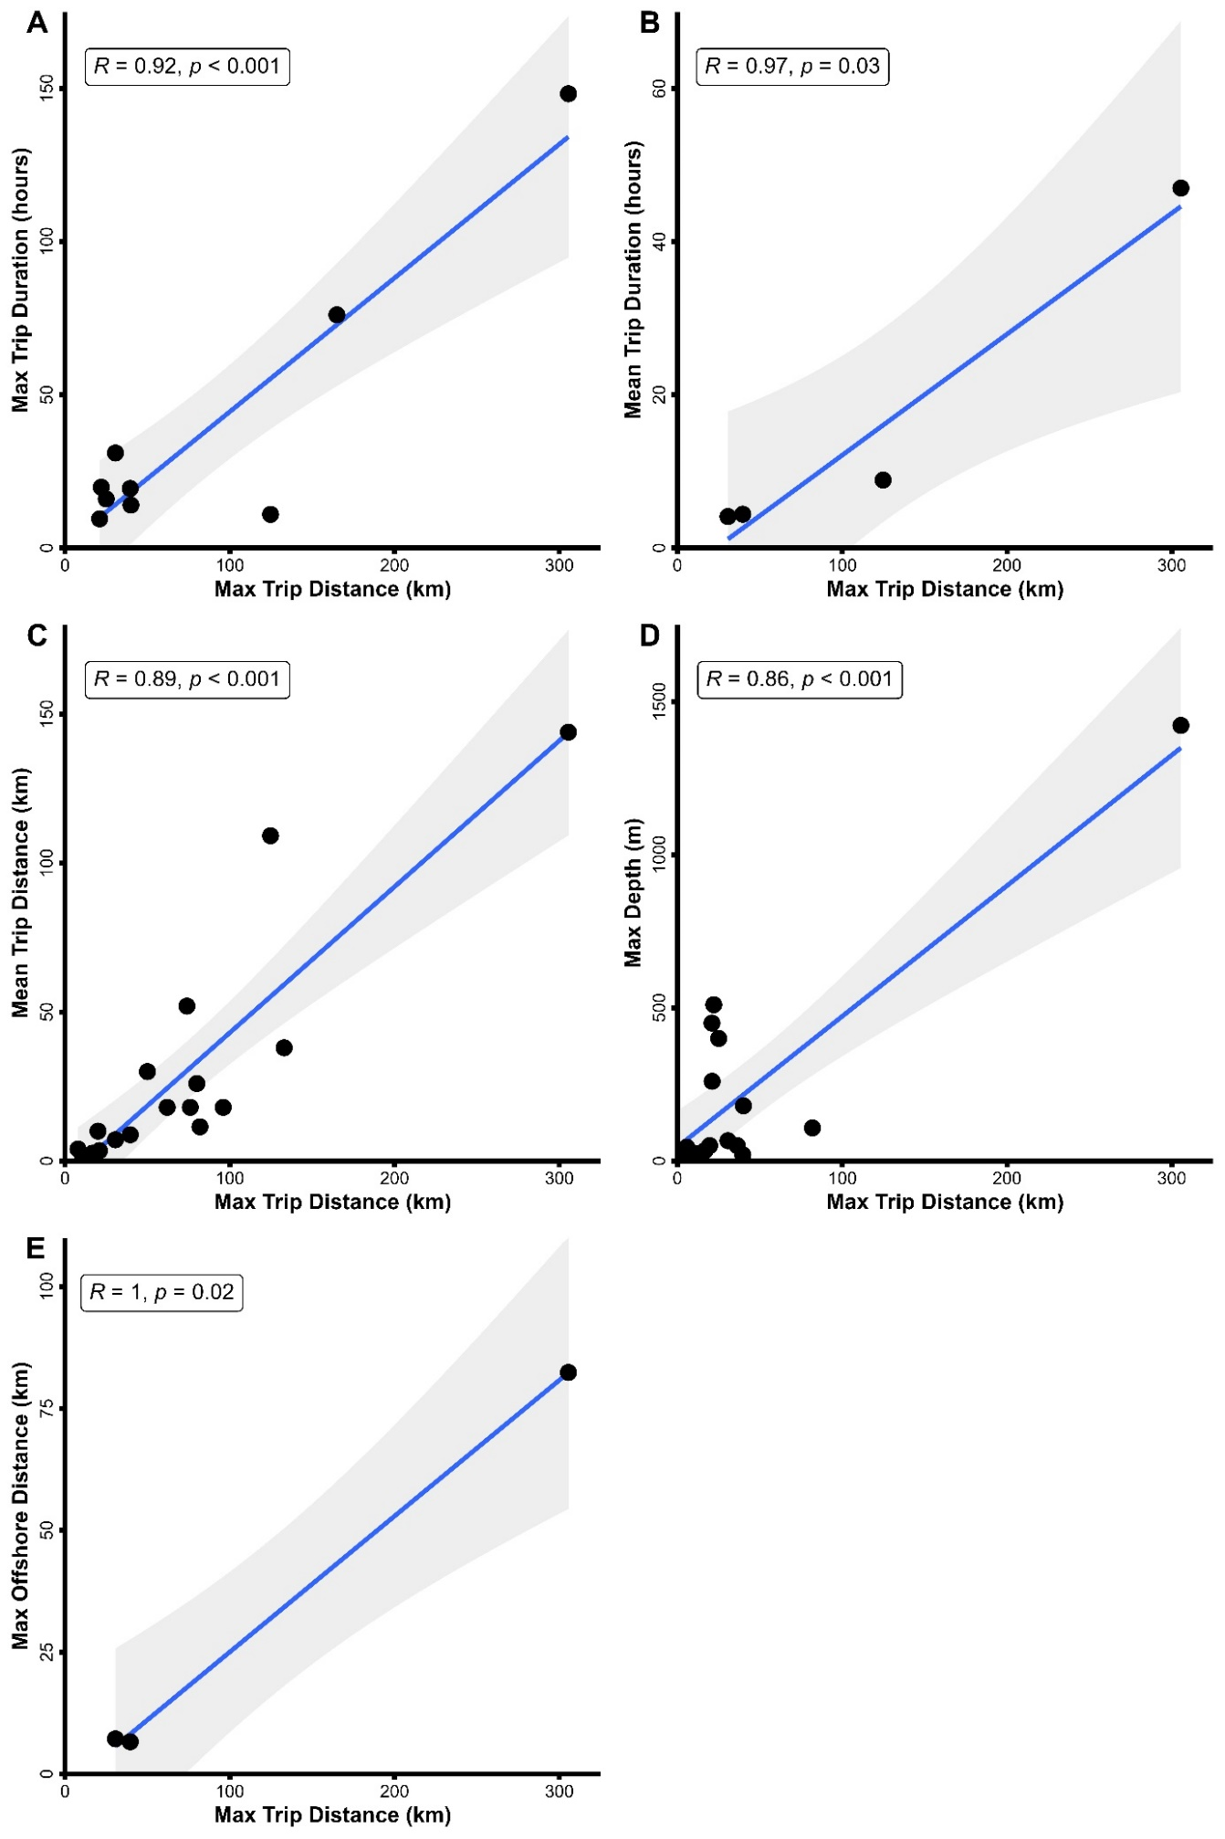
Figure S1 | Correlation plots between spatiotemporal variables: using the Pearson's correlation coefficient test.

